PRACTICE IN BIOINFORMATICS (15 CREDITS)
Prostate adenocarcinoma
Table of Contents

Expression analysis of FCGR3A, FOLH1 and PTGS2 in TCGA-PRAD 3
Expression analysis of FCGR3A, FOLH1 and PTGS2 in MSKCC2010 8
FOLH1 Expression Across Pathological T Stage in TCGA-PRAD 12
Comparison of FOLH1 Expression Across TCGA Cancer Types 13
Analysis of FOLH1 across biopsy site in Metastatic Prostate Adenocarcinoma (SU2C 2019) 15
Analysis of FOLH1 by neuroendocrine features & ETS Fusion Status in Metastatic Prostate Adenocarcinoma (SU2C 2019) 16
Identification of Genes Correlated with FOLH1 Expression in TCGA-PRAD 17
Identification of top correlated genes in metastatic prostate adenocarcinoma samples from SU2C_2019 cohort 19
Comparison of FOLH1 with Known Prostate Cancer Biomarkers (Primary Tumours) 21
Comparison of FOLH1 With Known Prostate Cancer Biomarkers (Metastatic Tumours from SU2C 2019 Cohort) 28
Differential Expression Analysis and Enrichment Analysis Between Normal Tissue and Primary Tumour of TCGA-PRAD 31
Differential Expression Analysis and Enrichment Analysis Of TCGA-PRAD Between High and Low FOLH1 Expression groups 34
Immune Transcriptomic Profiling in TCGA- PRAD (primary tumour + solid tissue samples) 36
Immune Transcriptomic Profiling of TCGA-PRAD in Only Primary Tumours 42
Immune Pathway Activity Associated with FOLH1 Expression in TCGA-PRAD 47
Immune Transcriptomic Profiling of MSKCC2010 Prostate Adenocarcinoma Primary Tumours 51
Immune Transcriptomic Profiling of Metastatic Prostate Cancer in MSKCC2010 55
MCP-Counter Analysis of The Tumour Microenvironment In TCGA-PRAD Primary Tumours 58
MCP-counter analysis of Tumour Microenvironment in SU2C Metastatic Samples of Prostate adenocarcinoma 62

Expression analysis of FCGR3A, FOLH1 and PTGS2 in TCGA-PRAD
The gene expression data of TCGA-PRAD (Prostate Adenocarcinoma) was downloaded from GDC data portal using the TCGAbiolinks Bioconductor package. The data was then analysed in R studio using R (version 4.60), to investigate the specific relevance of the 3 interested genes in prostate cancer: FCGR3A, FOLH1 and PTGS2.
- mRNA expression analysis between normal condition and primary tumours
Since the TCGA, unlike the MSKCC2010 dataset that Martina used, focused specifically on normal and primary tumour sample groups and had just 1 sample that was at the metastatic tumour condition, the comparison for these three genes was done between normal and primary tumour conditions.
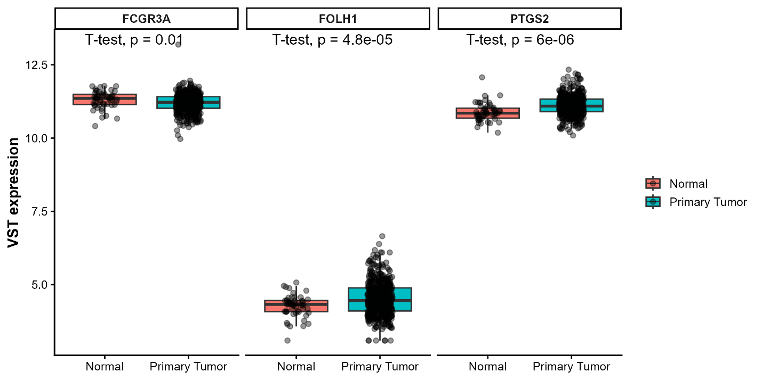

Gene | P value | T statistic | Significance
FCGR3A | 0.010088 | 2.651858 | *
FOLH1 | 4.83E-05 | -4.30167 | ***
PTGS2 | 6.01E-06 | -4.93238 | ***

The expressions of all three genes, FOLH1 (p value: 4.83E-05, and t statistic: -4.30167), PTGS2 (p value: 6.01E-06, t statistic: -4.93238) and FCGR3A (p value: 0.010088, t statistic:2.651858) differed significantly between the normal and primary tumour conditions. The boxplots show that for the genes FOLH1 and PTGS2, the expressions were higher in the primary tumour condition compared to the normal condition, whereas in FCGR3A, the expression was lower in primary tumour. The separate box plots which show this separation more clearly are below.
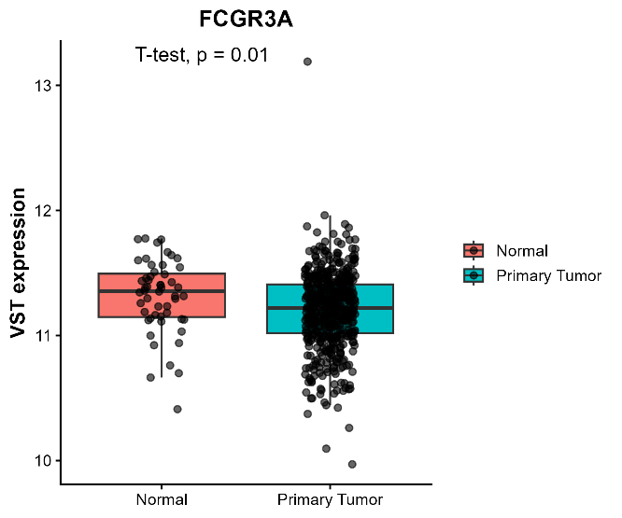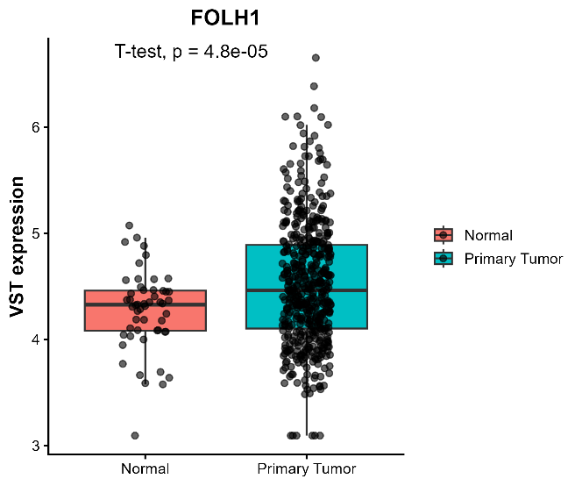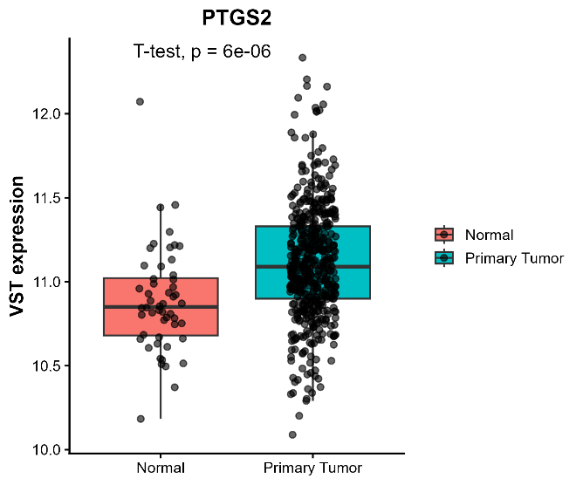

- Gleason Scores for primary tumours

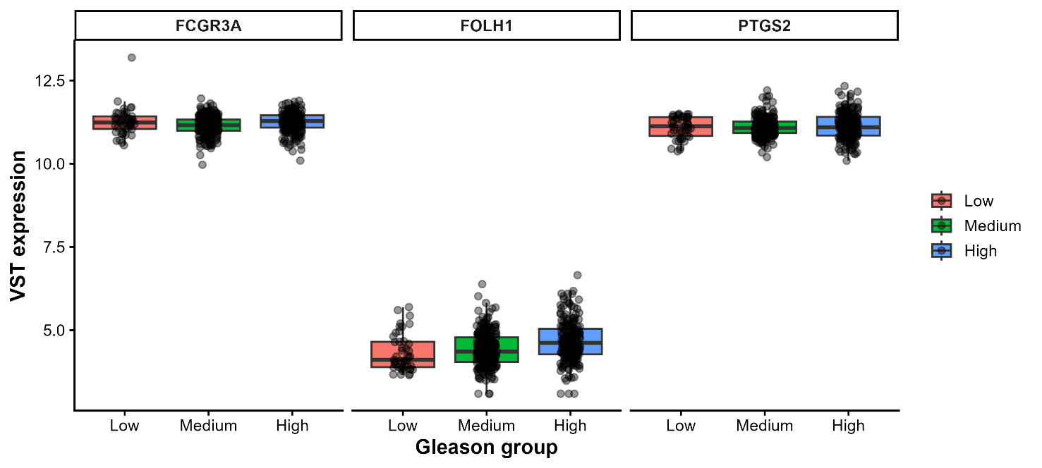
Gene | Source | Sum of Squares | df | Mean Square | F | Sig
FCGR3A | Between | 1.156181 | 2 | 0.578091 | 6.049713 | 0.002547
 | Within | 44.8161 | 469
 | Total | 45.97228 | 471
FOLH1 | Between | 8.569676 | 2 | 4.284838 | 13.2127 | 2.62E-06
 | Within | 152.0952 | 469
 | Total | 160.6649 | 471
PTGS2 | Between | 0.064703 | 2 | 0.032351 | 0.275434 | 0.759365
 | Within | 55.08682 | 469
 | Total | 55.15152 | 471

One-way ANOVA was performed to compare VST expression of FCGR3A, FOLH1, and PTGS2 across Gleason score groups in TCGA-PRAD primary tumours. The analysis showed a significant difference among Gleason groups for FCGR3A (F=6.0497, p=0.002547) (F= 6.0497, p=0.002547) (F=6.0497, p=0.002547) and FOLH1 (F=13.2127, p=2.62×10−6) (F = 13.2127, p = 2.62 \times 10^ {-6}) (F=13.2127, p=2.62×10−6), indicating that expression of these genes varies with tumour grade. In contrast, PTGS2 did not show a significant association with Gleason group (F=0.2754, p=0.759365) (F = 0.2754, p = 0.759365) (F=0.2754, p=0.759365). Overall, these results suggest that FCGR3A and especially FOLH1 are linked to Gleason score–dependent expression differences, whereas PTGS2 appears relatively stable across grade categories.
- Survival study via Kaplan-Meier curve
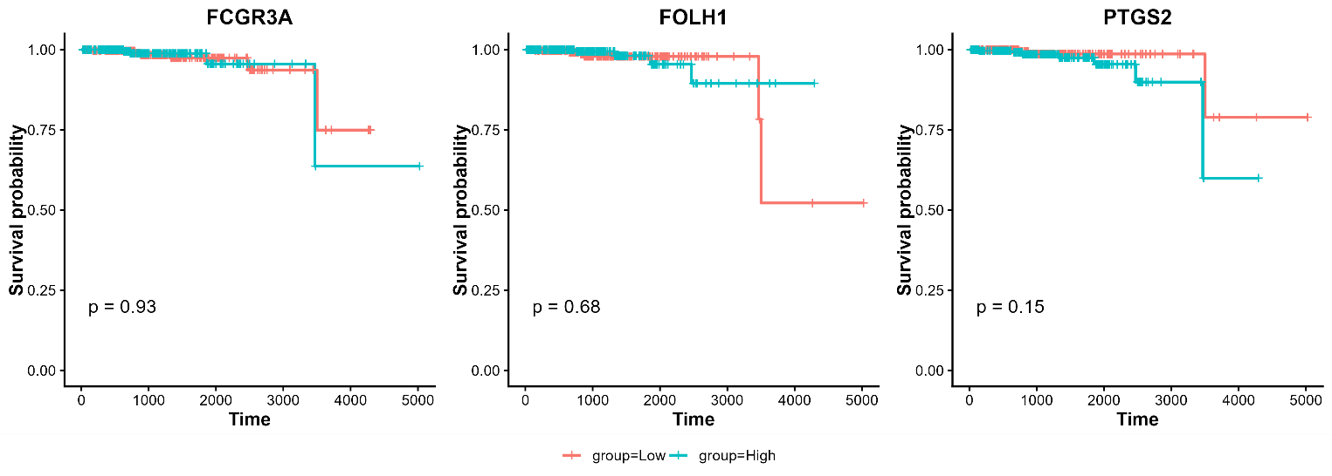
Gene | P value | Significance
FCGR3A | 0.934154 | ns
FOLH1 | 0.682536 | ns
PTGS2 | 0.147258 | ns

When patients were stratified into high- and low-expression groups based on median gene expression, the Kaplan–Meier curves did not reveal a clear separation for any of the three genes. FCGR3A showed almost completely overlapping survival curves, while FOLH1 and PTGS2 displayed only modest visual separation that did not reach statistical significance. Overall, these findings suggest that although these genes may differ in expression across tumour groups, their expression levels were not predictive of survival outcome in this analysis.
- Heatmaps
FOLH1 heatmap: The FOLH1 heatmap showed a distinct co-expression pattern, with one group of genes positively correlated with FOLH1 and another group negatively correlated. This suggests that FOLH1 is associated with a specific transcriptional program in TCGA-PRAD, likely reflecting differences between tumour-related and immune-related gene expression.
FCGR3A heatmap: The FCGR3A heatmap showed a strong immune-like co-expression pattern, with FCGR3A clustering with genes that are commonly associated with immune cell activity. This indicates that FCGR3A is embedded in an immune cell-related expression module in TCGA-PRAD.
PTGS2 heatmap: The PTGS2 heatmap showed a mixed but organized co-expression structure, with PTGS2 associated with a separate set of correlated genes. This pattern is consistent with PTGS2 being involved in inflammatory or microenvironment-related signalling in TCGA-PRAD.

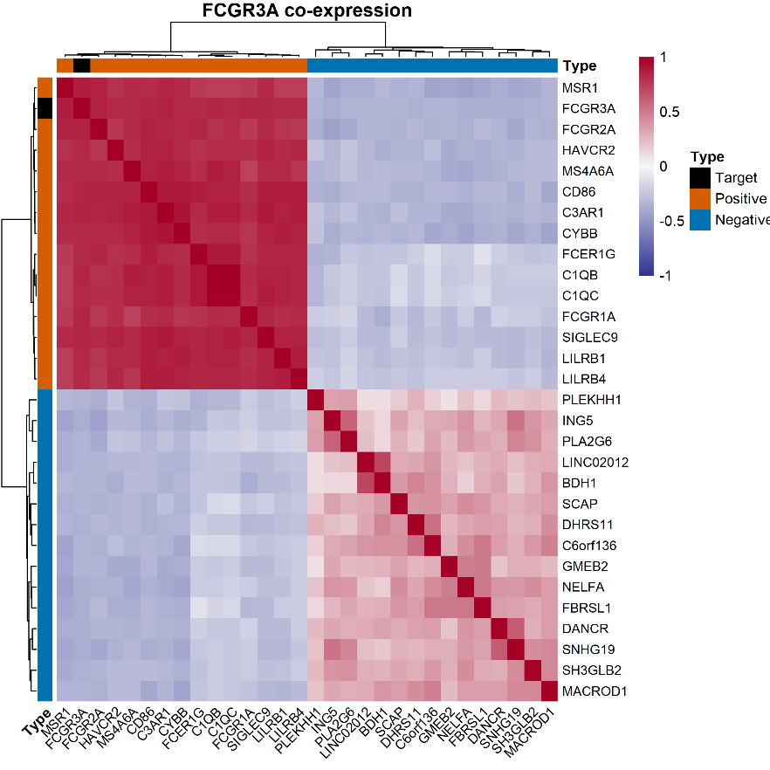
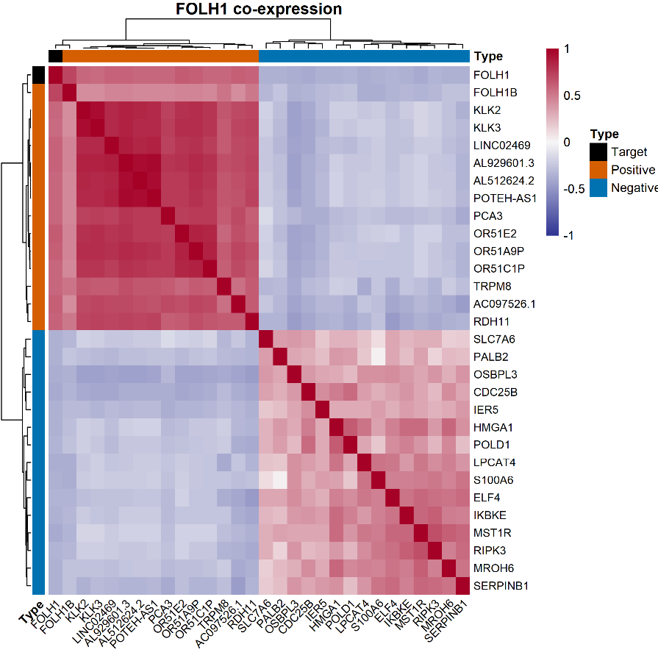
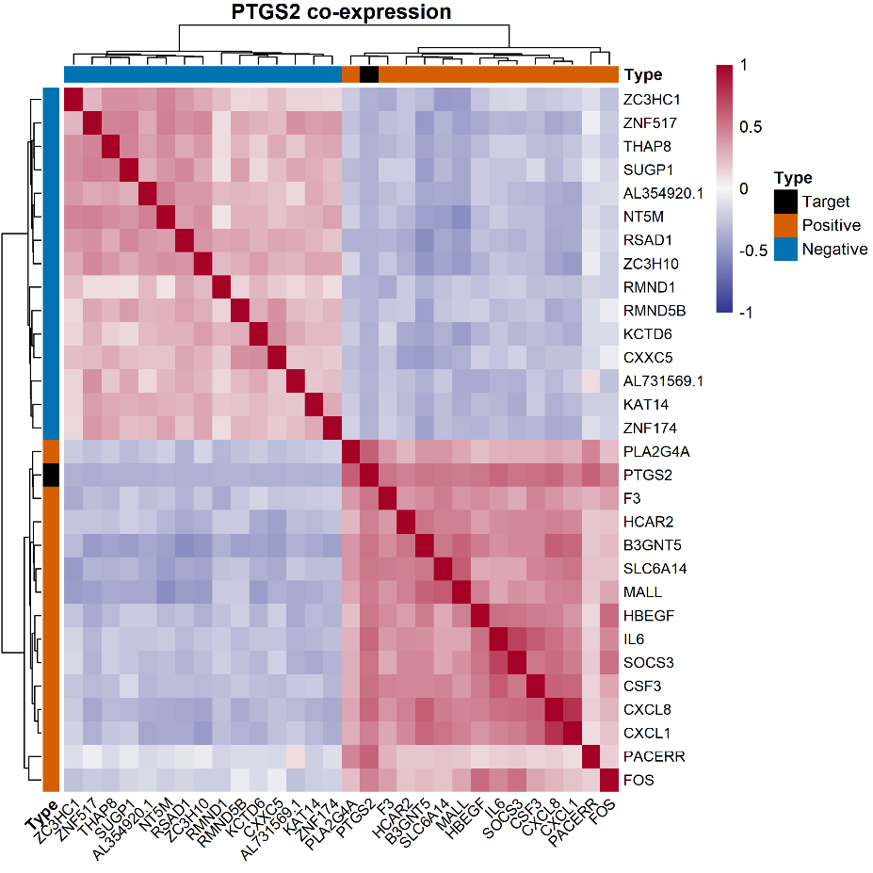

Expression analysis of FCGR3A, FOLH1 and PTGS2 in MSKCC2010

- mRNA expression analysis between primary tumours and metastatic
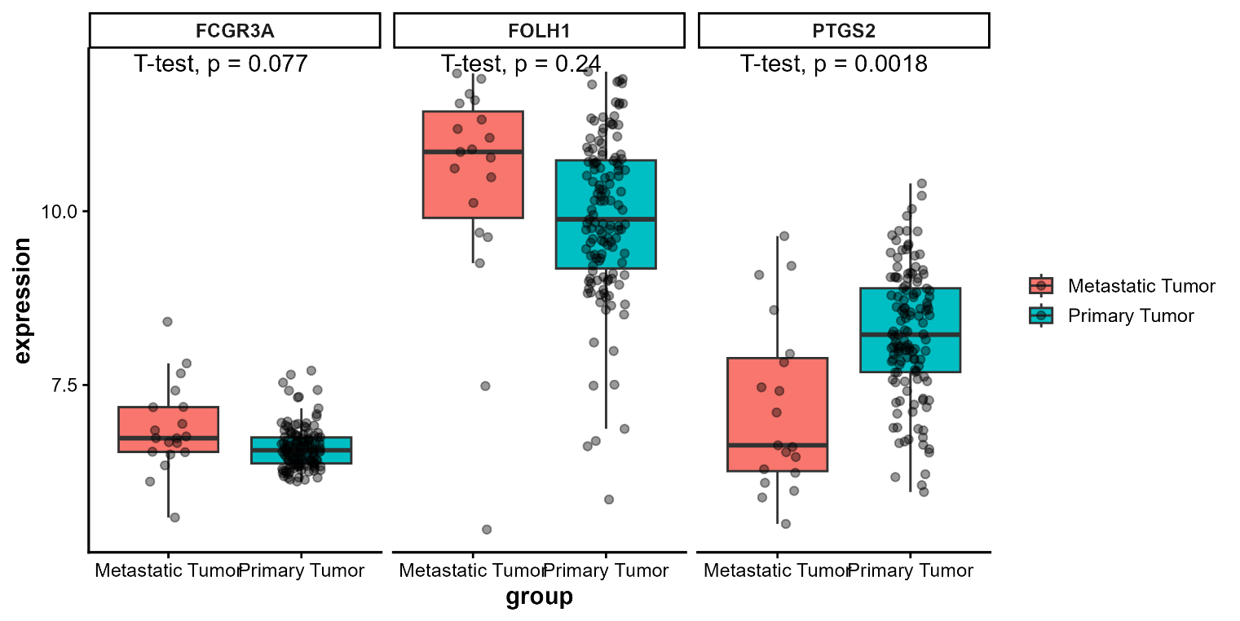
Gene | P Value | Statistic
FCGR3A | 0.07678192 | 1.86994478
FOLH1 | 0.23585284 | 1.22088752
PTGS2 | 0.00180644 | -3.56844432

Expression analysis in the MSKCC2010 cohort compared metastatic tumour samples with primary tumour samples for the three target genes. FCGR3A showed a modest increase in metastatic tumours, but the difference was not statistically significant. FOLH1 also did not differ significantly between groups. In contrast, PTGS2 was significantly differentially expressed, with lower expression in metastatic tumours relative to primary tumours based on the boxplot pattern and negative t statistic. Overall, only PTGS2 showed a robust association with tumour status in this cohort.

- Gleason Scores for primary tumours

Gene | Source | Sum Of Squares | Df | Mean Square | F | Sig
FCGR3A | Between | 0.38940045 | 2 | 0.19470022 | 2.077805 | ns
 | Within | 11.9005048 | 127 | 0.09370476
 | Total | 12.2899053 | 129
FOLH1 | Between | 12.254987 | 2 | 6.12749352 | 4.87011617 | **
 | Within | 159.78914 | 127 | 1.25818221
 | Total | 172.044127 | 129
PTGS2 | Between | 7.77488468 | 2 | 3.88744234 | 4.73295836 | *
 | Within | 104.312174 | 127 | 0.8213557
 | Total | 112.087059 | 129

Expression of FCGR3A remained relatively similar across low, intermediate, and high Gleason groups, and the ANOVA did not support a statistically significant difference. In contrast, FOLH1 showed the clearest grade-associated change, with lower expression in the low Gleason group and higher expression in the high group, consistent with a significant overall group effect. PTGS2 also varied across Gleason categories, but the separation was more modest than for FOLH1. Overall, these results suggest that FOLH1 and PTGS2 are associated with Gleason score–dependent expression changes in primary tumours, while FCGR3A is not.

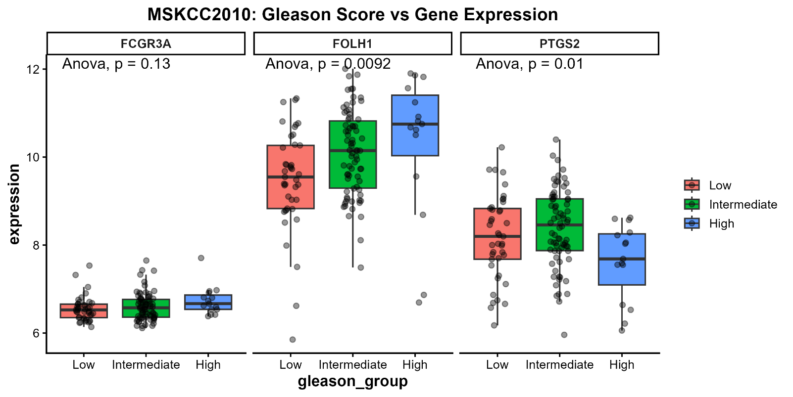

- Survival study via Kaplan-Meier curve
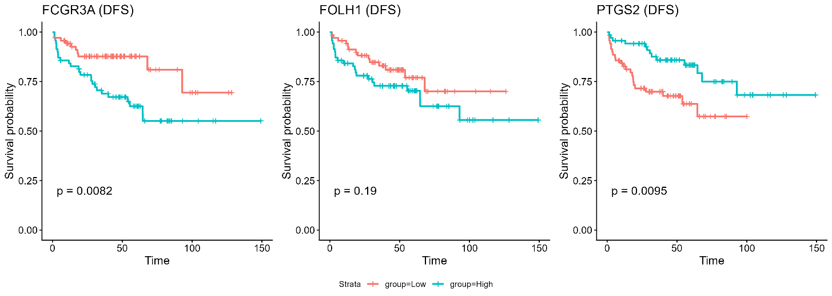
In the DFS Kaplan–Meier analysis, FCGR3A and PTGS2 showed significant survival differences between the high- and low-expression groups, while FOLH1 did not. The log-rank p values were 0.0082 for FCGR3A, 0.19 for FOLH1, and 0.0095 for PTGS2, indicating that only FCGR3A and PTGS2 were associated with disease-free survival in this cohort.

- Heatmaps
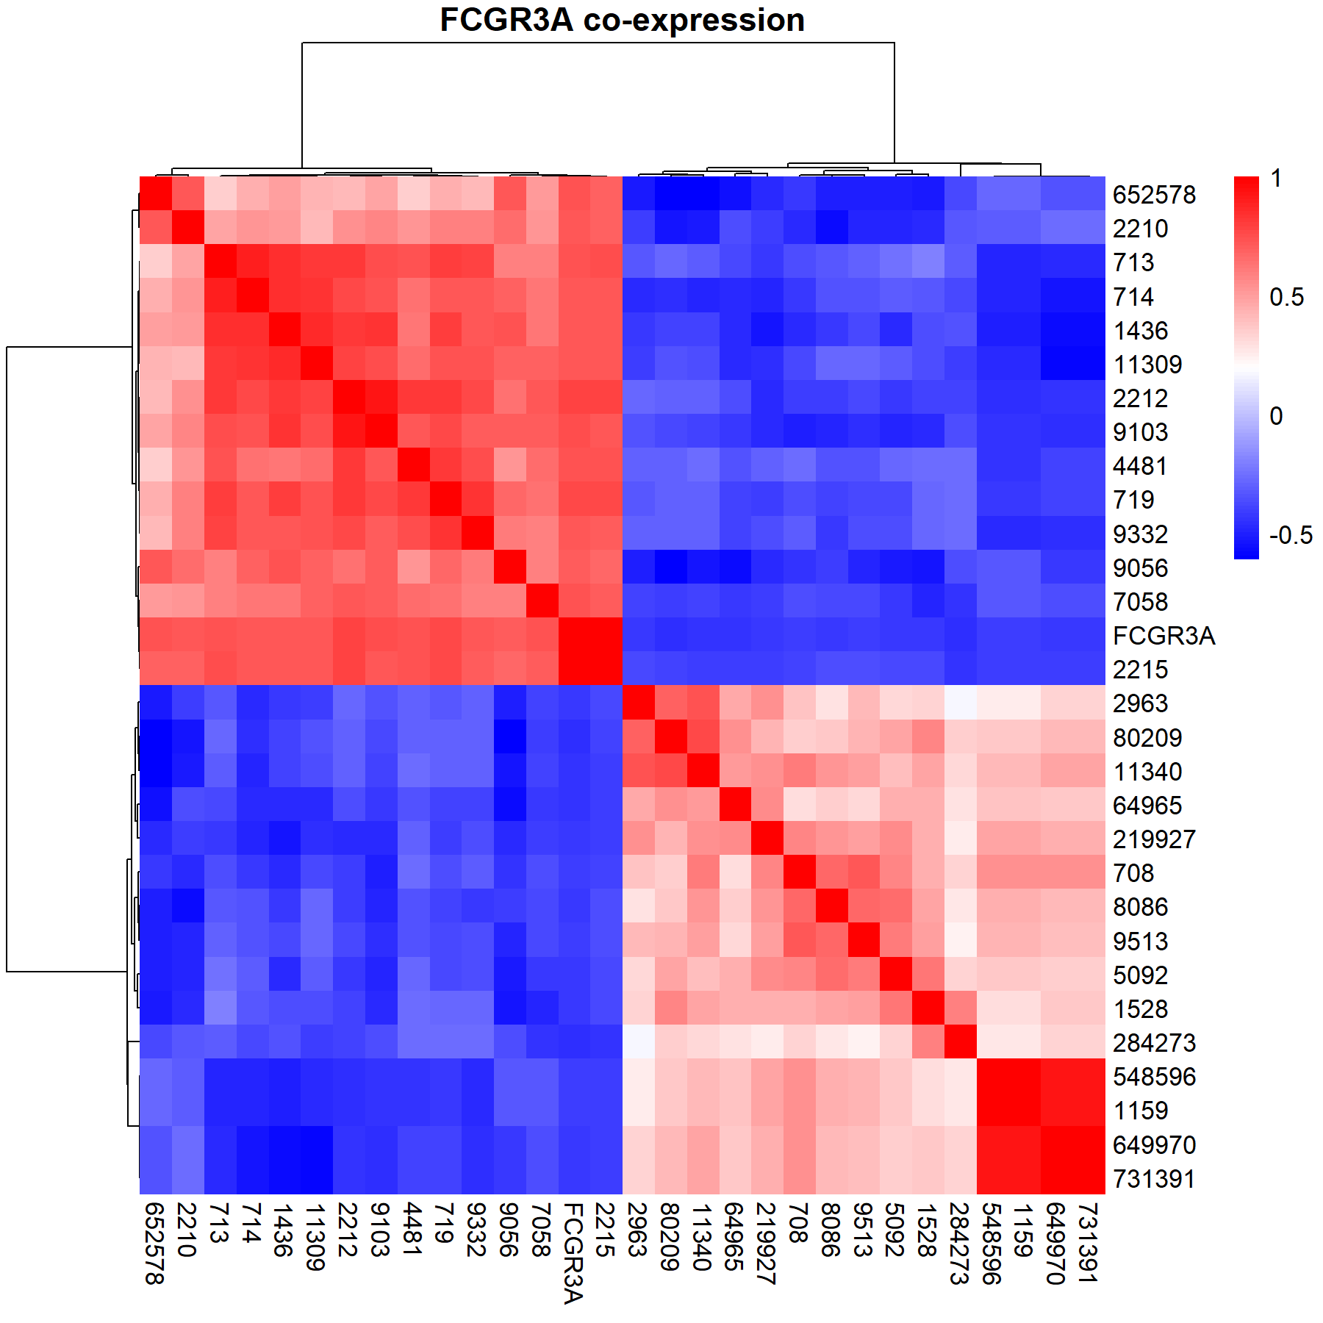
The FOLH1 heatmap shows a strong split into two opposite expression blocks. One block is positively associated with FOLH1, while the other is negatively associated, suggesting that FOLH1 is embedded in a stable co-expression program in MSKCC2010. This is consistent with the results from TCGA-PRAD dataset
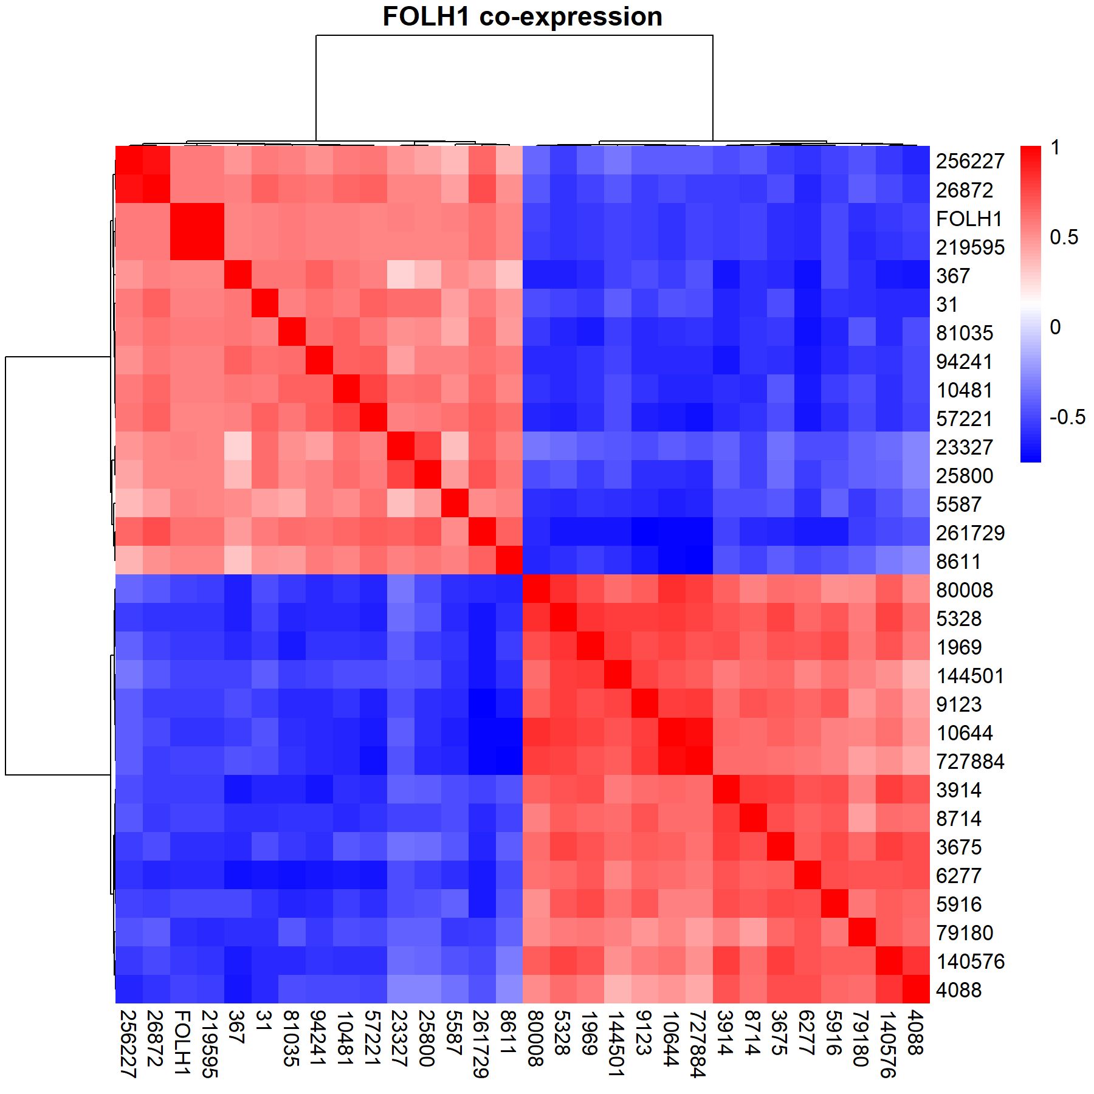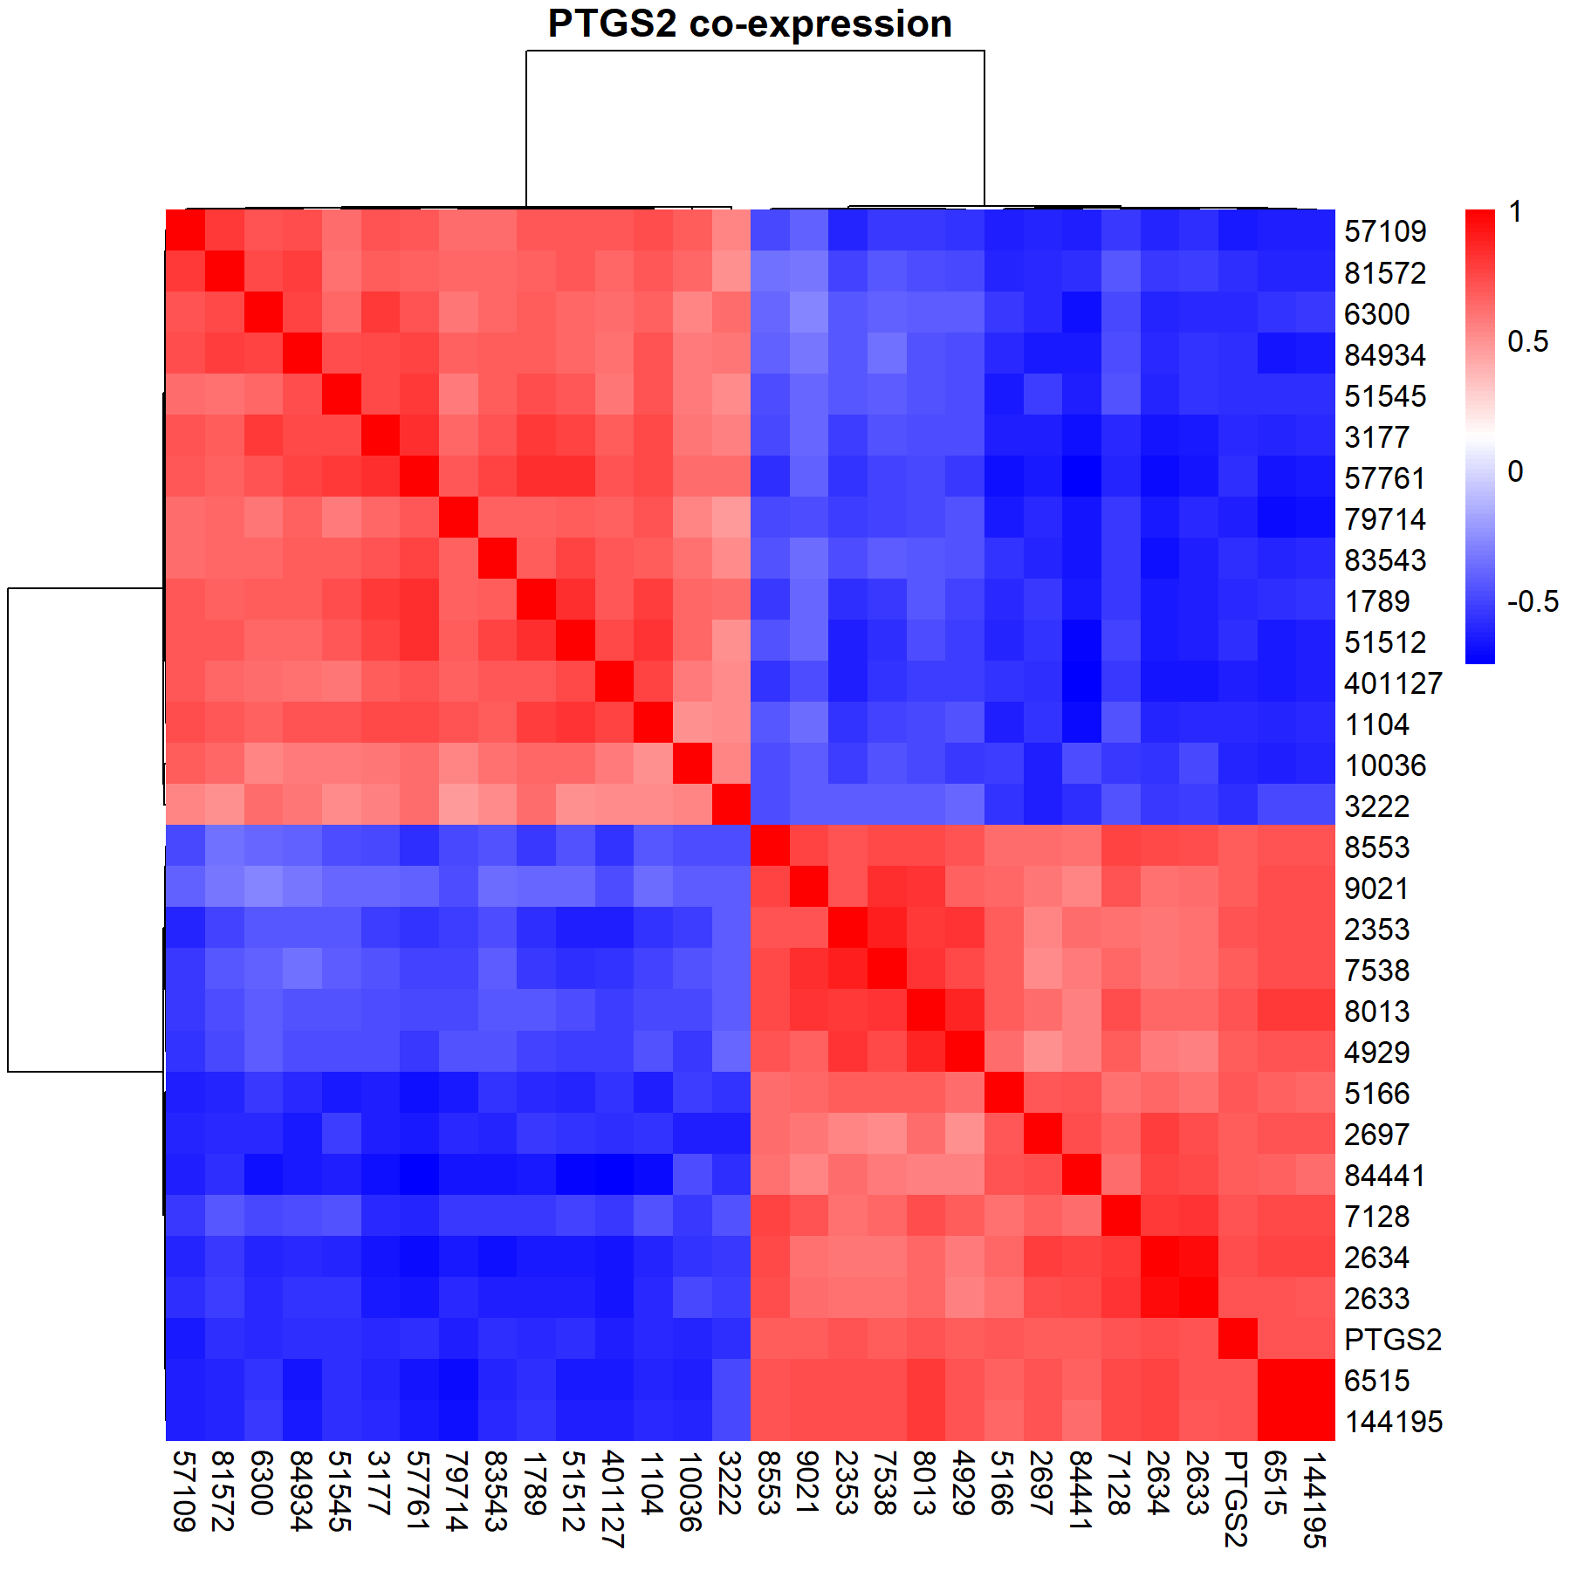
PTGS2 also shows a clear two-block pattern in MSKCC2010. The gene appears to be embedded in a correlated module that is opposed by another set of genes, which fits an inflammatory or microenvironment-related role.
FCGR3A shows the clearest and most immune-like co-expression pattern. The structure is very distinct, with a strong block of positively correlated genes and a separate block of negatively correlated genes, which is consistent with FCGR3A being tied to immune-cell biology. This looks broadly in line with the TCGA-PRAD heatmap.

FOLH1 Expression Across Pathological T Stage in TCGA-PRAD
TCGA-PRAD samples were subset from the pan-cancer dataset, normalized with DESeq2, and variance-stabilized prior to analysis. FOLH1 expression was then compared across pathological T-stage groups using sample-level boxplots and a non-parametric group comparison test.
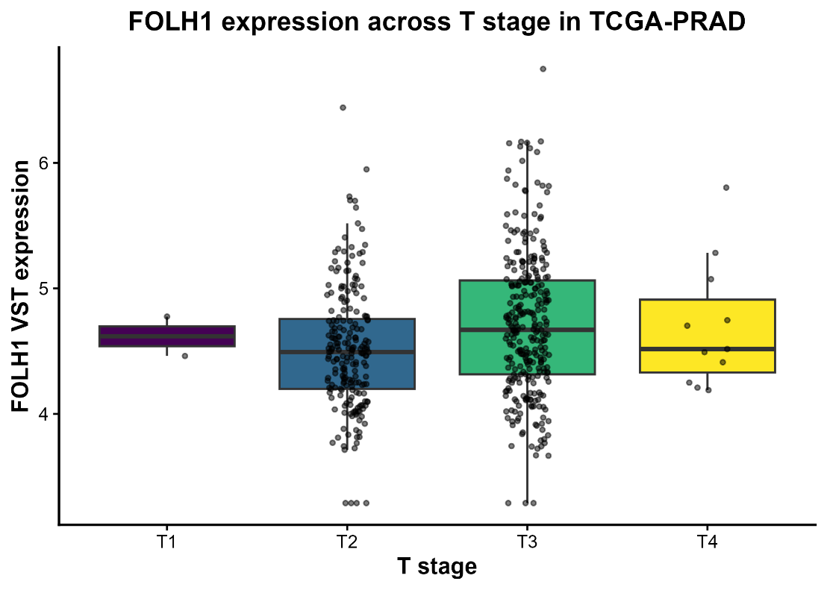
Comparison of FOLH1 expression across pathological T stage revealed a significant overall difference in TCGA-PRAD samples (Kruskal-Wallis test, p=0.001063p = 0.001063p=0.001063). While median expression was relatively similar across T1–T4 categories, the distribution differed significantly among groups, indicating that FOLH1 expression may vary with local tumor progression.
T stage | n | median | mean
T1 | 2 | 4.618477 | 4.618477
T2 | 212 | 4.492931 | 4.515154
T3 | 295 | 4.669395 | 4.714704
T4 | 11 | 4.516867 | 4.697983

Statistical Testing: Pairwise Wilcox
T stage | T stage | P adj
T3 | T2 | 0.000392
T4 | T2 | 0.921382
T2 | T1 | 1
T3 | T1 | 1
T4 | T1 | 1
T4 | T3 | 1

Comparison of FOLH1 Expression Across TCGA Cancer Types
The whole TCGA pan data was used in order to compare which cancers showed the highest expression of FOLH1 (PSMA) in their primary tumour samples. The counts were normalized and divided according to which cancer type they are from and compared using boxplots, which were based on the top 10 cancer types.

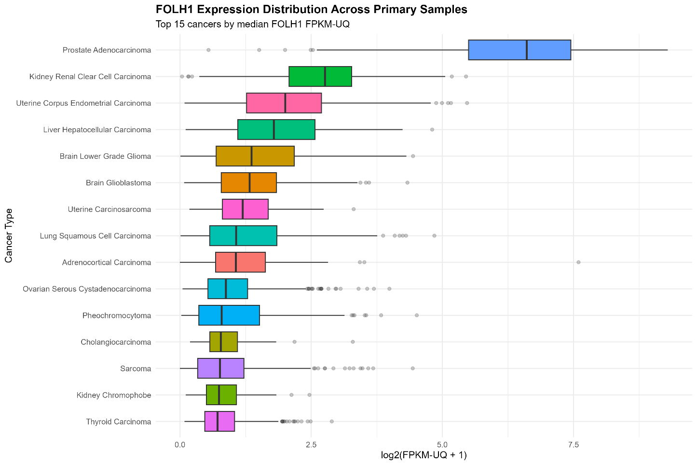
Summarized Table of All Cancers
Cancer type | N samples | Median fpkm_uq | median_log2 | Kruskal p overall
Prostate Adenocarcinoma | 501 | 96.6505 | 6.609556 | 0
Kidney Renal Clear Cell Carcinoma | 541 | 5.7862 | 2.762604 | 0
Uterine Corpus Endometrial Carcinoma | 553 | 3.0156 | 2.005616 | 0
Liver Hepatocellular Carcinoma | 371 | 2.4523 | 1.787558 | 0
Brain Lower Grade Glioma | 516 | 1.57265 | 1.363251 | 0
Brain Glioblastoma | 372 | 1.5077 | 1.326365 | 0
Uterine Carcinosarcoma | 57 | 1.2909 | 1.195914 | 0
Lung Squamous Cell Carcinoma | 511 | 1.0978 | 1.068877 | 0
Adrenocortical Carcinoma | 79 | 1.0931 | 1.065641 | 0
Ovarian Serous Cystadenocarcinoma | 426 | 0.83345 | 0.874561 | 0
Pheochromocytoma | 179 | 0.7324 | 0.792772 | 0
Cholangiocarcinoma | 35 | 0.7138 | 0.777199 | 0
Sarcoma | 259 | 0.696 | 0.762136 | 0
Kidney Chromophobe | 66 | 0.6734 | 0.742735 | 0
Thyroid Carcinoma | 505 | 0.6417 | 0.715191 | 0
Breast Invasive Carcinoma | 1111 | 0.577 | 0.657183 | 0
Lung Adenocarcinoma | 540 | 0.53175 | 0.615181 | 0
Esophageal Carcinoma | 184 | 0.50775 | 0.592394 | 0
Pancreatic Adenocarcinoma | 178 | 0.4983 | 0.583326 | 0
Head and Neck Squamous Cell Carcinoma | 520 | 0.45605 | 0.54206 | 0
Stomach Adenocarcinoma | 412 | 0.42895 | 0.514955 | 0
Bladder Urothelial Carcinoma | 412 | 0.395 | 0.480265 | 0
Mesothelioma | 87 | 0.3263 | 0.407407 | 0
Testicular Germ Cell Tumors | 150 | 0.298 | 0.376287 | 0
Colon Adenocarcinoma | 481 | 0.2872 | 0.364236 | 0
Rectal Adenocarcinoma | 166 | 0.2757 | 0.351287 | 0
Cervical Squamous Cell Carcinoma | 304 | 0.24555 | 0.316781 | 0
Skin Cutaneous Melanoma | 103 | 0.2341 | 0.303459 | 0
Uveal Melanoma | 80 | 0.22985 | 0.298482 | 0
Kidney Renal Papillary Cell Carcinoma | 290 | 0.18285 | 0.242267 | 0
Diffuse Large B-cell Lymphoma | 48 | 0.1062 | 0.145604 | 0
Thymoma | 120 | 0.0925 | 0.127633 | 0

Among primary tumours, FOLH1 showed the highest median FPKM-UQ in prostate adenocarcinoma, with kidney renal clear cell carcinoma and uterine corpus endometrial carcinoma also showing relatively elevated expression. In contrast, most other tumour types had substantially lower median values, and the lowest expression was seen in thymoma, diffuse large B-cell lymphoma, and kidney renal papillary cell carcinoma. Overall, FOLH1 expression differed strongly across cancer types, with the group comparison reaching extreme significance (Kruskal-Wallis p < 2.2e-16), indicating that the observed differences were not due to random variation alone. The same ranking pattern was also visible on the log scale, where prostate adenocarcinoma remained the dominant outlier and the rest of the cancers clustered at much lower expression levels.

Analysis of FOLH1 across biopsy site in Metastatic Prostate Adenocarcinoma (SU2C 2019)
The expression of FOLH1 depending on the biopsy site of metastatic tumours were looked into using the SU2C 2019 cohort 266 samples. The box plots and table below summarise the results.
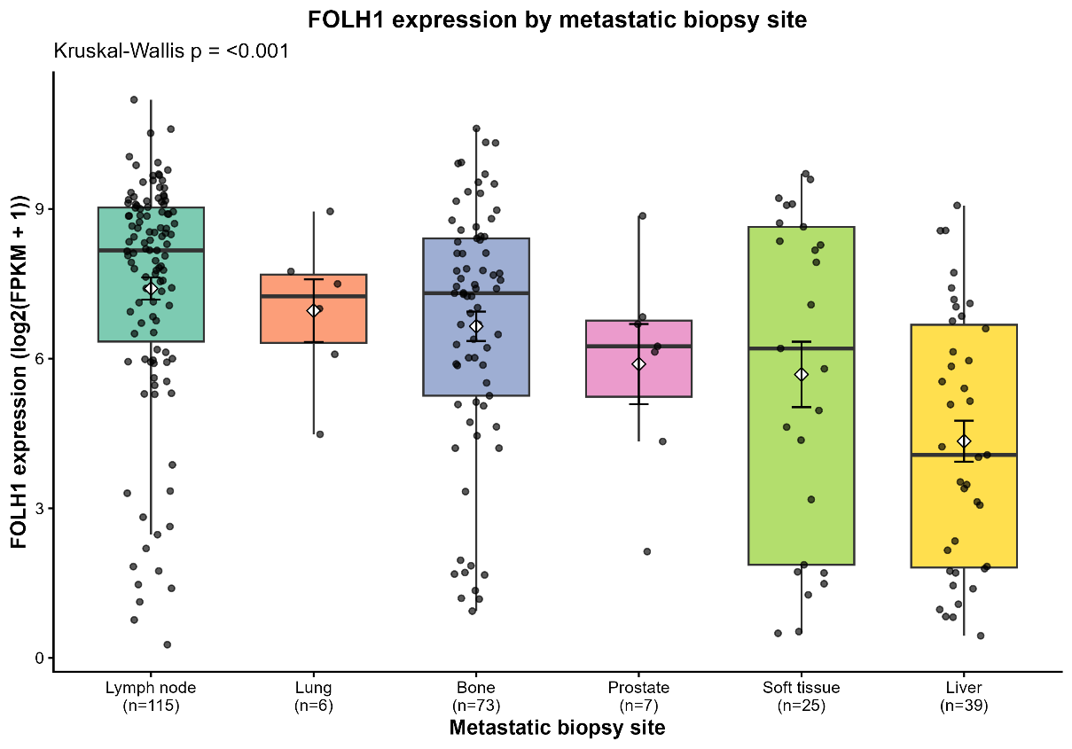

The expression levels between the Lymph node and Liver, as well as the Bone and liver were the only combinations that showed significant differences.
group1 | group2 | P adj | P adj signif
Lymph node | Liver | 1.12E-08 | ****
Bone | Liver | 0.000613 | ***
Lymph node | Bone | 0.061372 | ns
Lymph node | Soft tissue | 0.061372 | ns
Soft tissue | Liver | 0.063757 | ns
Lymph node | Prostate | 0.153264 | ns
Lung | Liver | 0.16927 | ns
Lymph node | Lung | 0.558177 | ns
Bone | Prostate | 0.558177 | ns
Bone | Soft tissue | 0.558177 | ns
Prostate | Liver | 0.558177 | ns
Lung | Prostate | 0.649621 | ns
Lung | Soft tissue | 0.741335 | ns
Prostate | Soft tissue | 0.741335 | ns
Lung | Bone | 0.979239 | ns

Analysis of FOLH1 by neuroendocrine features & ETS Fusion Status in Metastatic Prostate Adenocarcinoma (SU2C 2019)

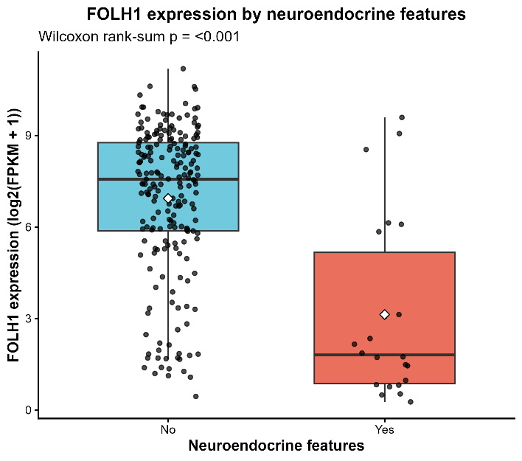
The same cohort was used with the clinical data to indicate the presence or absence of neuroendocrine features to compare the expression level of FOLH1 within the two groups. Previous publications suggest a negative relationship between FOLH1 levels and endocrine features, and my analysis reproduced this same conclusion, as can be seen from the bar plot below.

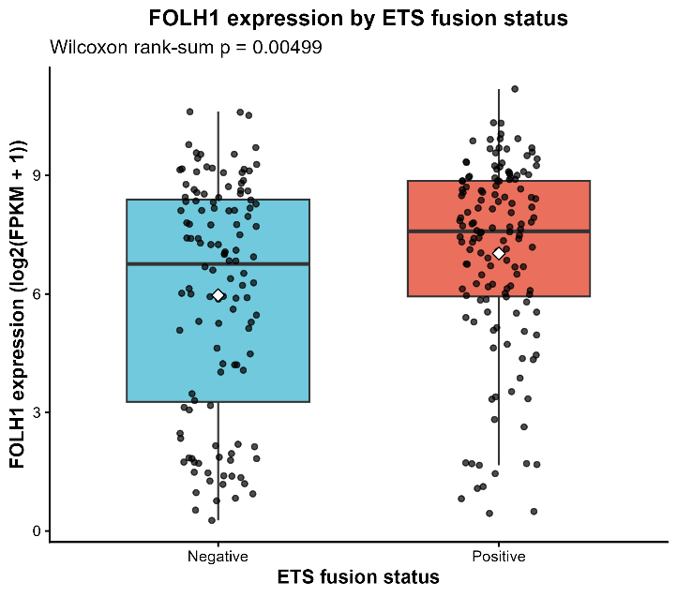
Next, similarly using the clinical data, FOLH1 expression levels were compared across positive and negative ETS Fusion Status, and the results show a significant difference between the two groups, where ETS fusion positive group shows an elevated expression of FOLH1.

Identification of Genes Correlated with FOLH1 Expression in TCGA-PRAD
This analysis investigated genes whose expression patterns were correlated with FOLH1 in TCGA-PRAD. The dataset was first filtered to retain only prostate adenocarcinoma samples. Expression counts were normalized and transformed using DESeq2 variance-stabilizing transformation to obtain a stabilized expression matrix for downstream analysis. Correlation analysis was then performed separately in primary tumour samples and solid tissue normal samples to identify the genes most positively and negatively associated with FOLH1 expression in each group. Finally, the results were summarized using ranked correlation plots, a tumour-versus-normal correlation scatter plot, and a heatmap of the strongest correlated genes.
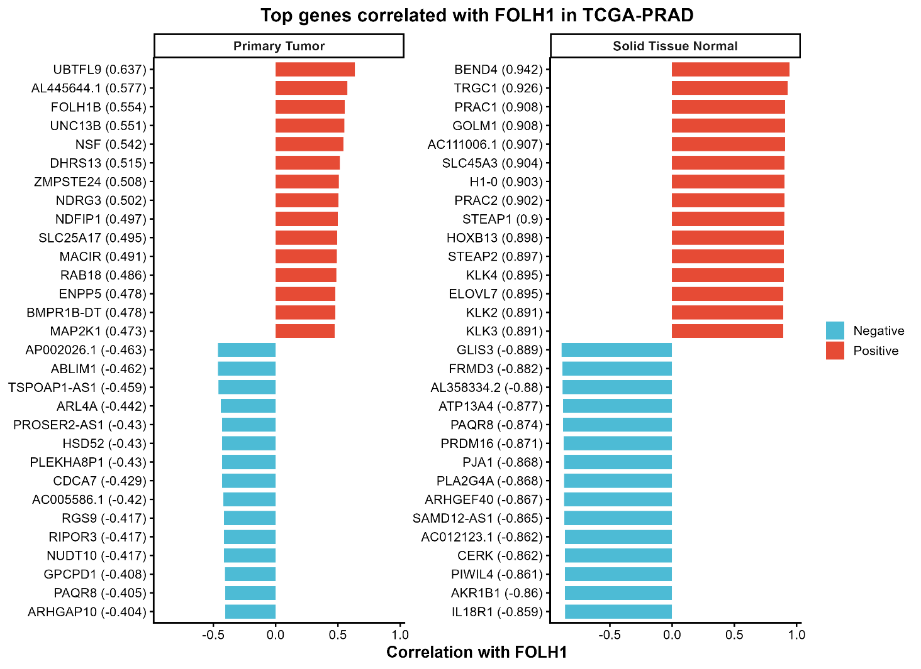
FOLH1 exhibited distinct co-expression patterns in TCGA-PRAD primary tumours and solid tissue normal samples. Although both groups showed strong positive and negative correlations, the specific correlated genes differed substantially between tumour and normal tissue, suggesting that FOLH1 is associated with transcriptional programs that are tissue-state-dependent.
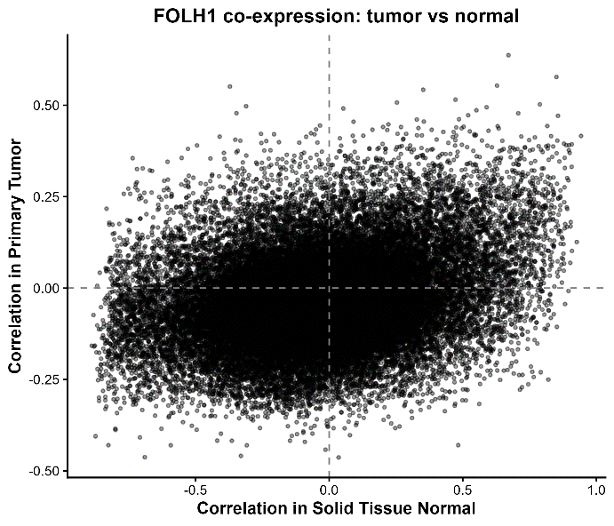
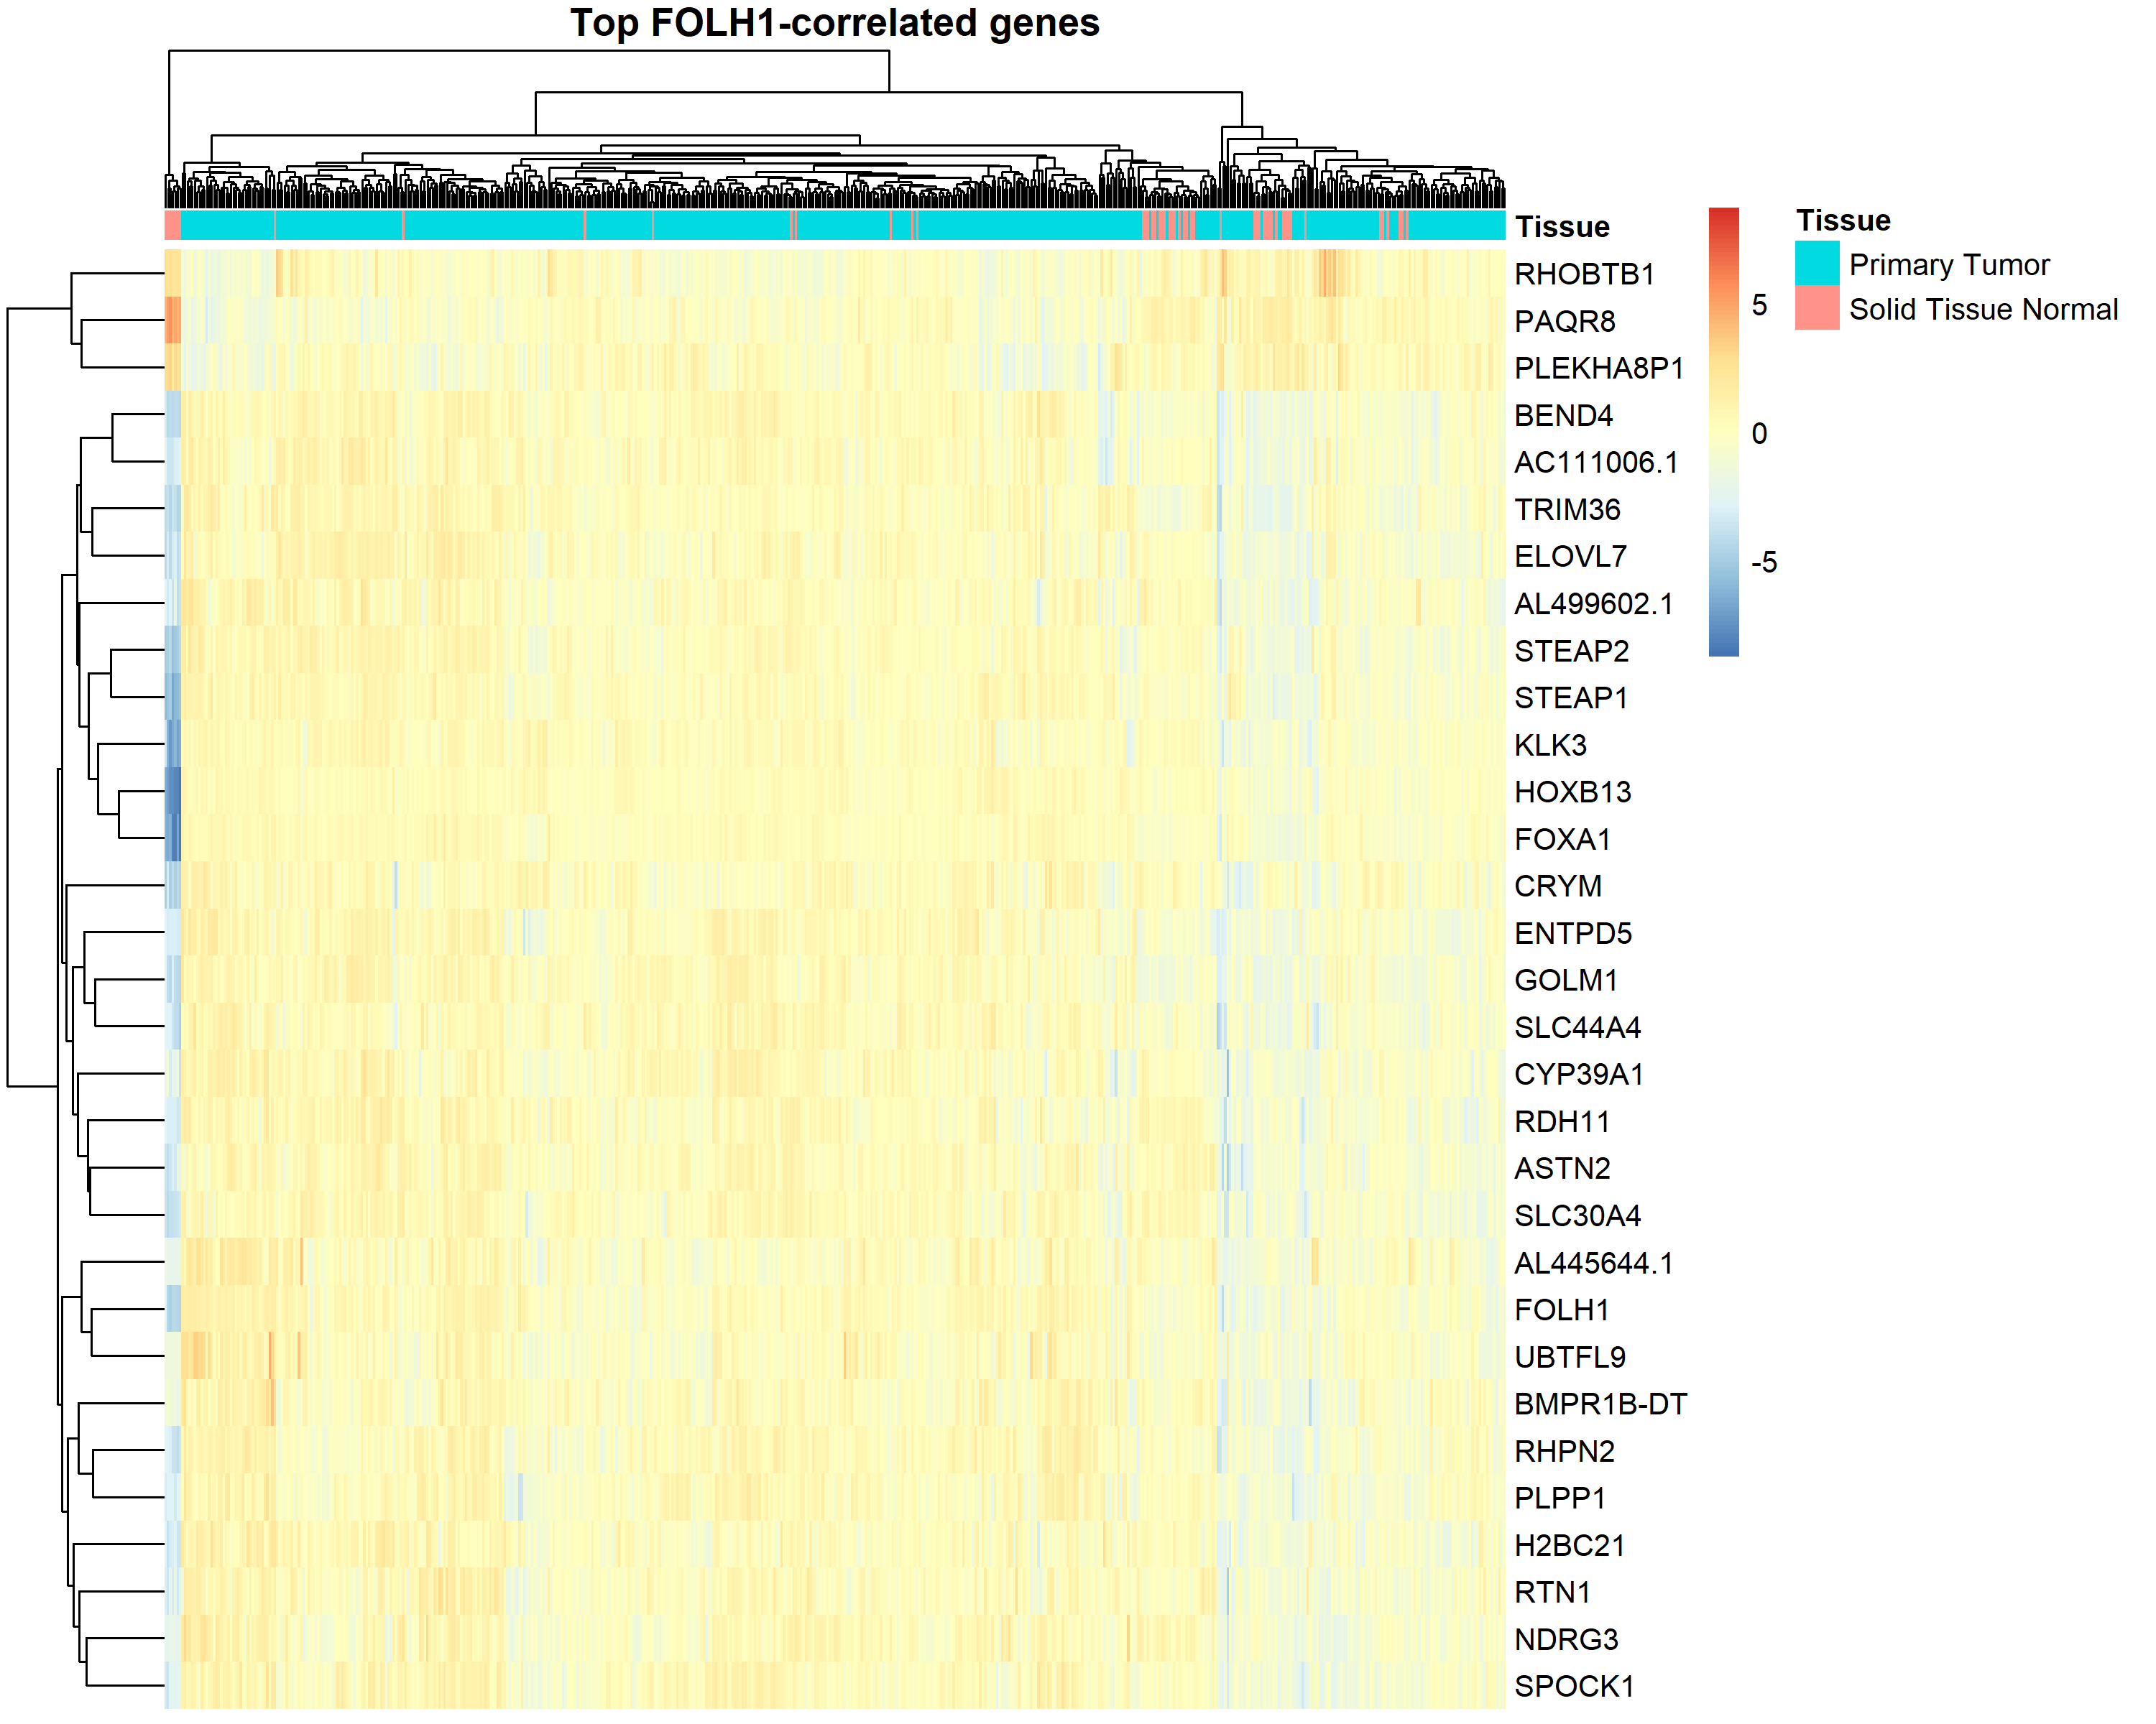
The tumour-versus-normal correlation scatter plot revealed a strong overall positive association between FOLH1 co-expression patterns in primary tumour and solid normal samples, indicating shared transcriptional coupling across tissue contexts. However, the broad dispersion of points suggests substantial context dependence. The heatmap of top correlated genes further indicated tissue-associated clustering, supporting the presence of a distinct FOLH1-linked expression program in TCGA-PRAD.

Identification of top correlated genes in metastatic prostate adenocarcinoma samples from SU2C_2019 cohort
The SU2C 2019 cohort, containing 266 metastatic samples was used to see which genes correlated the most with the fpkm counts using spearman’s correlation test. Each of these genes had a p value below 0.05, showing statistically significant corelates.
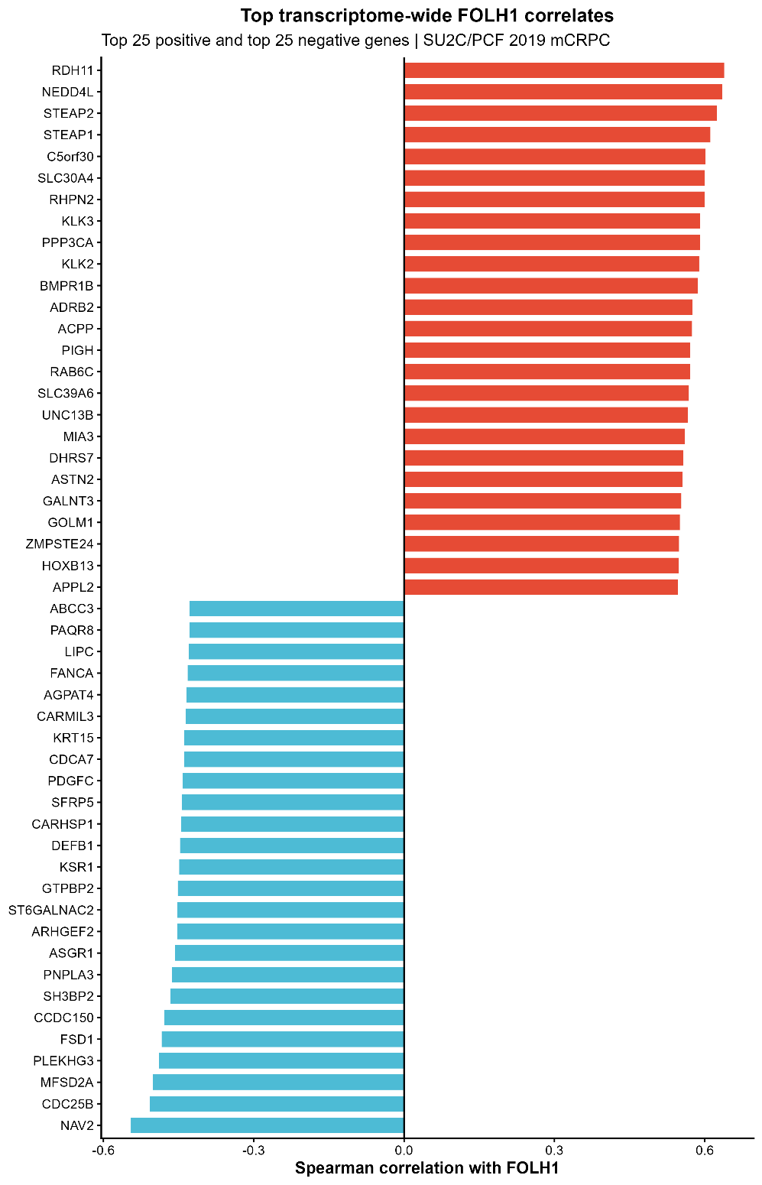
When compared with the list of known biomarkers we received from Felicia, only KLK3 appear on this list of top 25 positively and negatively correlated genes
Next, OS Survival study was carried out for these top 25 positively and negatively correlated biomarkers in order to see if there were any gene that could be possible candidates for prognostic biomarkers. KM plots were plotted.
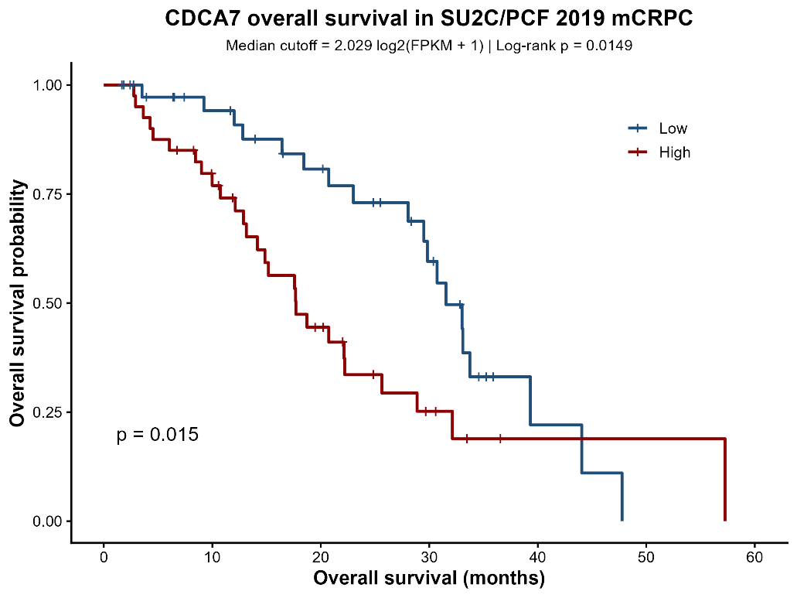
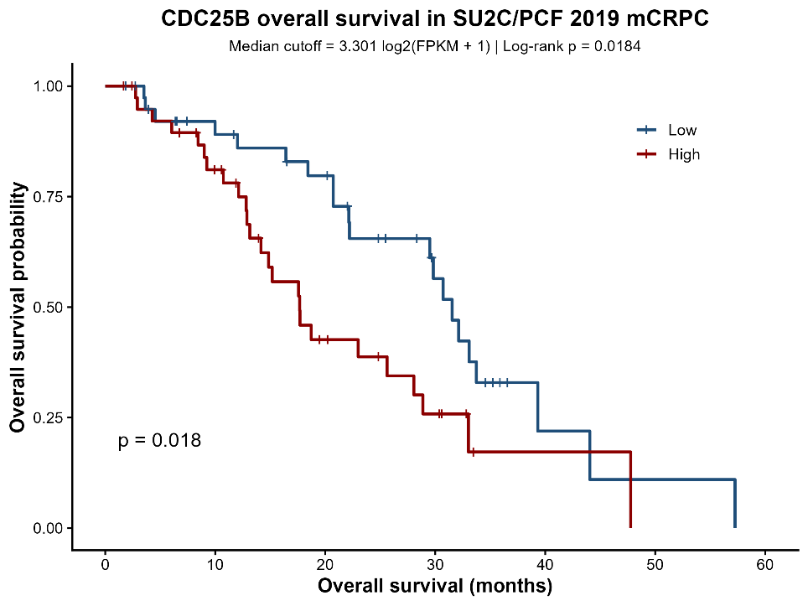
CDCA7 and CDC25B were among the top genes negatively correlated with FOLH1 in the SU2C/PCF 2019 mCRPC cohort, and high expression of either gene was associated with significantly shorter overall survival. CDCA7 is a MYC-responsive gene linked to proliferative transformation, whereas CDC25B promotes cell-cycle progression through cyclin-dependent kinase activation. Together, these findings suggest that low FOLH1 expression may coincide with a more proliferative and clinically aggressive mCRPC transcriptional state.

Comparison of FOLH1 with Known Prostate Cancer Biomarkers (Primary Tumours)
To contextualize FOLH1 co-expression, a panel of known biomarkers and lineage-associated genes was selected. Several genes, including AR, PTEN, CDH1, and VIM, are biologically relevant to pancreatic cancer progression, while others such as KLK3, NKX3-1, TMPRSS2, and ERG are primarily prostate-associated and were included to compare FOLH1 with a prostate lineage signature. New biomarkers mentioned by Felecia during our meeting were also included and highlighted in the table below. They were all then compared with FOLH1 expression to check for expression patterns.
Each biomarker was then also used to split samples into low and high expression groups based on the median cut-off, and KM plots that produced a significant Hazard ratio are included below.

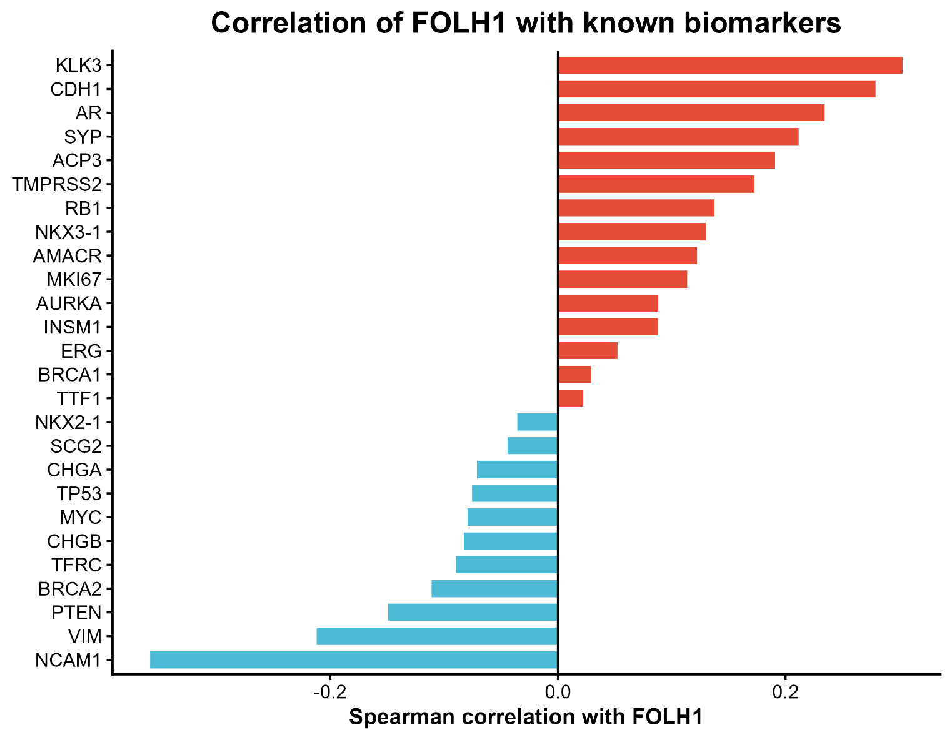
Biomarkers and their Spearman correlation with FOLH1 summary
Gene | Protein biomarker | Rho | P Value | Relevance to Pca
KLK3 |  | 0.302852 | 3.78E-11 | Encodes PSA and is one of the best-known Pca biomarkers.
CDH1 |  | 0.279127 | 1.26E-09 | Epithelial adhesion gene; relevant to prostate cancer progression and epithelial phenotype
AR |  | 0.234392 | 4.03E-07 | Core androgen signalling gene; central to prostate cancer development, progression, and therapy response
SYP | Synaptophysin | 0.211446 | 5.13E-06 | Strong neuroendocrine marker in prostate cancer.
ACP3 | PAP | 0.190661 | 4.09E-05 | Classic prostate marker; less commonly used now than PSA but still relevant.
TMPRSS2 |  | 0.172814 | 0.000205 | Prostate-expressed gene; important in prostate cancer, especially through TMPRSS2-ERG fusion biology
RB1 |  | 0.13736 | 0.003258 | Tumour suppressor linked to aggressive and neuroendocrine-like prostate cancer
NKX3-1 |  | 0.130285 | 0.00528 | Prostate lineage transcription factor; commonly used as a prostate marker and associated with prostate differentiation
AMACR |  | 0.122251 | 0.008894 | Well-established prostate cancer biomarker, often overexpressed in prostate tumours
MKI67 |  | 0.113685 | 0.015034 | General proliferation marker used to assess tumour growth and aggressiveness
AURKA |  | 0.088152 | 0.059704 | Associated with advanced and castration-resistant prostate cancer, especially aggressive disease.
INSM1 |  | 0.087868 | 0.060533 | Marker of neuroendocrine differentiation, relevant in aggressive/neuroendocrine prostate cancer.
ERG |  | 0.052171 | 0.265716 | Important prostate cancer marker, especially in TMPRSS2-ERG fusion-positive tumours.
BRCA1 |  | 0.029467 | 0.529785 | DNA repair gene linked to inherited prostate cancer risk and more aggressive disease in some cases.
NKX2-1 |  | -0.03566 | 0.446938 | the gene behind TTF-1 protein marker; relevant mainly to neuroendocrine differentiation
SCG2 | Secretogranin II | -0.04446 | 0.342961 | Neuroendocrine-associated marker relevant to prostate cancer subtype switching.
CHGA | Chromogranin A | -0.07116 | 0.128788 | Marker of neuroendocrine differentiation in prostate cancer.
TP53 |  | -0.07543 | 0.107333 | Important tumour suppressor commonly altered in advanced prostate cancer
MYC |  | -0.07926 | 0.09056 | Oncogene often involved in prostate cancer progression.
CHGB | Chromogranin B | -0.08287 | 0.076768 | Marker of neuroendocrine differentiation in prostate cancer.
TFRC | CD71 | -0.08954 | 0.055775 | More of a general cell proliferation/iron uptake marker; can be useful in tumour biology.
BRCA2 |  | -0.11091 | 0.017698 | Strongly associated with prostate cancer risk and aggressive disease.
PTEN |  | -0.14908 | 0.001393 | Major tumour suppressor frequently altered in prostate cancer and linked to aggressive disease
VIM |  | -0.21179 | 4.95E-06 | Mesenchymal marker associated with EMT, invasion, and aggressive prostate cancer behaviour
NCAM1 | CD56 | -0.35825 | 2.76E-15 | Neuroendocrine marker, often used in aggressive prostate cancer contexts.

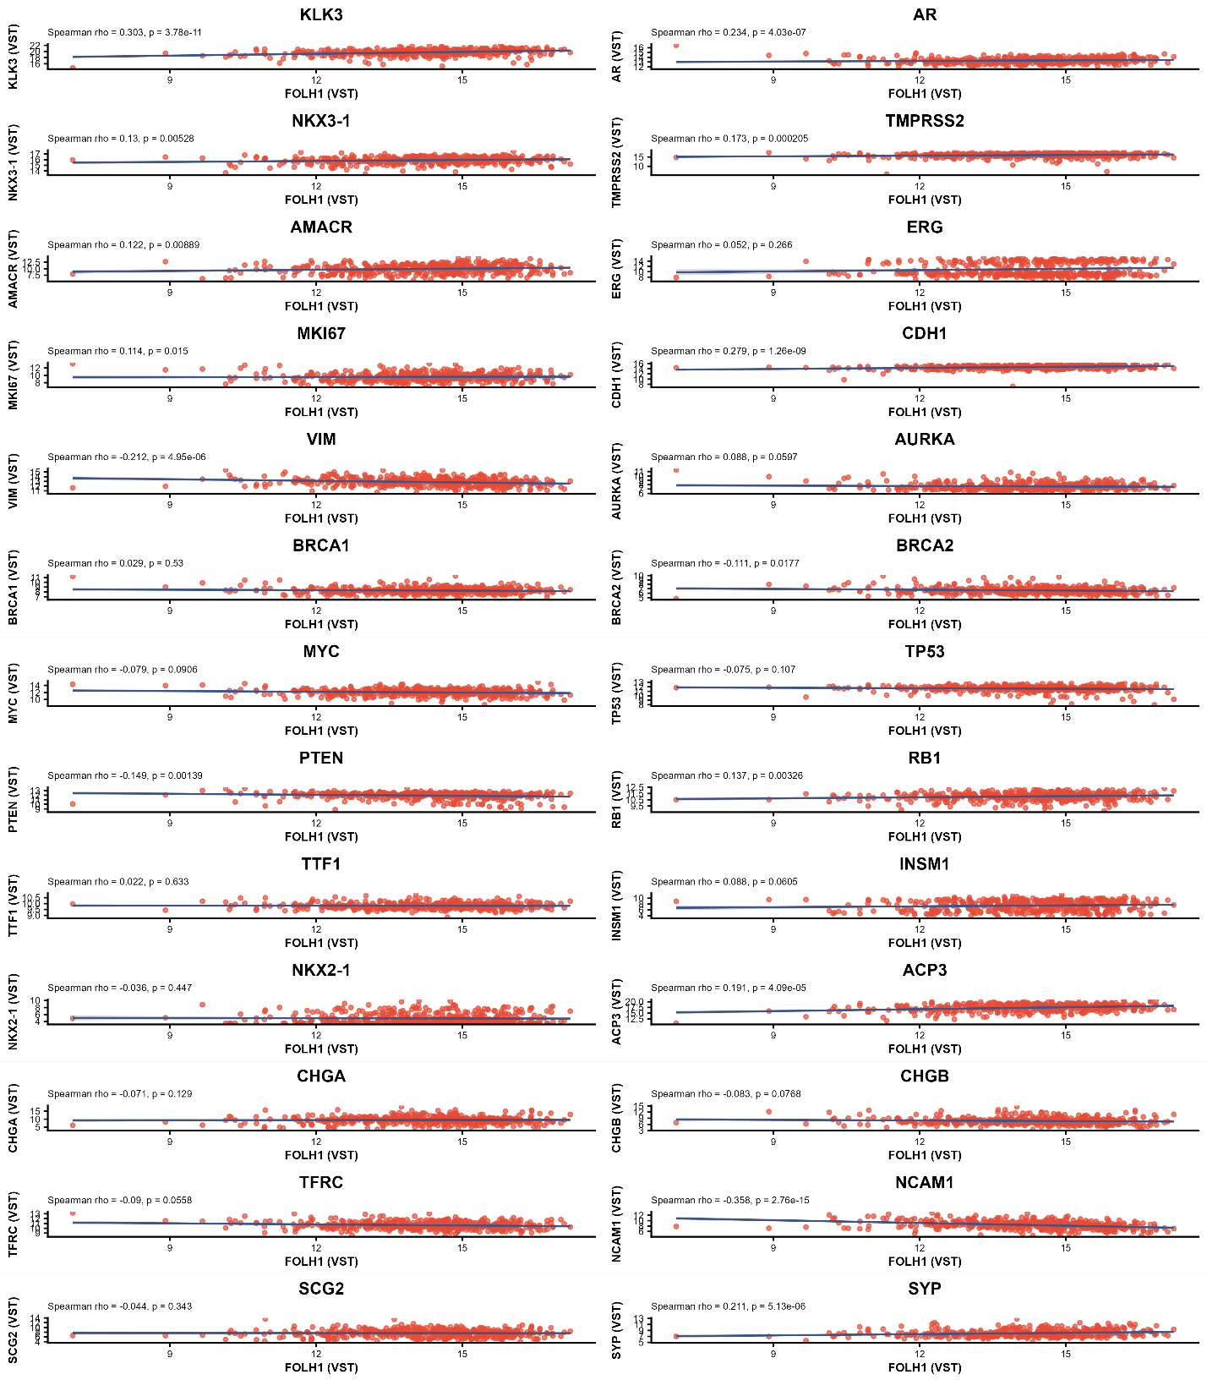

DFS Survival analysis for biomarkers
Out of all the above listed biomarkers, PAP (ACP3), AURKA, CDH1, KLK3, MKI67, NCAM1 all showed statistically significant distinct separation between their high and low expression sample groups in the survival analysis, while NKX-3 and PTEN also showed close to significant separation.
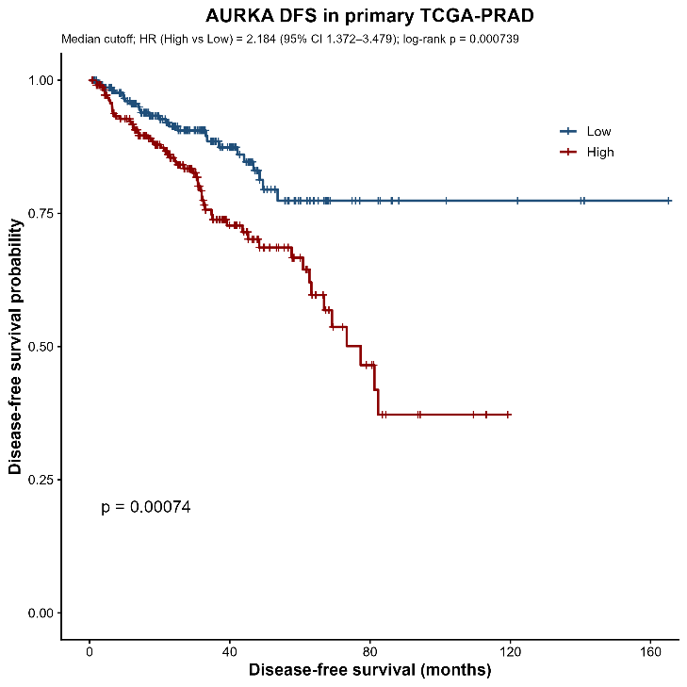
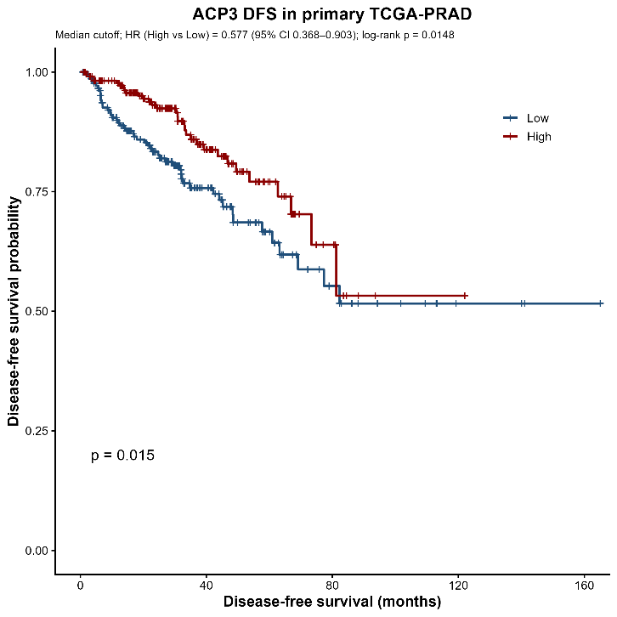
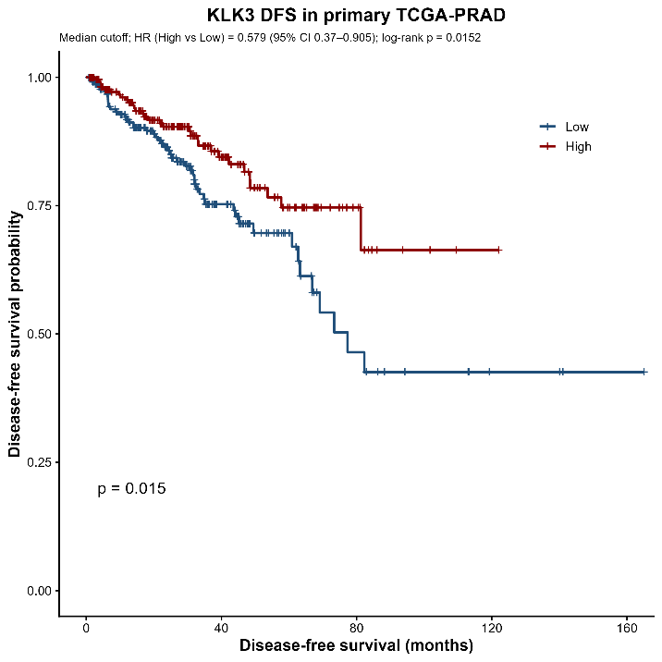
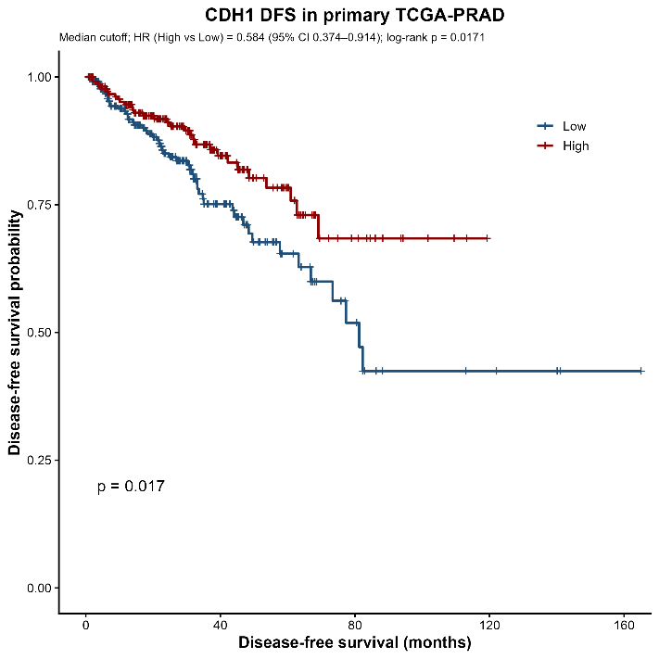
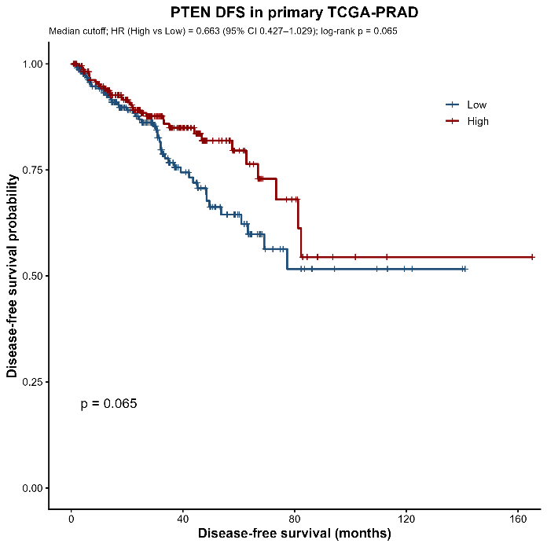
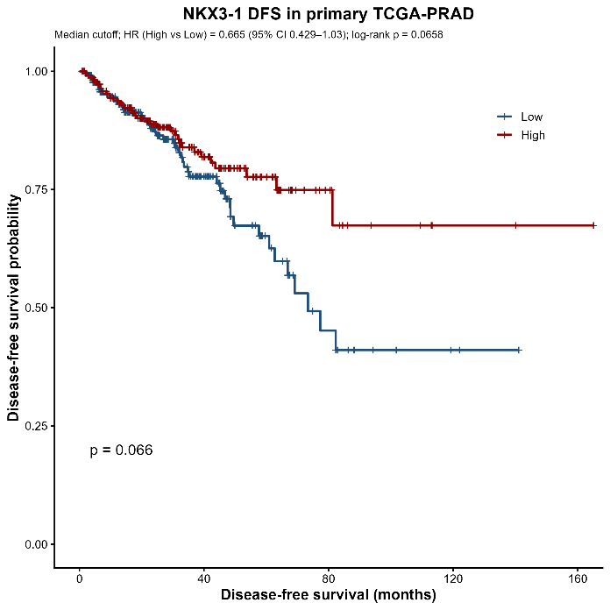
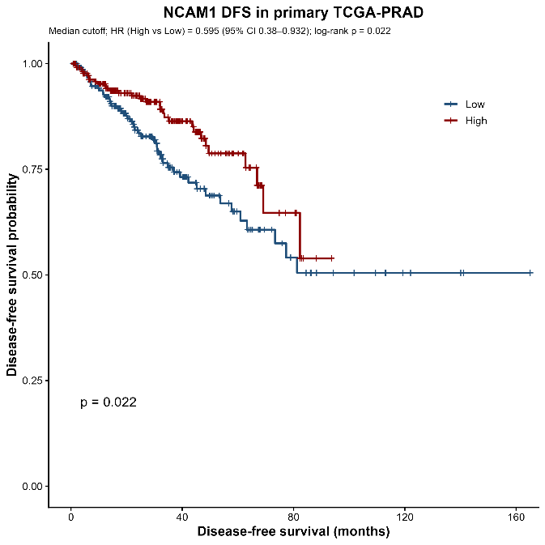
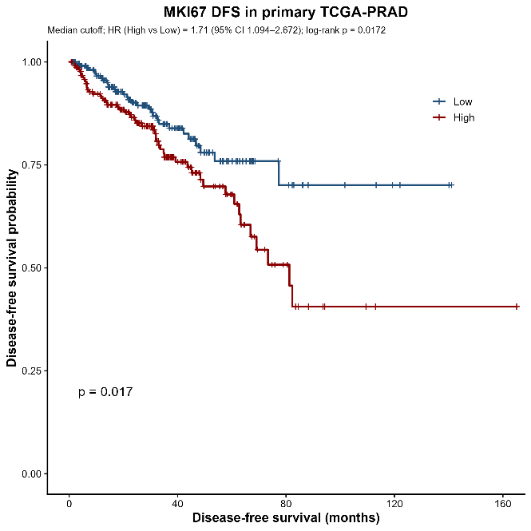
FOLH1 expression and ERG fusion status in TCGA-PRAD
FOLH1 expression was compared between primary TCGA-PRAD tumors classified as ERG fusion-positive or ERG fusion-negative in order to assess whether a relationship with this molecular subtype could be identified. This comparison was performed to determine whether ERG fusion status was associated with differences in FOLH1 expression in primary prostate tumors.

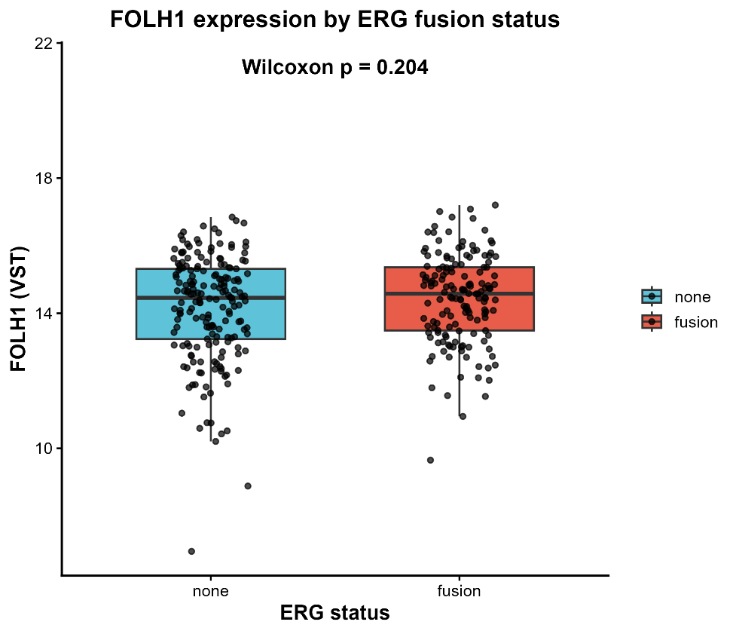

The resulting boxplot showed that FOLH1 expression was broadly similar between the two groups, and no statistically significant difference was detected by the Wilcoxon test (p = 0.204). These findings suggest that FOLH1 expression was not strongly influenced by ERG fusion status in this primary tumor cohort

Comparison of FOLH1 With Known Prostate Cancer Biomarkers (Metastatic Tumours from SU2C 2019 Cohort)
Similar to the TCGA-PRAD workflow earlier where primary tumours were prioritized, the same analysis was done this time on metastatic samples from the SU2C cohort. The table below summarises the correlation coefficients obtained after running spearman’s correlation test.
Biomarker gene | correlation | P value | Adjusted p value | significance
KLK3 | 0.591166 | 1.85E-26 | 2.40E-25 | yes
TMPRSS2 | 0.507683 | 7.83E-19 | 6.79E-18 | Yes
NKX3-1 | 0.483506 | 5.44E-17 | 3.54E-16 | Yes
AR | 0.328389 | 4.17E-08 | 1.36E-07 | Yes
CDH1 | 0.328345 | 4.19E-08 | 1.36E-07 | Yes
AMACR | 0.31505 | 1.53E-07 | 4.43E-07 | Yes
MYC | 0.202974 | 0.00087 | 0.001615 | yes
RB1 | 0.174867 | 0.004228 | 0.007328 | Yes
TTF1 | 0.141854 | 0.020647 | 0.033551 | Yes
TP53 | 0.131183 | 0.032459 | 0.044418 | Yes
ERG | 0.110883 | 0.070997 | 0.092297 | No
SYP | -0.00883 | 0.886044 | 0.886044 | No
VIM | -0.06105 | 0.321253 | 0.334104 | No
INSM1 | -0.06849 | 0.265689 | 0.28783 | No
PTEN | -0.07203 | 0.241667 | 0.273189 | No
CHGA | -0.08674 | 0.158346 | 0.187136 | No
SCG2 | -0.09232 | 0.133145 | 0.164847 | No
NKX2-1 | -0.13291 | 0.030226 | 0.043659 | yes
CHGB | -0.13328 | 0.029762 | 0.043659 | Yes
TFRC | -0.2455 | 5.18E-05 | 0.000104 | Yes
BRCA1 | -0.2508 | 3.51E-05 | 7.61E-05 | Yes
AURKA | -0.30063 | 5.85E-07 | 1.38E-06 | Yes
MKI67 | -0.31136 | 2.18E-07 | 5.66E-07 | Yes
BRCA2 | -0.33703 | 1.73E-08 | 7.51E-08 | Yes
NCAM1 | -0.3967 | 1.85E-11 | 9.63E-11 | Yes
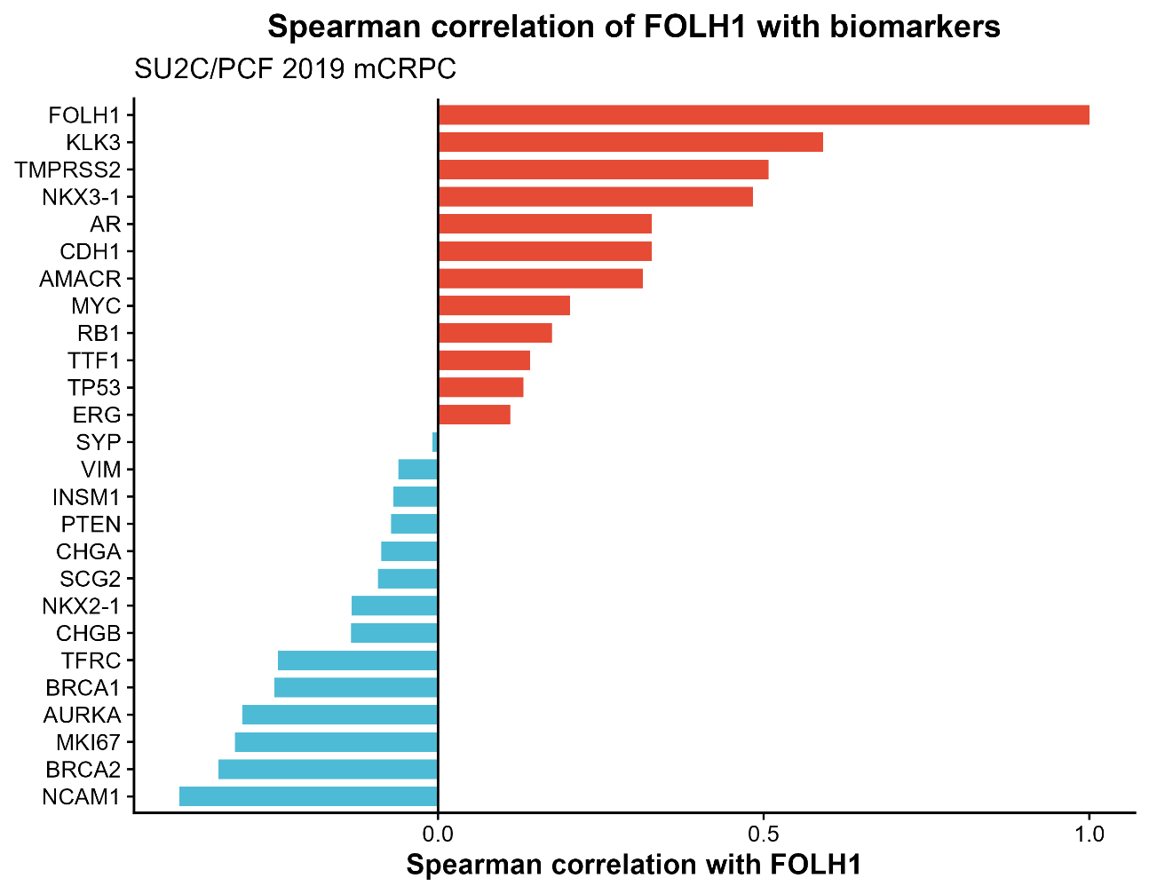
Next, OS survival study was carried out on each of these biomarkers to see prognostic value in metastatic conditions. Each biomarkers expression levels across samples were divided into high and low groups based of median cut off values. The biomarkers that showed significant separation between the two groups are represented below.
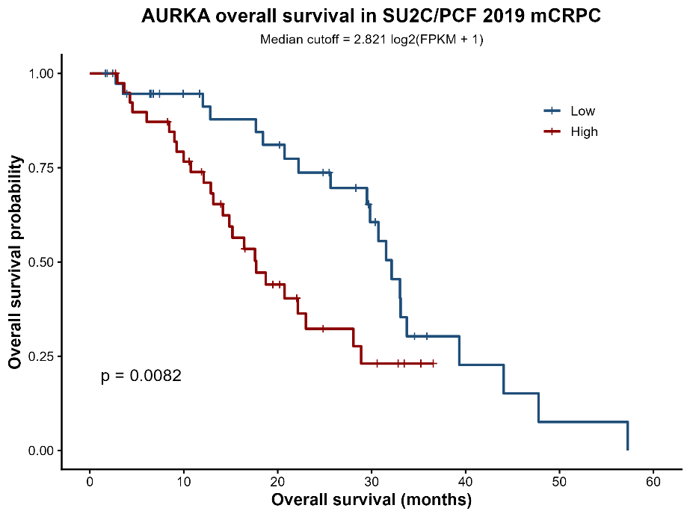

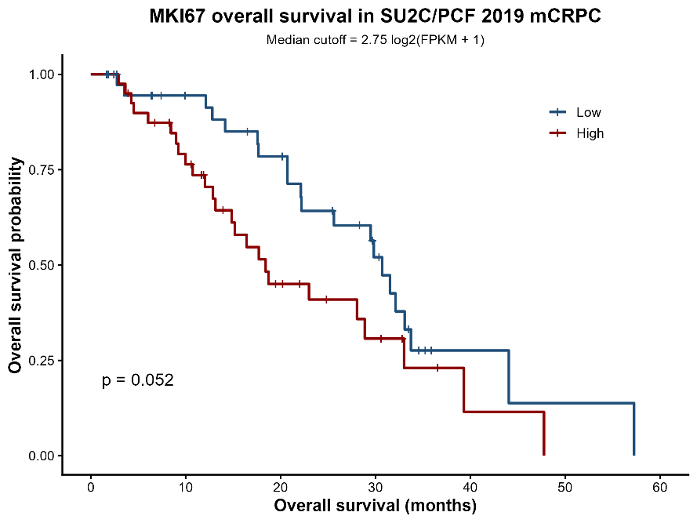
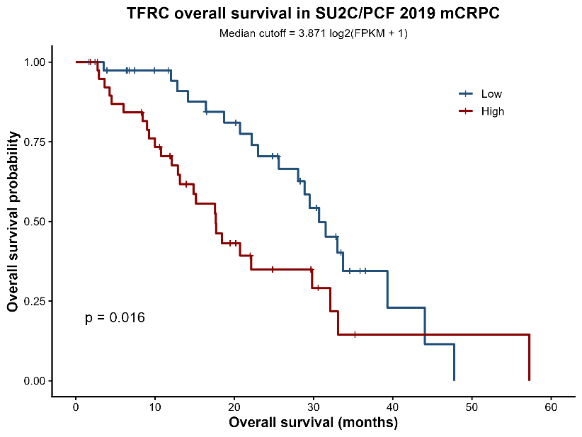
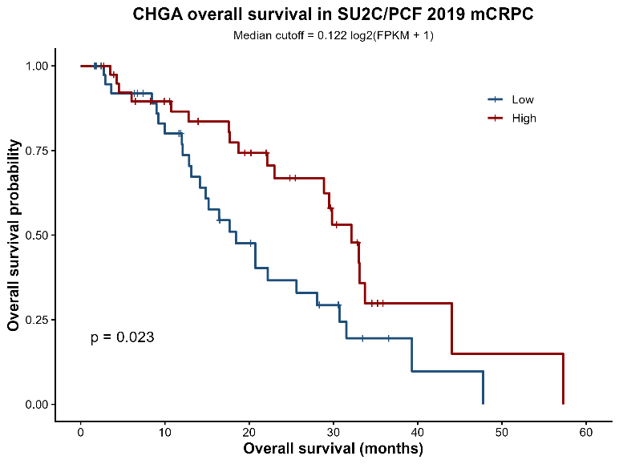

Differential Expression Analysis and Enrichment Analysis Between Normal Tissue and Primary Tumour of TCGA-PRAD
Differential expression analysis was carried out using generalized linear modelling of RNA-seq data from the TCGA-PRAD dataset. Lowly expressed were first filled out using a threshold of log2cpm > 1. This resulted in reduction of candidate genes from around 60,000 to just 17,000.
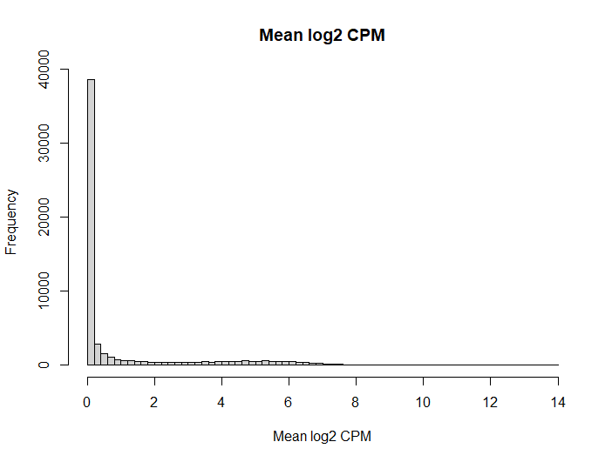
Then generalized linear modelling was carried out based on Normal tissue and primary tumour conditions. 1930 DEGs were identified based of the logCPM and p value cut-offs, of which the top 10 differentially expressed genes and their features are shown below.
Log fold change | Log cpm | F value | P value | Gene symbol (HGNC) | Description
-6.01392 | 3.524428 | 1454.311 | 4.14e-157 | Mfsd2a | Mfsd2 lysolipid transporter a, lysophospholipid
-6.8017 | 4.268651 | 1399.269 | 9.02e-154 | Serpina5 | Serpin family a member 5
-3.91701 | 5.777932 | 1056.986 | 1.06e-130 | Akr1b1 | Aldo-keto reductase family 1 member b
-4.26938 | 1.529424 | 937.8938 | 3.67e-121 | Klhl14 | Kelch like family member 14
-3.38479 | 3.04985 | 823.3196 | 9.13e-112 | Ndrg4 | Ndrg family member 4
-4.34583 | 2.573196 | 782.8729 | 4.04e-108 | Crtac1 | Cartilage acidic protein 1
-3.50885 | 2.10812 | 761.4903 | 3.53e-106 | Rasl10b | Ras like family 10-member b
-2.72879 | 2.382963 | 650.7333 | 1.34e-95 | Slc2a9 | Solute carrier family 2 member 9
-4.47815 | 2.845228 | 631.7797 | 1.14e-93 | Ca2 | Carbonic anhydrase 2
-7.39332 | 6.566194 | 627.1622 | 3.15e-93 | Pip | Prolactin induced protein
Then, enrichment analysis was carries out on these DEGs to identify the top enriched pathways. There were 44 pathways that were significantly enriched, through these DEGs, of which the topmost are displayed in dot plots and enrichment map below.

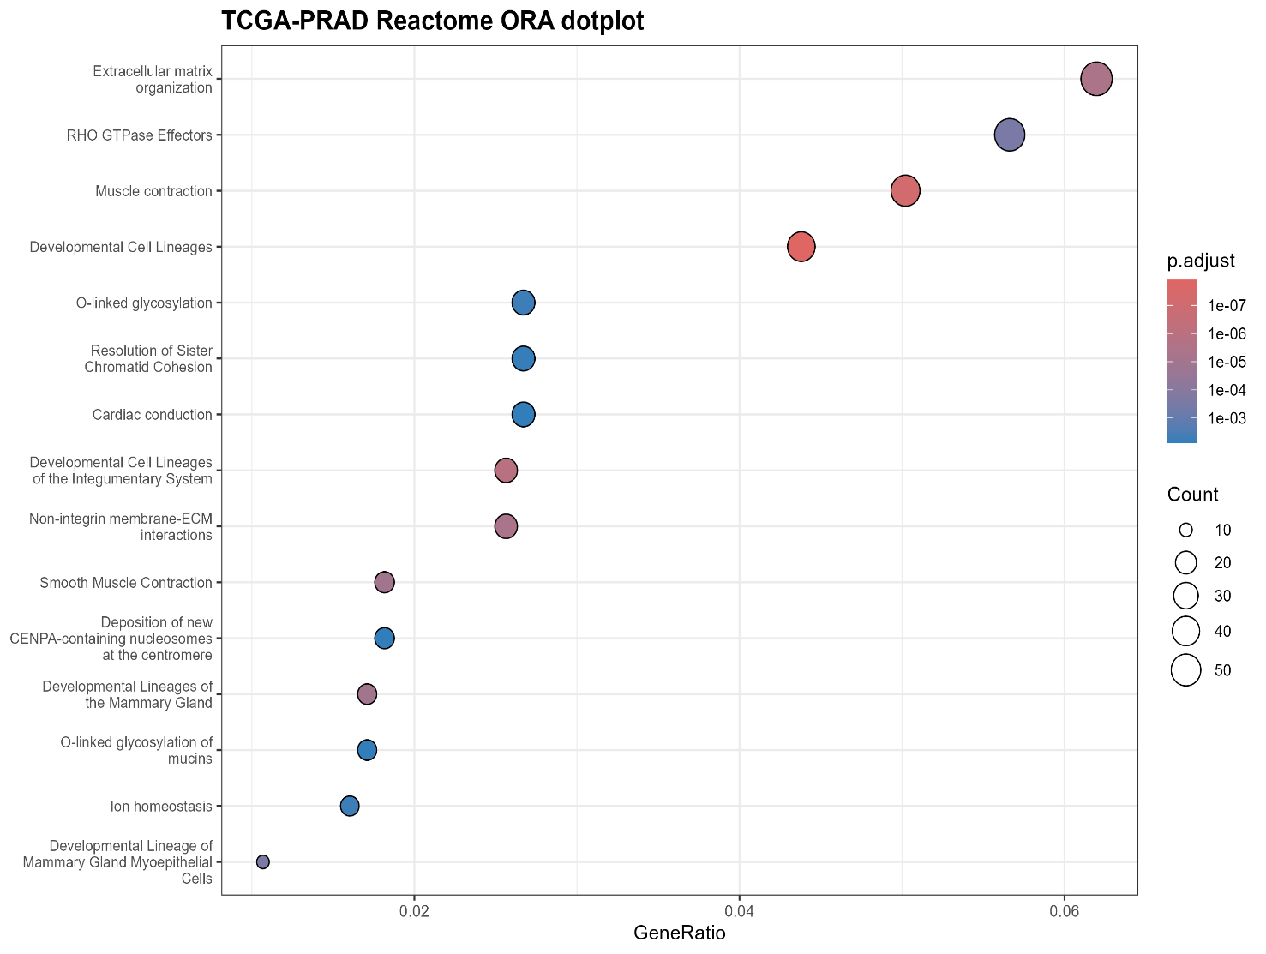
The top enriched terms were mainly associated with extracellular matrix organization, RHO GTPase effectors, muscle contraction, and developmental lineage programs, indicating that the DEG signature is strongly linked to cell adhesion, structural remodeling, and signaling pathways involved in tumour progression.
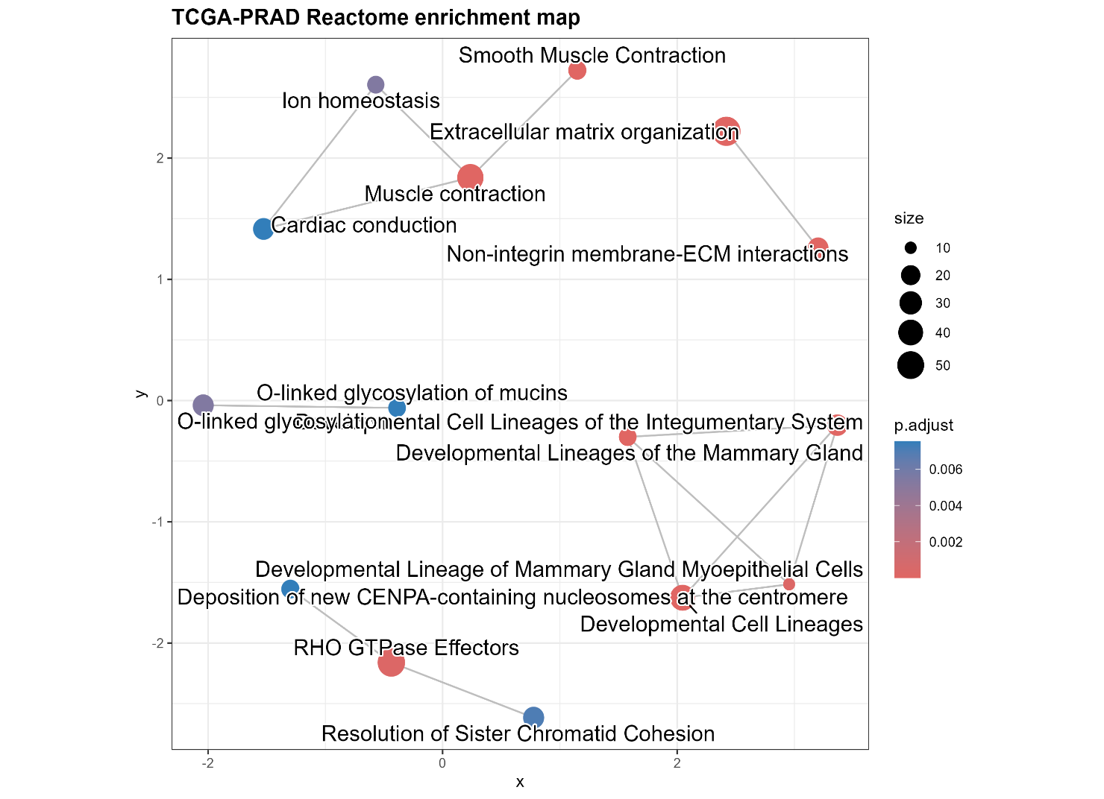
Description | Gene Ratio | P value | P adjust
Developmental Cell Lineages | 41/936 | 7.14E-12 | 1.23E-08
Muscle contraction | 47/936 | 8.20E-11 | 7.07E-08
Developmental Cell Lineages of the Integumentary System | 24/936 | 1.93E-09 | 1.11E-06
Extracellular matrix organization | 58/936 | 9.62E-09 | 4.15E-06
Non-integrin membrane-ECM interactions | 24/936 | 1.50E-08 | 5.17E-06
Developmental Lineages of the Mammary Gland | 16/936 | 4.12E-08 | 1.05E-05
Smooth Muscle Contraction | 17/936 | 4.27E-08 | 1.05E-05
Developmental Lineage of Mammary Gland Myoepithelial Cells | 10/936 | 1.25E-06 | 0.00027
RHO GTPase Effectors | 53/936 | 1.51E-06 | 0.000289
O-linked glycosylation | 25/936 | 3.24E-05 | 0.005383
Ion homeostasis | 15/936 | 3.43E-05 | 0.005383
Resolution of Sister Chromatid Cohesion | 25/936 | 4.89E-05 | 0.007019
O-linked glycosylation of mucins | 16/936 | 5.87E-05 | 0.007544
Cardiac conduction | 25/936 | 7.25E-05 | 0.007544

Differential Expression Analysis and Enrichment Analysis Of TCGA-PRAD Between High and Low FOLH1 Expression groups
To assess the transcriptional differences associated with FOLH1 expression, TCGA-PRAD primary tumour samples were divided into high and low FOLH1 groups using the median FOLH1 expression value as the cut-off. Differential expression analysis was then performed with edgeR to identify genes that were significantly altered between the two groups, and fold-change plus FDR thresholds were applied to define significant DEGs. The resulting genes were annotated using gene identifiers, and Reactome over-representation analysis was conducted to identify enriched biological pathways. Dot plot and enrichment map visualizations were generated to summarize the pathway-level results.
The top 10 differentially expressed genes, other than FOLH1, are shown below.
Gene symbol | Log Fold Change | Log CPM | P Value | Description
ETV4 | 3.916392 | 5.71878 | 2.02E-30 | ETS variant transcription factor 4
 | 1.647837 | 0.876493 | 3.62E-30 | novel transcript
CPS1 | 2.921889 | 3.259302 | 3.69E-30 | carbamoyl-phosphate synthase 1
SLC10A7 | 1.128236 | 4.86645 | 2.67E-27 | solute carrier family 10 member 7
FOLH1B | 2.172545 | 3.386855 | 3.62E-26 | folate hydrolase 1B (pseudogene)
PLAC9 | -1.42085 | 2.196402 | 7.62E-25 | placenta associated 9
CARMN | -1.45155 | 4.928804 | 3.40E-24 | cardiac mesoderm enhancer-associated non-coding RNA
RNF112 | -1.19882 | 1.581923 | 9.31E-24 | ring finger protein 112
CRYAB | -1.2257 | 5.90239 | 2.70E-23 | crystallin alpha B
OXER1 | -1.0472 | 1.144476 | 5.36E-23 | oxo eicosanoid receptor 1

Then, enrichment analysis was carries out on all significant DEGs to identify the top enriched pathways.
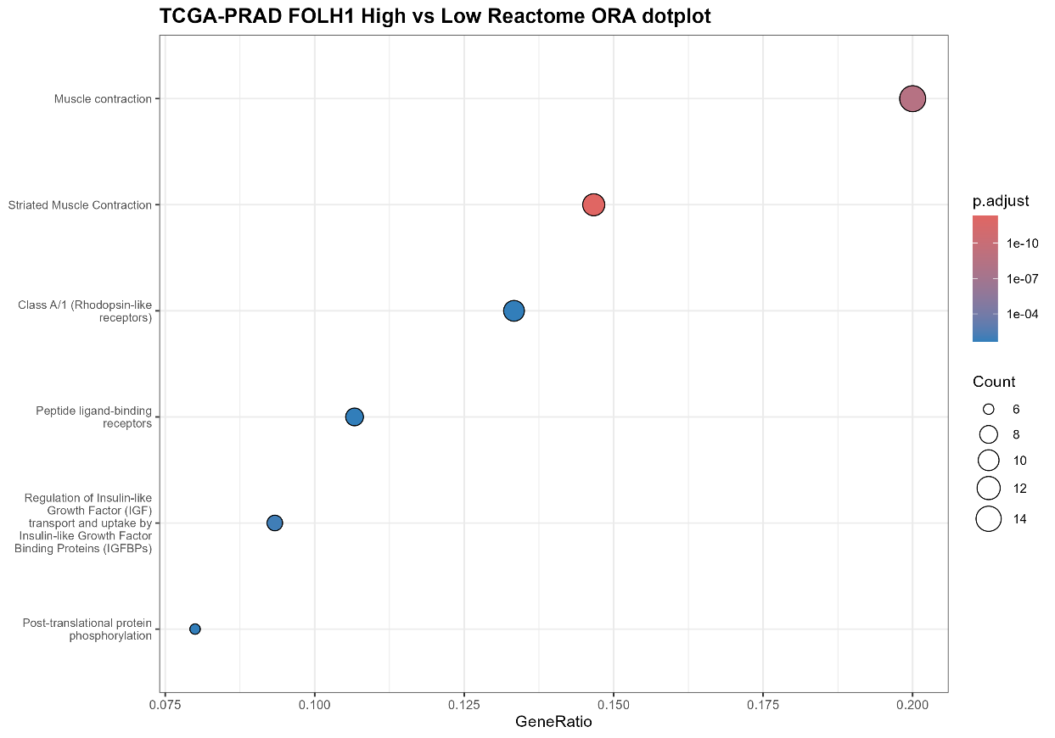
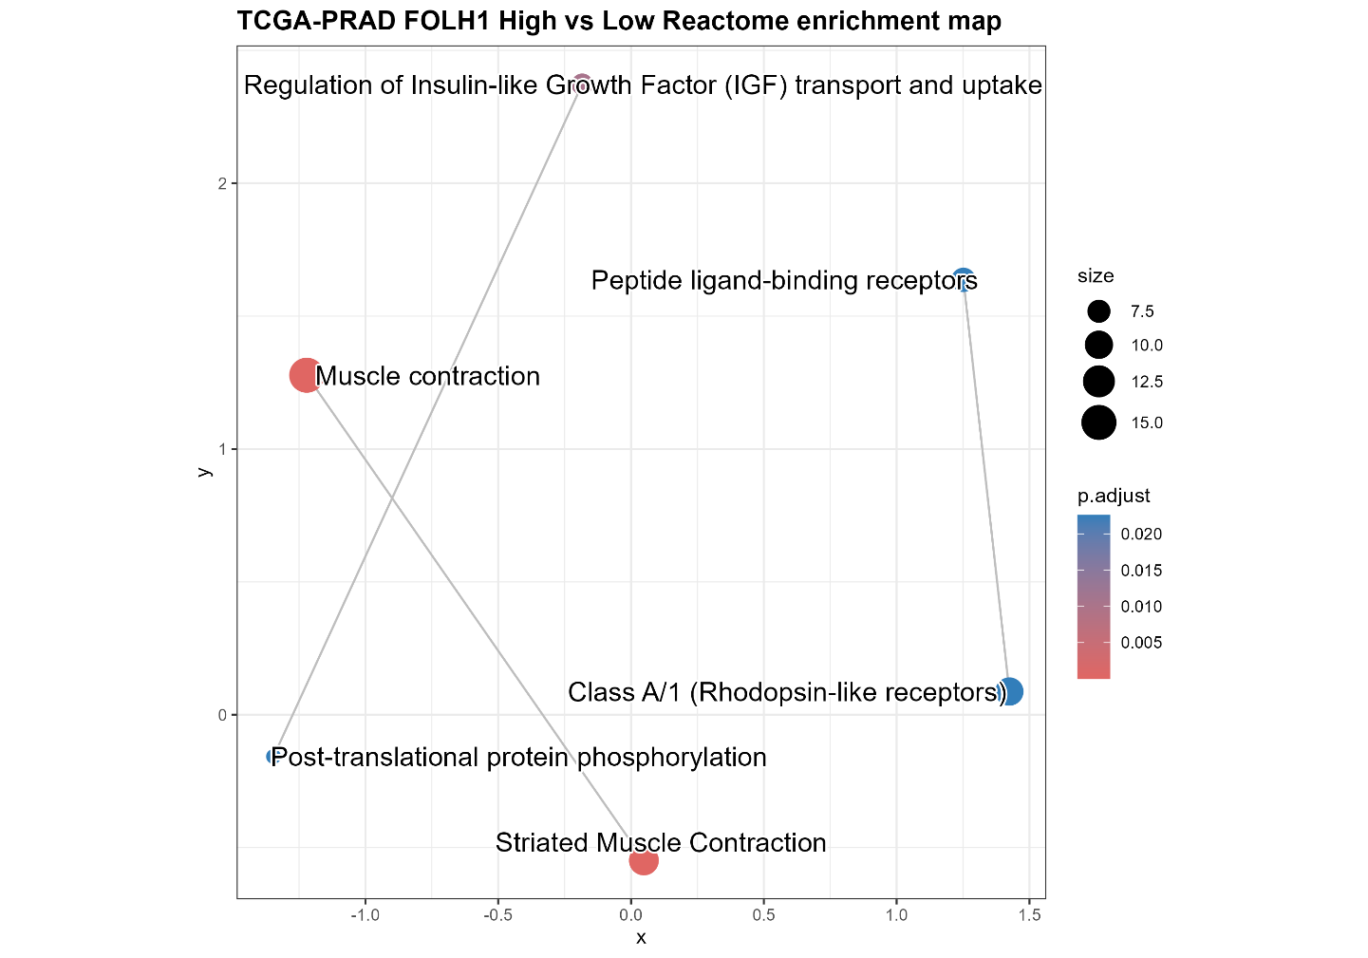
The Reactome over-representation analysis suggests that genes differing between FOLH1-high and FOLH1-low primary TCGA-PRAD tumors are mainly involved in muscle-related and receptor signaling pathways. The strongest signals are for muscle contraction and striated muscle contraction, with additional enrichment for peptide ligand-binding receptors, Class A/1 rhodopsin-like receptors, and regulation of IGF transport and uptake, indicating that FOLH1-associated transcriptional changes may be linked to contractile, signaling, and growth-factor-related processes

Immune Transcriptomic Profiling in TCGA- PRAD (primary tumour + solid tissue samples)
TCGA-PRAD raw data was used. Immune-related gene signatures were evaluated using GSVA/ssGSEA to generate per-sample immune scores, which were then used to stratify samples into high- and low-immune groups. Differential expression analysis was performed between these groups using limma-voom, and significant genes were subjected to GO and KEGG enrichment analysis using clusterProfiler. The association between FOLH1 expression and immune score was assessed using Spearman correlation, and survival differences between immune groups were evaluated with Kaplan–Meier analysis.
Immune gene sets defined
T cells | "CD3D","CD3E","CD2","TRAC","LCK","IL7R"
CD8_T | "CD8A","CD8B","NKG7","GZMB","PRF1”
Cytotoxic | "NKG7","GZMB","PRF1","GNLY","KLRD1"
B cells | "MS4A1","CD79A","CD79B","CD19","CD74"
NK cells | "NKG7","GNLY","KLRD1","FCGR3A"
Monocytes Macrophages | "LYZ","FCN1","CD68","CSF1R","TYROBP"
Treg | "FOXP3","IL2RA","CTLA4","IKZF2"
Checkpoint | ”PDCD1","CD274","CTLA4","LAG3","TIGIT","HAVCR2"
Antigen Presentation | "HLA-A","HLA-B","HLA-C","B2M","TAP1","TAP2"

GSVA Immune score by group
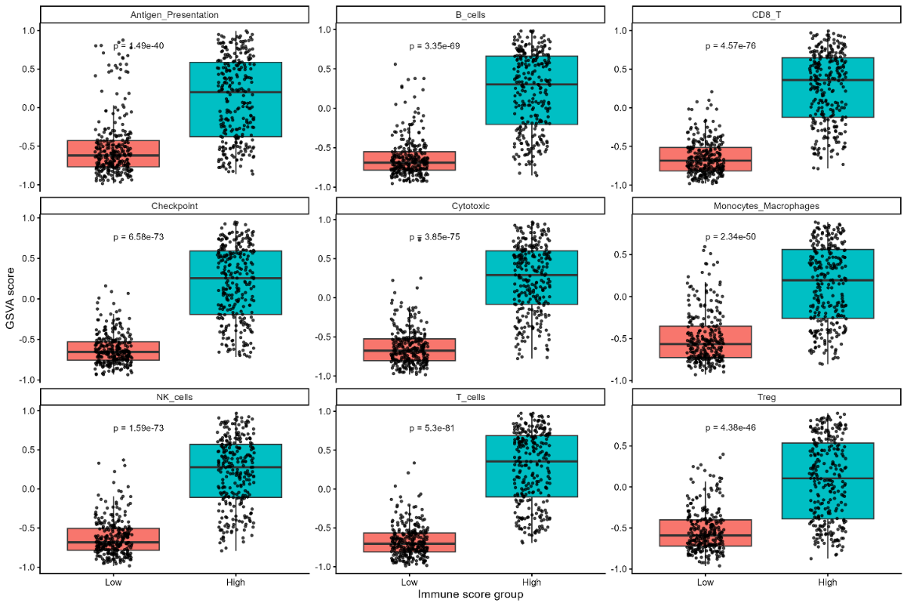
Top 15 Differentially Expressed Genes
Gene | Log fold change | Average Expression | T Statistic | P Value | Adjusted P Val
CD247 | 1.670853 | 1.064488 | 23.39226 | 7.90E-85 | 4.55E-80
CD3D | 1.839921 | 1.232231 | 23.19933 | 7.73E-84 | 2.23E-79
CD3E | 1.744229 | 2.819236 | 22.87503 | 3.58E-82 | 6.86E-78
CD48 | 1.679911 | 1.063618 | 22.76901 | 1.25E-81 | 1.80E-77
CORO1A | 1.532366 | 3.97087 | 22.64098 | 5.68E-81 | 6.55E-77
CST7 | 1.610342 | 1.121057 | 22.40187 | 9.58E-80 | 9.20E-76
TRAC | 1.733751 | 3.049679 | 22.18189 | 1.29E-78 | 1.06E-74
TRBC1 | 1.837145 | 1.850999 | 22.12653 | 2.47E-78 | 1.78E-74
TRBC2 | 1.783411 | 2.629451 | 22.04095 | 6.79E-78 | 4.35E-74
CCL5 | 1.659084 | 3.718931 | 22.02335 | 8.36E-78 | 4.82E-74
GZMA | 1.680232 | 0.930557 | 21.93895 | 2.26E-77 | 1.19E-73
CD6 | 1.660304 | 1.769612 | 21.89449 | 3.82E-77 | 1.84E-73
NKG7 | 1.568546 | 1.139153 | 21.82368 | 8.81E-77 | 3.91E-73
PRF1 | 1.453767 | 1.523068 | 21.67212 | 5.26E-76 | 2.17E-72
SELPLG | 1.346125 | 2.936814 | 21.61408 | 1.04E-75 | 4.00E-72

GO enrichment analysis results
Description | Gene Ratio | P value | P adjusted
Leukocyte mediated immunity | 171/883 | 8.08E-116 | 4.75E-112
Lymphocyte mediated immunity | 150/883 | 3.03E-109 | 8.92E-106
Adaptive immune response based on somatic recombination of immune receptors built from immunoglobulin superfamily domains | 150/883 | 6.01E-101 | 1.18E-97
B cell mediated immunity | 92/883 | 1.27E-74 | 1.86E-71
Immunoglobulin mediated immune response | 89/883 | 5.91E-72 | 6.95E-69
Regulation of lymphocyte activation | 135/883 | 7.88E-72 | 7.72E-69
Immune response-regulating cell surface receptor signalling pathway | 126/883 | 2.57E-71 | 2.16E-68
Immune response-activating cell surface receptor signalling pathway | 110/883 | 4.62E-63 | 3.39E-60
Leukocyte cell-cell adhesion | 119/883 | 8.93E-63 | 5.84E-60
Regulation of T cell activation | 110/883 | 1.48E-61 | 8.68E-59
Leukocyte proliferation | 94/883 | 4.15E-58 | 2.22E-55
Regulation of leukocyte cell-cell adhesion | 108/883 | 1.10E-57 | 5.38E-55
Lymphocyte proliferation | 87/883 | 1.94E-56 | 8.78E-54
Mononuclear cell proliferation | 87/883 | 7.15E-56 | 3.00E-53
Positive regulation of leukocyte activation | 100/883 | 2.07E-54 | 8.13E-52

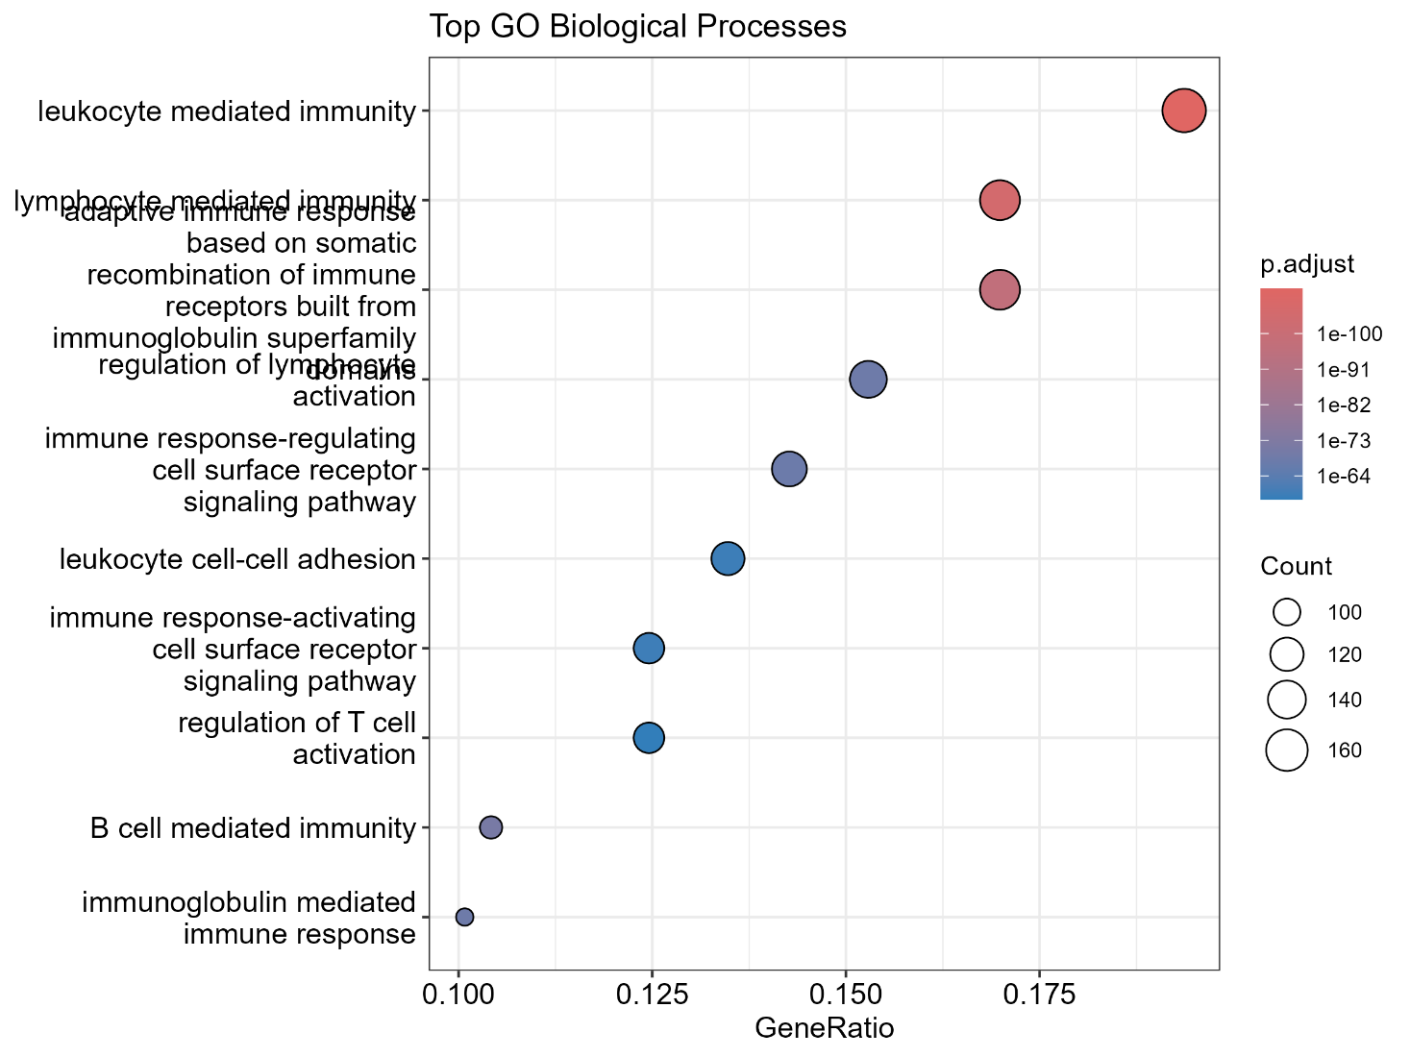
GO enrichment analysis of the DEGs between low and high immune-score groups in TCGA-PRAD revealed a highly significant immune activation signature. The top enriched biological processes were leukocyte mediated immunity, lymphocyte mediated immunity, adaptive immune response, B cell mediated immunity, and immunoglobulin mediated immune response, indicating that the observed transcriptomic differences largely reflect variation in immune infiltration and immune activity within the tumour microenvironment.
KEGG enrichment analysis
Description | Gene Ratio | Fold Enrichment | P value | P adjusted
Cytokine-cytokine receptor interaction | 90/441 | 6.444323 | 6.81E-50 | 2.40E-47
Viral protein interaction with cytokine and cytokine receptor | 53/441 | 11.30907 | 1.91E-44 | 3.36E-42
Hematopoietic cell lineage | 48/441 | 10.24218 | 1.31E-37 | 1.54E-35
Chemokine signalling pathway | 52/441 | 5.749063 | 4.68E-26 | 4.12E-24
Allograft rejection | 26/441 | 14.22525 | 6.23E-26 | 4.39E-24
Cell adhesion molecule (CAM) interaction | 47/441 | 6.267999 | 2.06E-25 | 1.21E-23
Rheumatoid arthritis | 37/441 | 8.310538 | 3.98E-25 | 2.00E-23
Graft-versus-host disease | 27/441 | 12.80272 | 4.69E-25 | 2.06E-23
Intestinal immune network for iga production | 28/441 | 11.94921 | 8.99E-25 | 3.52E-23
Staphylococcus aureus infection | 37/441 | 7.974759 | 2.26E-24 | 7.95E-23
Inflammatory bowel disease | 31/441 | 10.02233 | 3.14E-24 | 1.01E-22
Type I diabetes mellitus | 26/441 | 12.60874 | 6.35E-24 | 1.80E-22
Leishmaniasis | 33/441 | 9.02756 | 6.64E-24 | 1.80E-22
Th17 cell differentiation | 36/441 | 7.047369 | 1.30E-21 | 3.28E-20
Tuberculosis | 44/441 | 5.187106 | 3.17E-20 | 7.43E-19

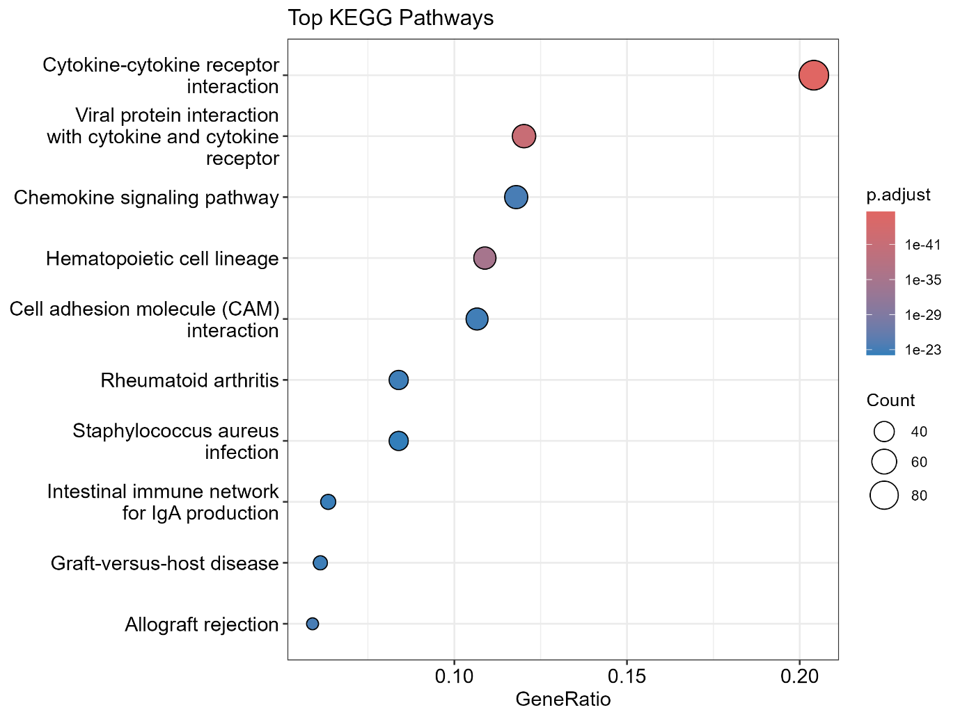
KEGG pathway enrichment analysis of the DEGs between low and high immune-score groups in TCGA-PRAD revealed strong enrichment of immune signalling pathways. The top pathways included cytokine-cytokine receptor interaction, viral protein interaction with cytokine and cytokine receptor, chemokine signalling, and hematopoietic cell lineage, indicating that transcriptomic differences between the two groups are primarily associated with immune communication, immune-cell recruitment, and microenvironmental activation.

Association Of FOLH1 With Immune Score Using Spearman’s Correlation Coefficient
gene | rho | P value
FOLH1 | -0.14395 | 0.000694

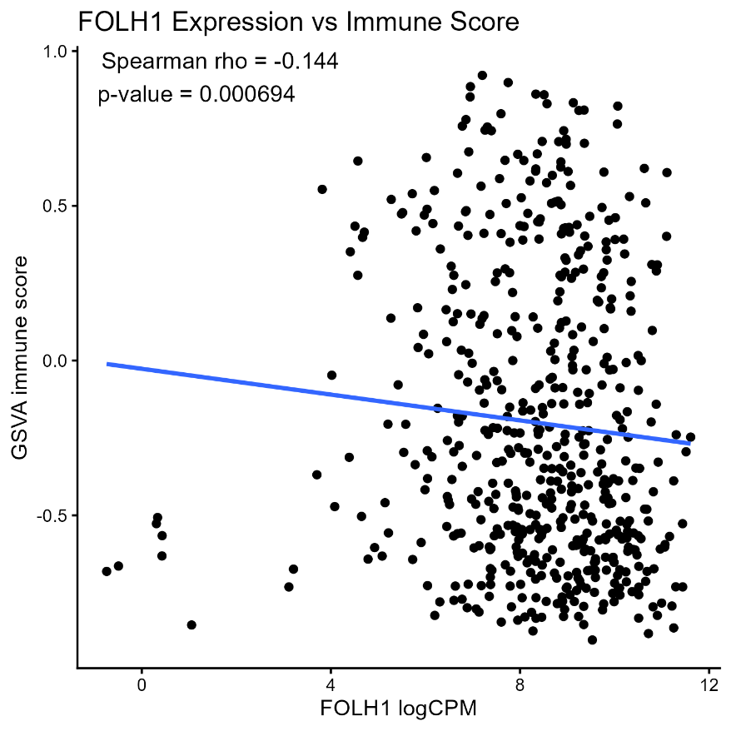
Spearman correlation analysis revealed a weak but significant inverse association between FOLH1 expression and immune score in TCGA-PRAD (rho = -0.144, p = 0.000694), suggesting that higher FOLH1 expression is associated with slightly lower immune activity within the tumour microenvironment.
KM survival curves based on high and low immune groups
Kaplan–Meier analysis (KM plot shown below) showed no significant difference in survival between low and high immune-score groups in TCGA-PRAD (p = 0.61). The survival curves remained largely overlapping across follow-up, indicating that immune score alone was not a strong predictor of survival in this cohort.
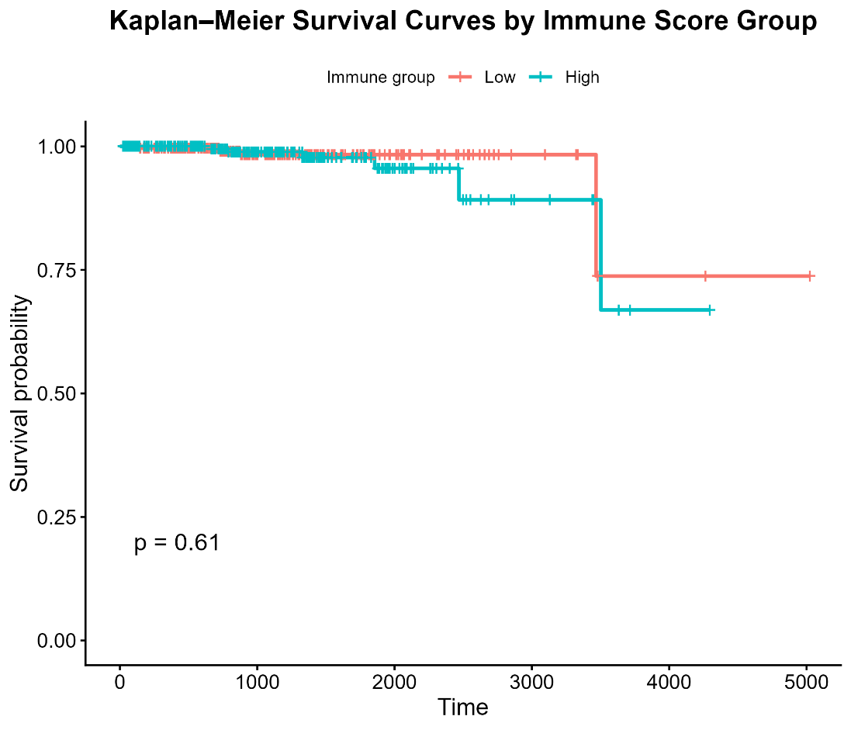

Immune Transcriptomic Profiling of TCGA-PRAD in Only Primary Tumours
The same analysis was conducted as previous, but this time only using the samples in primary tumour condition. The immune gene sets were defined same as before.
GSVA Immune score by group for primary tumours
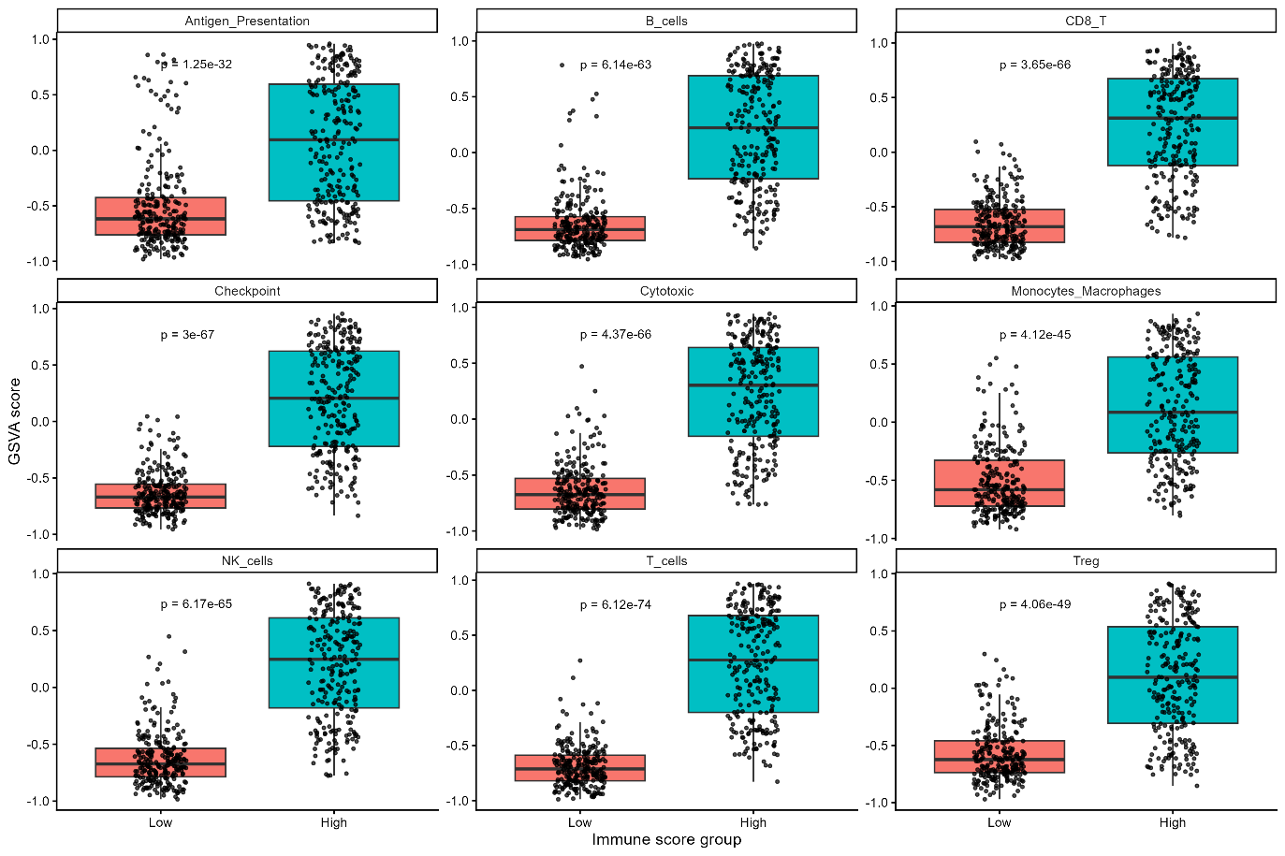
Top 15 Differentially Expressed Genes in primary tumours
Gene | Log fold change | Average expr | T | P Value | Adj P Val | B
CD247 | 1.734607 | 1.069928 | 23.27946 | 5.27E-82 | 3.04E-77 | 176.0772
CD48 | 1.723747 | 1.049985 | 23.02546 | 9.20E-81 | 2.65E-76 | 173.2383
CD3E | 1.789414 | 2.81937 | 22.47677 | 4.44E-78 | 8.52E-74 | 167.2269
CD3D | 1.863747 | 1.248265 | 22.43241 | 7.32E-78 | 1.05E-73 | 166.629
TRAC | 1.788034 | 3.056704 | 22.04312 | 5.87E-76 | 6.76E-72 | 162.3763
CD74 | 1.320042 | 9.582457 | 21.70148 | 2.75E-74 | 2.64E-70 | 158.1978
CD52 | 1.680664 | 2.26188 | 21.63611 | 5.74E-74 | 4.72E-70 | 157.7901
TRBC2 | 1.8168 | 2.638725 | 21.52579 | 1.99E-73 | 1.43E-69 | 156.57
IL12RB1 | 1.483489 | 0.418617 | 21.51436 | 2.26E-73 | 1.45E-69 | 156.2996
CD2 | 1.759076 | 2.288273 | 21.39376 | 8.78E-73 | 5.05E-69 | 155.0799
CORO1A | 1.529029 | 3.970727 | 21.2916 | 2.77E-72 | 1.45E-68 | 153.9653
PRF1 | 1.498124 | 1.498767 | 21.20651 | 7.22E-72 | 3.46E-68 | 152.9473
CST7 | 1.596956 | 1.10351 | 21.19403 | 8.31E-72 | 3.68E-68 | 152.7813
TRBC1 | 1.841106 | 1.884441 | 21.17842 | 9.90E-72 | 4.06E-68 | 152.6538
CD6 | 1.645041 | 1.817812 | 21.17244 | 1.06E-71 | 4.06E-68 | 152.5843

GO enrichment analysis results in primary tumours
Description | Gene Ratio | P value | P adjust
Leukocyte mediated immunity | 176/926 | 3.44E-118 | 2.02E-114
Lymphocyte mediated immunity | 157/926 | 5.23E-115 | 1.54E-111
Adaptive immune response based on somatic recombination of immune receptors built from immunoglobulin superfamily domains | 156/926 | 5.76E-105 | 1.13E-101
B cell mediated immunity | 96/926 | 3.00E-78 | 4.41E-75
Immunoglobulin mediated immune response | 92/926 | 3.13E-74 | 3.68E-71
Regulation of lymphocyte activation | 136/926 | 4.01E-70 | 3.93E-67
Immune response-regulating cell surface receptor signalling pathway | 126/926 | 8.58E-69 | 7.21E-66
Leukocyte cell-cell adhesion | 121/926 | 2.24E-62 | 1.64E-59
Immune response-activating cell surface receptor signalling pathway | 110/926 | 7.09E-61 | 4.63E-58

The Go enrichment analysis gave almost the exact same results when considering just the primary tumours in TCGA-PRAD as it did when considering both primary tumour and normal solid tissue together. the observed transcriptomic differences largely reflect variation in immune infiltration and immune activity within the tumour microenvironment.
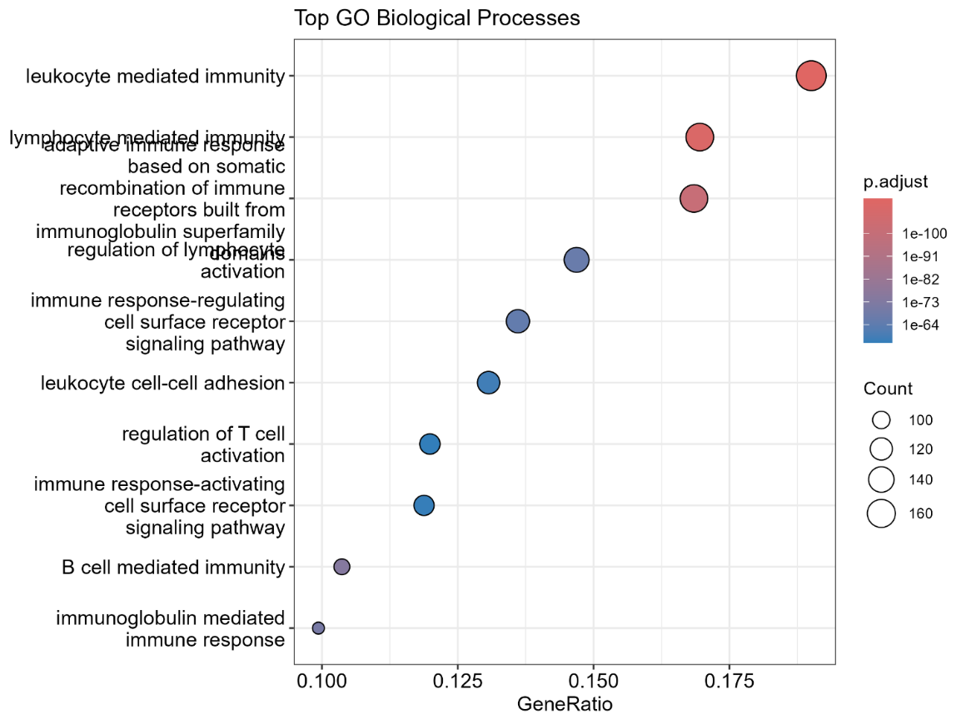

KEGG enrichment analysis in primary tumours
Category | Subcategory | Description | Gene Ratio | P Value | P Adjust
Environmental Information Processing | Signalling molecules and interaction | Cytokine-cytokine receptor interaction | 94/467 | 9.73E-52 | 3.43E-49
Environmental Information Processing | Signalling molecules and interaction | Viral protein interaction with cytokine and cytokine receptor | 57/467 | 8.70E-49 | 1.53E-46
Organismal Systems | Immune system | Hematopoietic cell lineage | 47/467 | 3.97E-35 | 4.66E-33
Human Diseases | Immune disease | Allograft rejection | 28/467 | 1.39E-28 | 1.04E-26
Organismal Systems | Immune system | Chemokine signalling pathway | 56/467 | 1.52E-28 | 1.04E-26
Organismal Systems | Immune system | Intestinal immune network for IgA production | 31/467 | 1.78E-28 | 1.04E-26
Environmental Information Processing | Signalling molecules and interaction | Cell adhesion molecule (CAM) interaction | 51/467 | 3.26E-28 | 1.64E-26
Human Diseases | Endocrine and metabolic disease | Type I diabetes mellitus | 27/467 | 9.18E-25 | 4.04E-23
Human Diseases | Immune disease | Graft-versus-host disease | 27/467 | 2.19E-24 | 8.57E-23
Human Diseases | Immune disease | Rheumatoid arthritis | 37/467 | 3.07E-24 | 1.08E-22

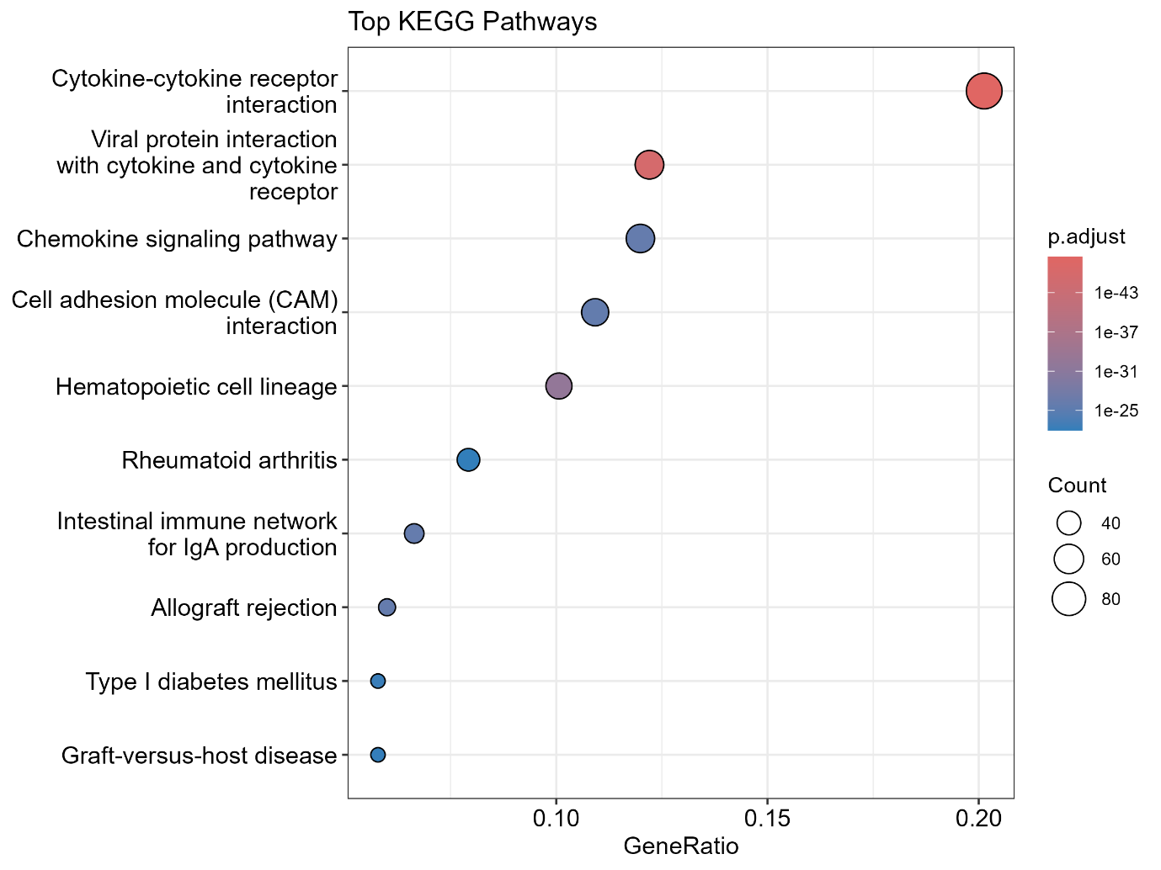
The primary tumour showed strong over-representation of immune-related pathways, including cytokine-cytokine receptor interaction, viral protein interaction with cytokine and cytokine receptor, chemokine signalling, and cell adhesion molecule interaction. These findings indicate that the transcriptional differences observed in primary tumours are primarily linked to immune signalling and immune-cell trafficking within the tumour microenvironment.

Association Of FOLH1 With Immune Score Using Spearman’s Correlation Coefficient in TCGA-PRAD primary tumours
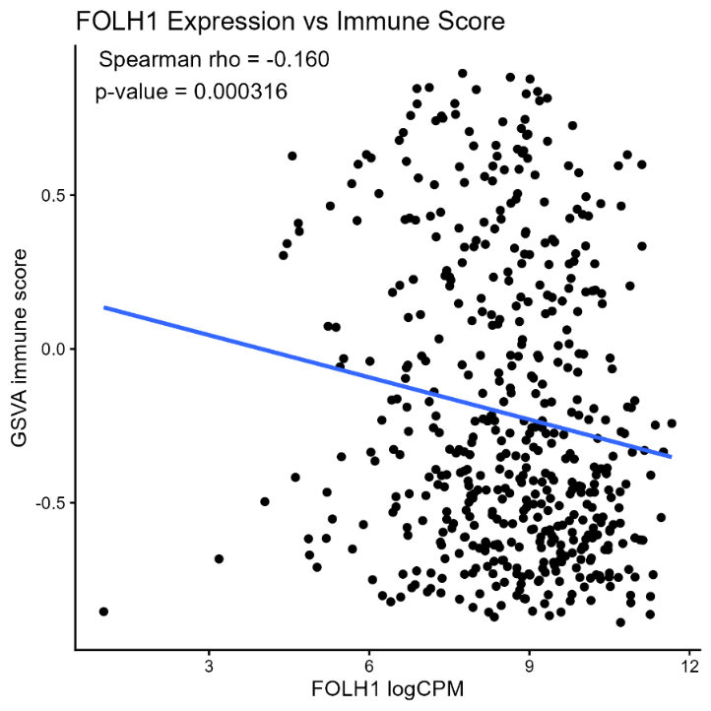
KM survival curves based on high and low immune groups in TCGA-PRAD primary tumours
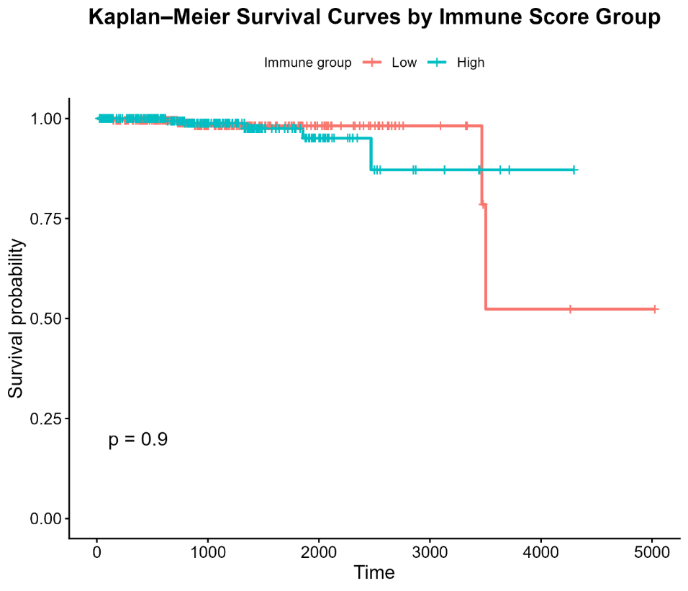
Same as before, the correlation of FOLH1 with GSVA immune score showed a weak negative correlation that was statistically significant, while the survival study showed no significance, indicating that immune score alone was not a strong predictor of survival in this cohort.

Immune Pathway Activity Associated with FOLH1 Expression in TCGA-PRAD
TCGA prostate tumour samples were stratified into High and Low groups by median FOLH1 expression, GSVA was used to compute immune pathway activity per sample, and differential pathway activity between the groups was assessed with a linear model and empirical Bayes moderation; results were summarized in tables and visualized with boxplots, a volcano plot, and a dot plot.
The immune gene sets that were used for each Hallmark pathway is shown below.
HALLMARK_INTERFERON_GAMMA_RESPONSE | "STAT1","IRF1","CXCL9","CXCL10","IDO1","HLA-A","HLA-B","HLA-C", "B2M","PSMB8","PSMB9","TAP1","TAP2","CD274"
HALLMARK_INTERFERON_ALPHA_RESPONSE | "ISG15","IFIT1","IFIT2","IFIT3","MX1","OAS1","OAS2","OAS3","IFI6","IFI27","RSAD2","STAT2"
HALLMARK_INFLAMMATORY_RESPONSE | "IL1B","TNF","NFKBIA","CXCL8","CCL2","CCL5","ICAM1","PTGS2","JUN","FOS","PLAUR","SERPINE1"
HALLMARK_TNFA_SIGNALING_VIA_NFKB | "TNF","NFKBIA","NFKBIZ","CXCL2","CXCL3","CXCL8","IL6","ICAM1","JUNB","BCL3","RELB","TRAF1"
HALLMARK_COMPLEMENT | "C1QA","C1QB","C1QC","C2","C3","C4A","C4B","CFB","CFD","CR1","SERPING1"
HALLMARK_ALLOGRAFT_REJECTION | "IFNG","GZMB","PRF1","CD8A","HLA-A","HLA-B","HLA-C","B2M","TAP1","TAP2","CD74","CIITA","CXCL9","CXCL10"
ANTIGEN_PRESENTATION_MHC_I | "HLA-A","HLA-B","HLA-C","B2M","TAP1","TAP2","ERAP1","PSMB8","PSMB9","NLRC5"
ANTIGEN_PRESENTATION_MHC_II | "HLA-DRA","HLA-DRB1","HLA-DPA1","HLA-DPB1","HLA-DQA1","HLA-DQB1","CD74","CIITA"
T_CELL_CYTOTOXICITY | "CD8A","CD8B","NKG7","GNLY","PRF1","GZMB","GZMH","KLRD1","CTSW"
T_CELL_ACTIVATION | "CD3D","CD3E","CD3G","TRAC","LCK","ZAP70","LAT","IL7R","LTB"
NK_CELL_RESPONSE | "NKG7","GNLY","KLRD1","FCGR3A","TYROBP","TRAC","PRF1","GZMB"
CHECKPOINT_PATHWAY | "PDCD1","CD274","PDCD1LG2","CTLA4","LAG3","TIGIT","HAVCR2","IDO1"
MACROPHAGE_MONOCYTE | "LYZ","CSF1R","TYROBP","AIF1","FCER1G","SPI1","CTSB","SAT1","FCGR3A"
CHEMOKINE_SIGNALING | "CXCL9","CXCL10","CXCL11","CCL2","CCL3","CCL4","CCL5","CCR5","CXCR3","CXCR4"
IL6_JAK_STAT3_SIGNALING | "IL6","IL6R","JAK1","JAK2","STAT3","SOCS3","FOS","JUN","CCL2"

Boxplots for immune pathway activity by FOLH1
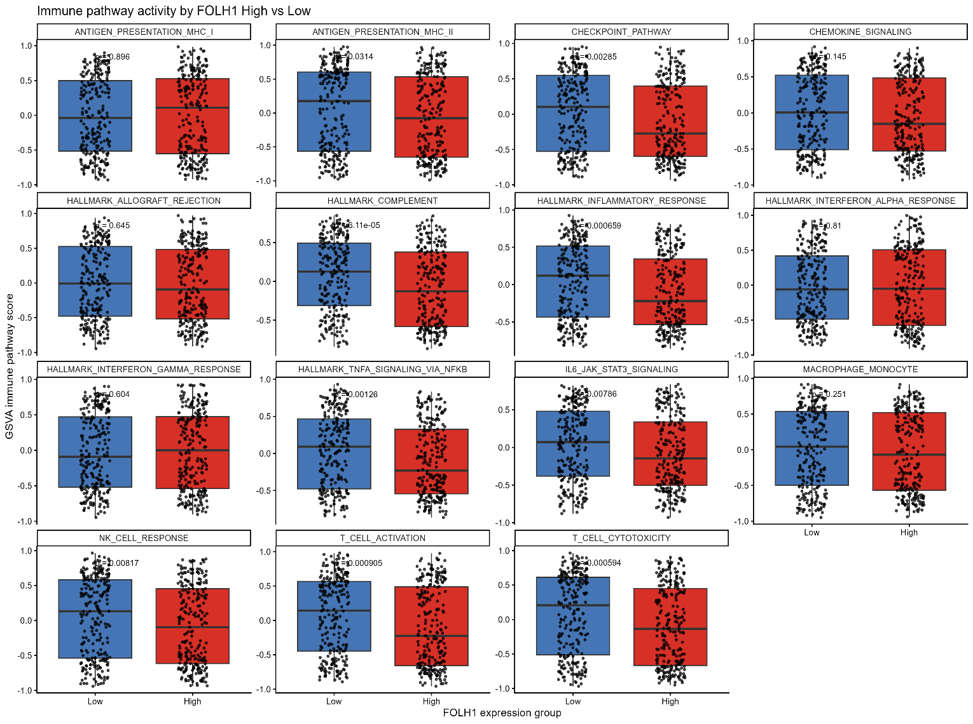
GSVA-based immune profiling showed that FOLH1-high primary tumors exhibited reduced activity of several immune pathways, including complement, inflammatory response, TNFα/NFκB signaling, IL6/JAK/STAT3 signaling, T cell activation, T cell cytotoxicity, and NK cell response. These findings suggest that higher FOLH1 expression is associated with a less immune-inflamed tumor microenvironment in TCGA-PRAD

Tope 10 immune pathways in FOLH1 high group
Pathway | Logfc | Adjusted P Value | Direction
HALLMARK_INTERFERON_GAMMA_RESPONSE | 0.033281 | 0.614285 | FOLH1_High
ANTIGEN_PRESENTATION_MHC_I | 0.014538 | 0.825151 | FOLH1_High
HALLMARK_INTERFERON_ALPHA_RESPONSE | -0.00023 | 0.996255 | FOLH1_Low
HALLMARK_ALLOGRAFT_REJECTION | -0.01615 | 0.825151 | FOLH1_Low
MACROPHAGE_MONOCYTE | -0.05925 | 0.314658 | FOLH1_Low
CHEMOKINE_SIGNALING | -0.07313 | 0.185902 | FOLH1_Low
ANTIGEN_PRESENTATION_MHC_II | -0.11242 | 0.057036 | FOLH1_Low
IL6_JAK_STAT3_SIGNALING | -0.11689 | 0.01741 | FOLH1_Low
NK_CELL_RESPONSE | -0.13332 | 0.016719 | FOLH1_Low
HALLMARK_TNFA_SIGNALING_VIA_NFKB | -0.14677 | 0.003642 | FOLH1_Low

Tope 10 immune pathways in FOLH1 low group
Pathway | Logfc | Adjusted P Value | Direction
T_CELL_CYTOTOXICITY | -0.17822 | 0.002295 | FOLH1_Low
T_CELL_ACTIVATION | -0.17316 | 0.002295 | FOLH1_Low
HALLMARK_COMPLEMENT | -0.16868 | 0.002119 | FOLH1_Low
HALLMARK_INFLAMMATORY_RESPONSE | -0.15694 | 0.002295 | FOLH1_Low
CHECKPOINT_PATHWAY | -0.15111 | 0.004807 | FOLH1_Low
HALLMARK_TNFA_SIGNALING_VIA_NFKB | -0.14677 | 0.003642 | FOLH1_Low
NK_CELL_RESPONSE | -0.13332 | 0.016719 | FOLH1_Low
IL6_JAK_STAT3_SIGNALING | -0.11689 | 0.01741 | FOLH1_Low
ANTIGEN_PRESENTATION_MHC_II | -0.11242 | 0.057036 | FOLH1_Low
CHEMOKINE_SIGNALING | -0.07313 | 0.185902 | FOLH1_Low

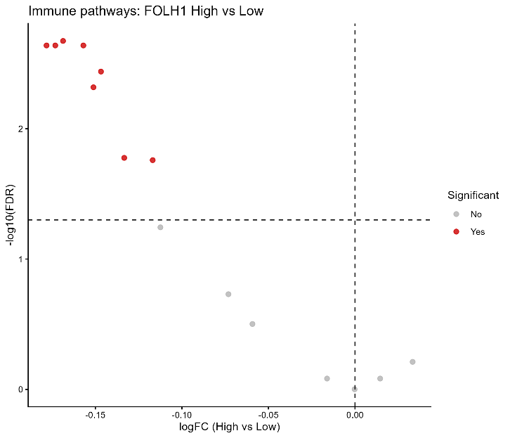
Volcano plot
The volcano plot showed that most significant immune pathways had negative logFC values in the FOLH1 high vs low comparison, indicating reduced immune pathway activity in FOLH1-high tumors
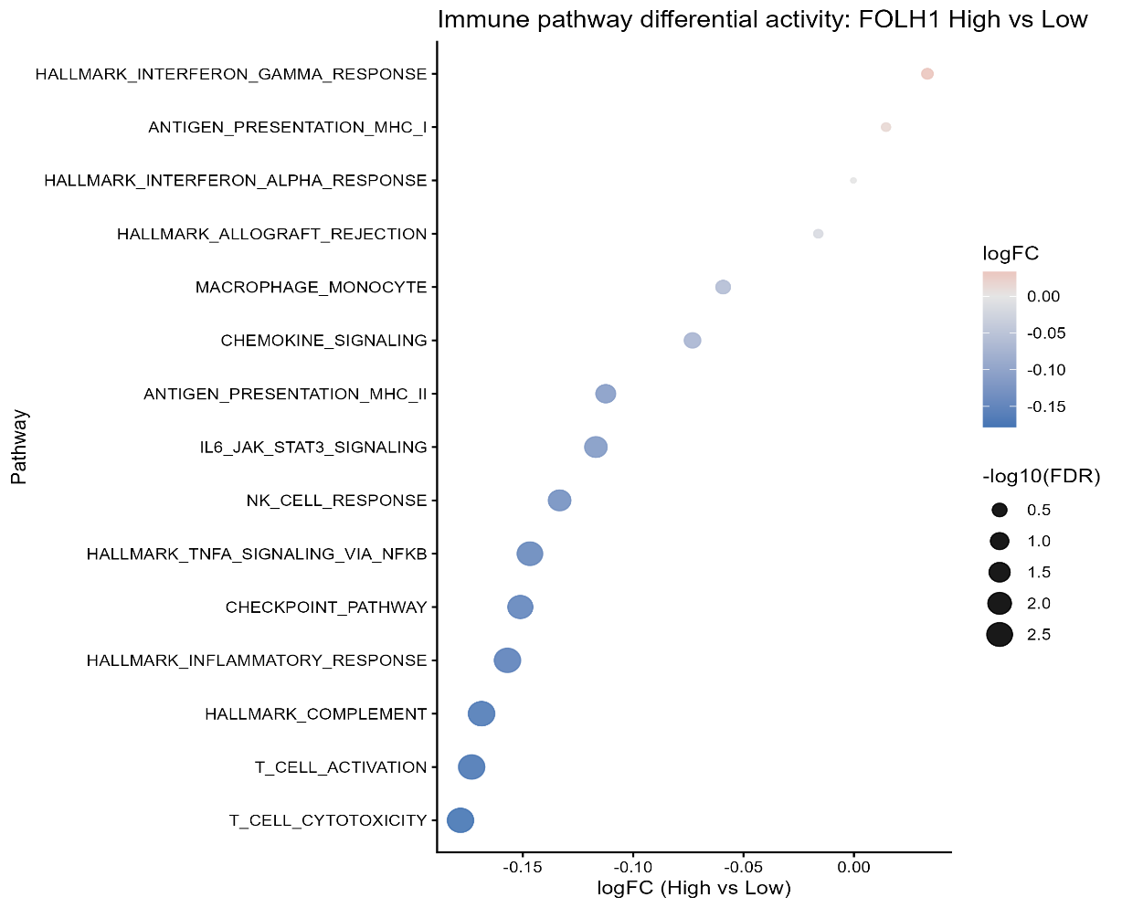
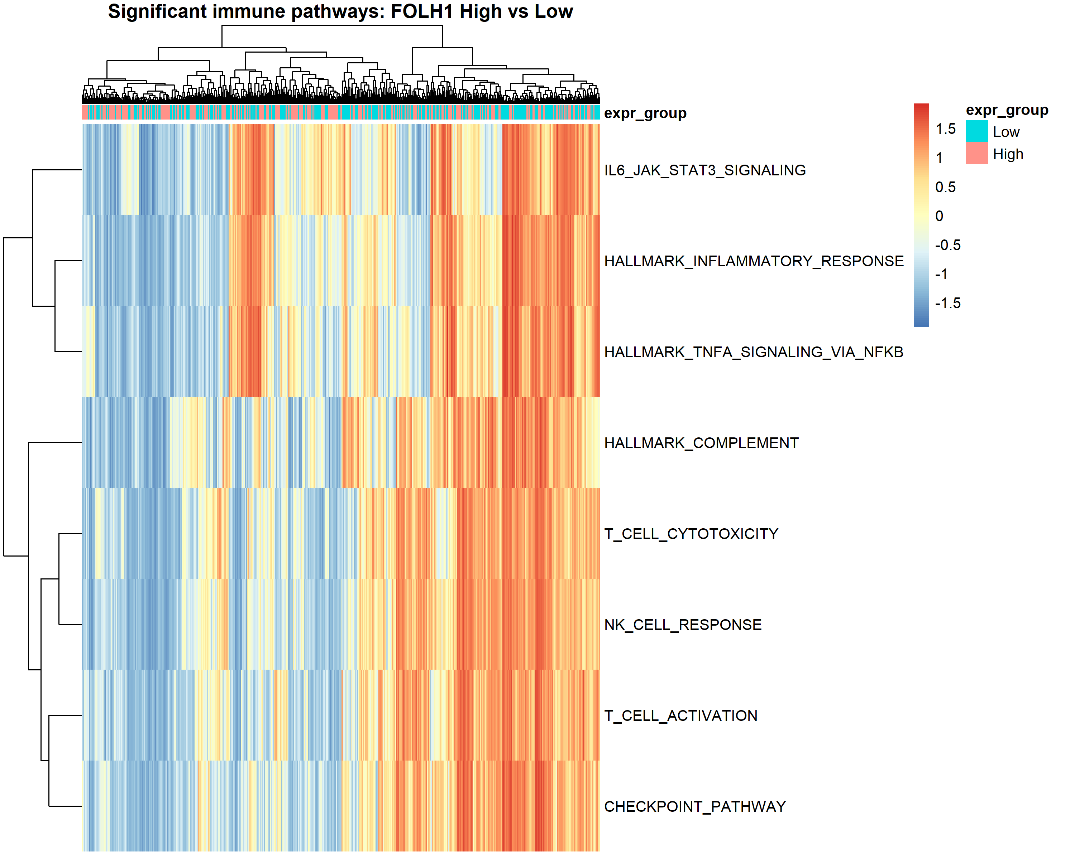
Differential immune pathway analysis showed that FOLH1-high tumors exhibited significantly lower activity of several immune-related pathways, including T-cell activation, cytotoxicity, checkpoint signaling, complement, and inflammatory signaling. The heatmap further demonstrated that these pathways collectively separated FOLH1-high from FOLH1-low tumors.

Immune Transcriptomic Profiling of MSKCC2010 Prostate Adenocarcinoma Primary Tumours
Primary samples from the MSKCC2010 cohort were analysed to explore immune-related patterns in metastatic prostate cancer. Immune scores were generated for each sample, and the cohort was divided into high and low immune score groups. Differential expression analysis was then performed to identify genes associated with immune variation, followed by pathway analysis to determine which biological processes were represented. The relationship between FOLH1 expression and immune score was also examined, and survival analysis was carried out to assess whether immune score was associated with patient outcome.
GSVA Immune score by group for MSKCC2010 primary tumours
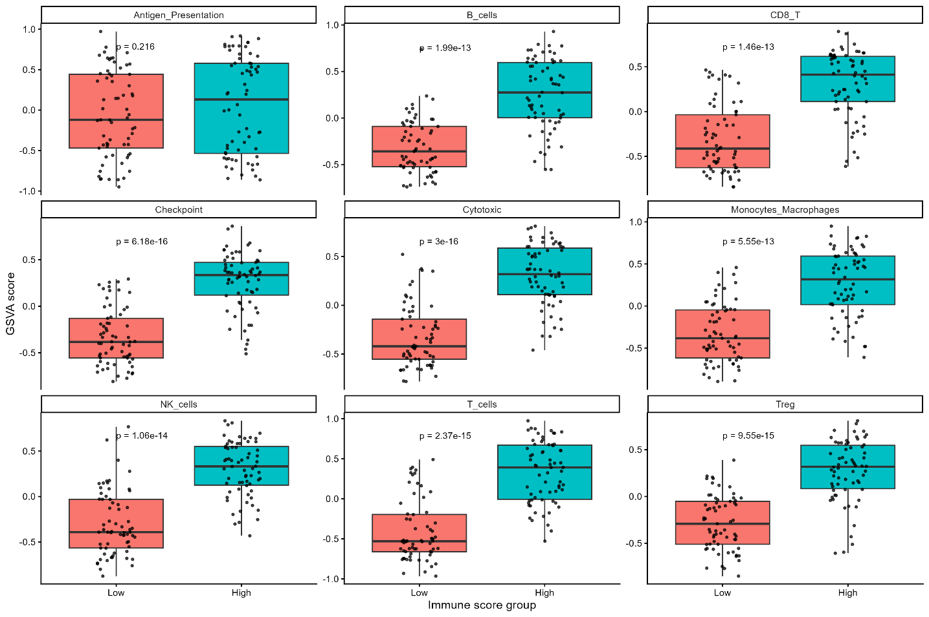
GO enrichment analysis results in MSKCC2010 primary tumours
After differential expression analysis was performed to identify genes associated with immune variation, only a limited number of genes met the strict significance threshold. So a ranked pathway analysis approach was used instead to capture broader biological trend, rather than considering only the significant DEGs
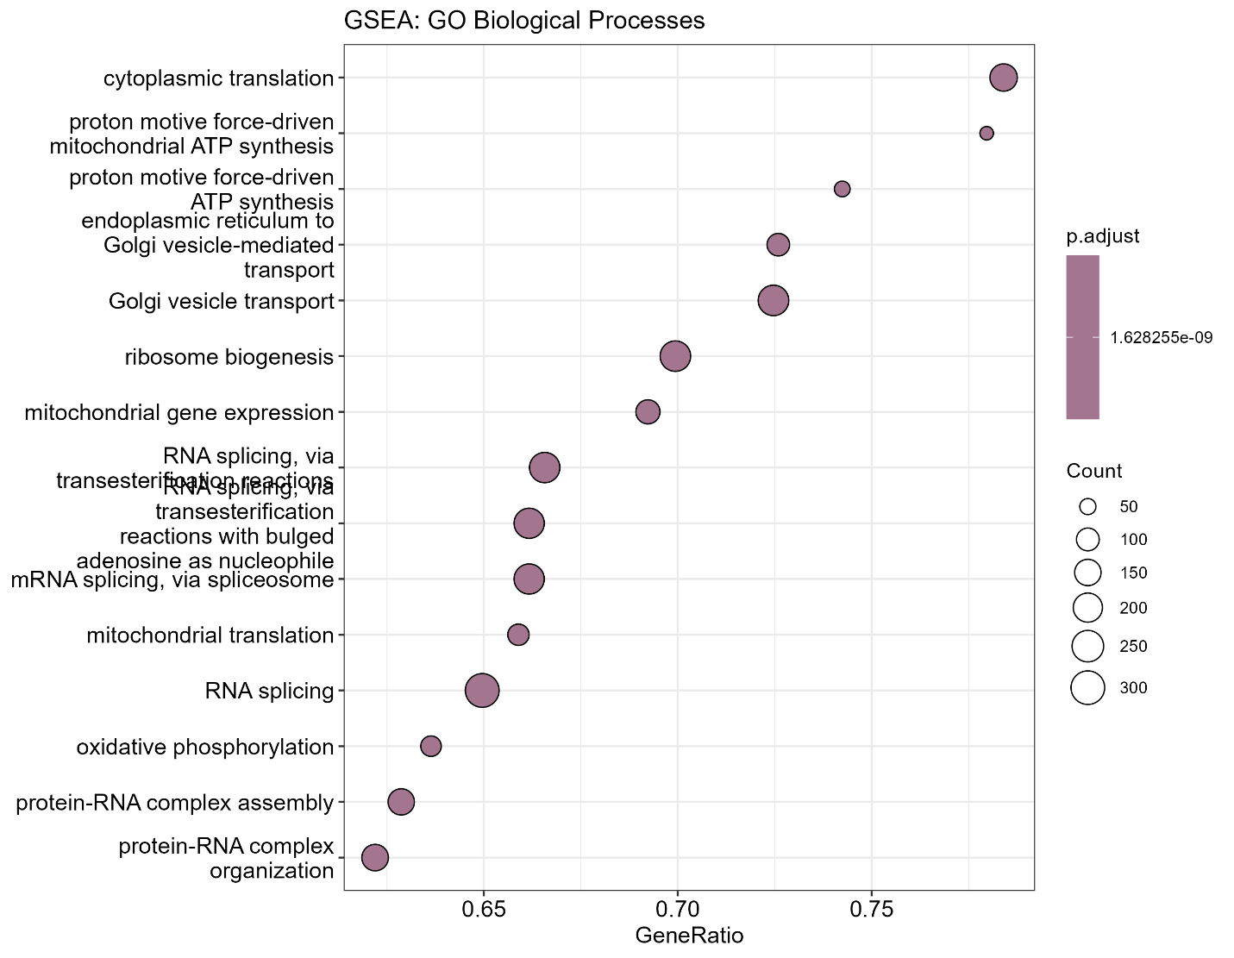
Description | Set Size | Enrichment Score | NES | P value | P adjust
cytoplasmic translation | 213 | -0.64106 | -4.51119 | 1.00E-10 | 1.63E-09
Golgi vesicle transport | 316 | -0.58753 | -4.43902 | 1.00E-10 | 1.63E-09
RNA splicing | 468 | -0.5371 | -4.32991 | 1.00E-10 | 1.63E-09
protein-RNA complex organization | 246 | -0.57523 | -4.29496 | 1.00E-10 | 1.63E-09
mitochondrial gene expression | 169 | -0.61691 | -4.25366 | 1.00E-10 | 1.63E-09
RNA splicing, via transesterification reactions | 338 | -0.55314 | -4.19204 | 1.00E-10 | 1.63E-09
proton motive force-driven ATP synthesis | 66 | -0.74695 | -4.18018 | 1.00E-10 | 1.63E-09
protein-RNA complex assembly | 237 | -0.57879 | -4.14988 | 1.00E-10 | 1.63E-09
ribosome biogenesis | 326 | -0.54699 | -4.14235 | 1.00E-10 | 1.63E-09

KEGG enrichment analysis in MSKCC2010 primary tumours
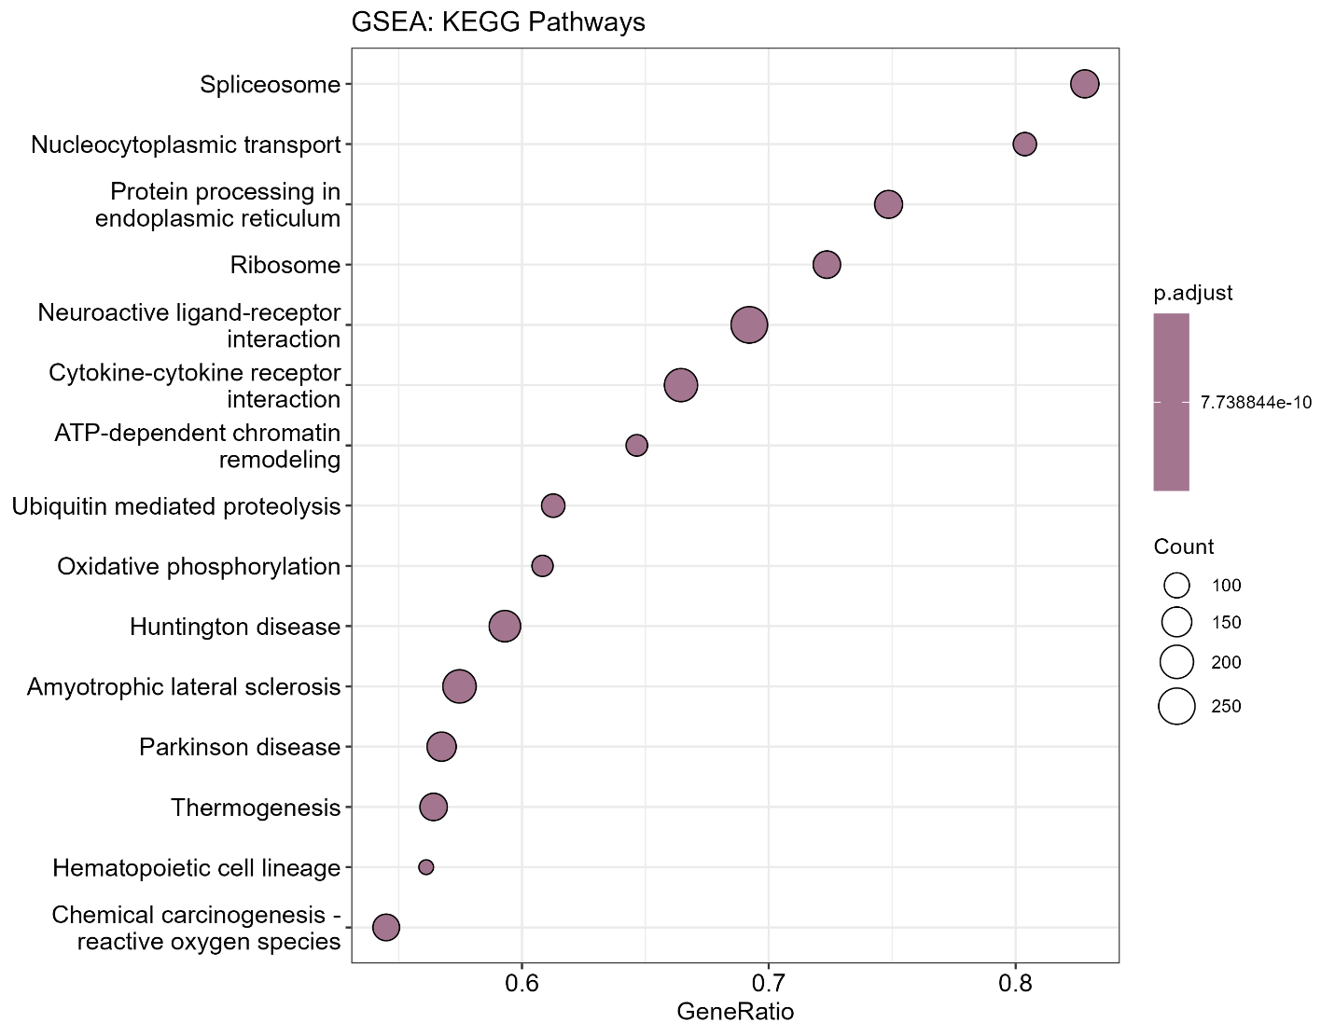
Description | Set Size | P Value | P Adjust
Ribosome | 170 | 1.00E-10 | 7.74E-10
Spliceosome | 157 | 1.00E-10 | 7.74E-10
Protein processing in endoplasmic reticulum | 171 | 1.00E-10 | 7.74E-10
Oxidative phosphorylation | 120 | 1.00E-10 | 7.74E-10
Nucleocytoplasmic transport | 107 | 1.00E-10 | 7.74E-10
Huntington disease | 290 | 1.00E-10 | 7.74E-10
Parkinson disease | 252 | 1.00E-10 | 7.74E-10
Amyotrophic lateral sclerosis | 348 | 1.00E-10 | 7.74E-10
Ubiquitin mediated proteolysis | 142 | 1.00E-10 | 7.74E-10
Thermogenesis | 218 | 1.00E-10 | 7.74E-10

KEGG enrichment in primary tumours was dominated by pathways involved in ribosome biogenesis/translation, RNA splicing, ER protein processing, ubiquitin-mediated proteolysis, and oxidative phosphorylation, indicating widespread remodelling of gene-expression and proteostasis programs.

Association Of FOLH1 With Immune Score Using Spearman’s Correlation Coefficient in MSKCC2010 primary tumours
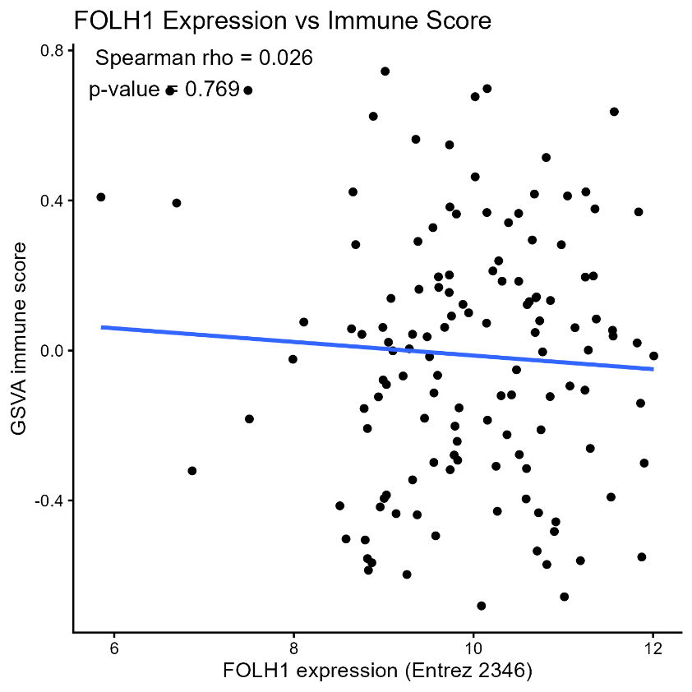
In the MSKCC2010 primary-tumor cohort, FOLH1 expression was not significantly correlated with the GSVA-derived immune score (Spearman rho = 0.026, p = 0.769).
KM survival curves based on high and low immune groups in MSKCC2010 primary tumours
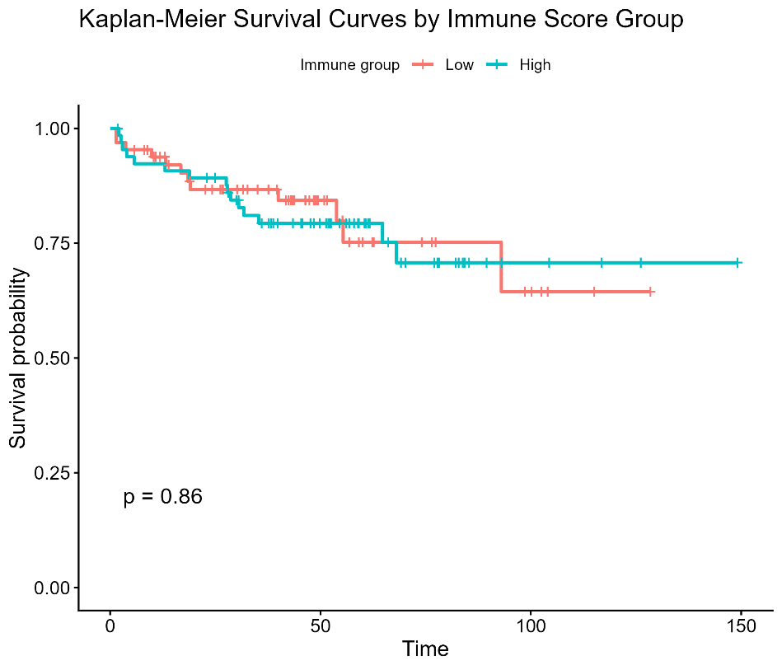
Kaplan–Meier analysis showed no significant difference in survival between high- and low-immune-score groups (p = 0.86), indicating that the immune score did not stratify prognosis in this cohort.

Immune Transcriptomic Profiling of Metastatic Prostate Cancer in MSKCC2010
The metastatic samples from the MSKCC2010 microarray cohort were extracted and matched with the available clinical metadata, and immune activity was then assessed at the transcriptomic level. GSVA-based immune scores were generated using curated immune gene signatures that were converted to match the Entrez-based expression matrix. The samples were then divided into high and low immune score groups, differentially expressed genes were identified between these groups, and functional enrichment analysis was performed to explore the associated biological pathways. The relationship between FOLH1 expression and immune score was also examined, and survival analysis was carried out to determine whether immune score was associated with patient outcome. Overall, immune-related molecular features were investigated in order to better characterize the biology of metastatic prostate cancer.
There were only 19 usable metastatic samples from MSKCC2010 after filtering, so this analysis should be taken as more of an “explorative” analysis.
GSVA Immune score by group for Metastatic tumours
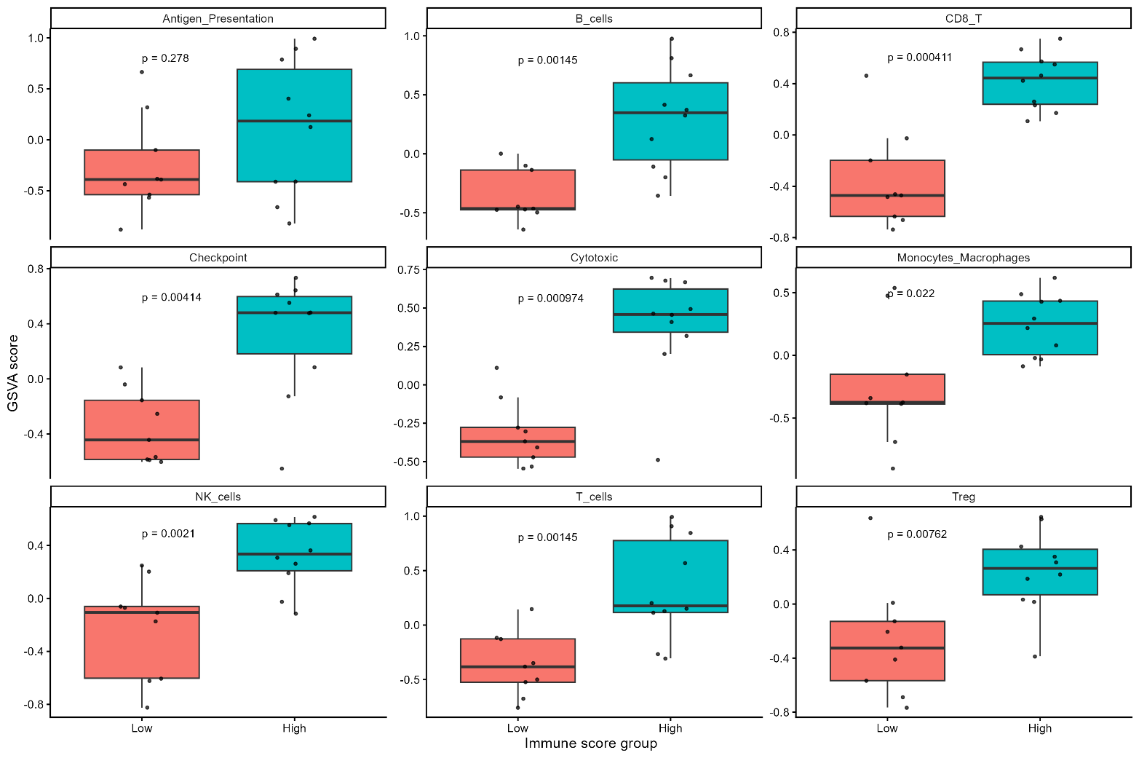

Top 10 Differentially Expressed Genes in metastatic tumours
Symbol | Log Fold Change | Average Expression | P Value | Adjusted P Value
SNORD16 | -1.27501 | 7.087016 | 1.01E-05 | 0.032175
SLC37A1 | -1.04708 | 9.072706 | 1.75E-05 | 0.032175
XAF1 | 1.016972 | 7.80976 | 1.79E-05 | 0.032175
UBR3 | -1.04301 | 7.962544 | 2.10E-05 | 0.032175
CLCN3 | -1.28712 | 8.804685 | 4.50E-05 | 0.032175
NARS1 | -1.0586 | 8.98961 | 5.04E-05 | 0.032175
ME2 | -1.0812 | 7.993852 | 5.55E-05 | 0.032175
SNORD101 | -1.38097 | 6.464528 | 5.94E-05 | 0.032175
NAP1L2 | -1.15748 | 6.846351 | 5.95E-05 | 0.032175
CD69 | 1.065972 | 6.281236 | 6.25E-05 | 0.032175

KEGG enrichment analysis in Metastatic tumours
Category | Subcategory | Description | Gene Ratio | P Value | P Adjust
Metabolism | Lipid metabolism | Fatty acid biosynthesis | 3/47 | 9.04E-05 | 0.031288
Metabolism | Global and overview maps | Fatty acid metabolism | 4/47 | 0.000178 | 0.031288

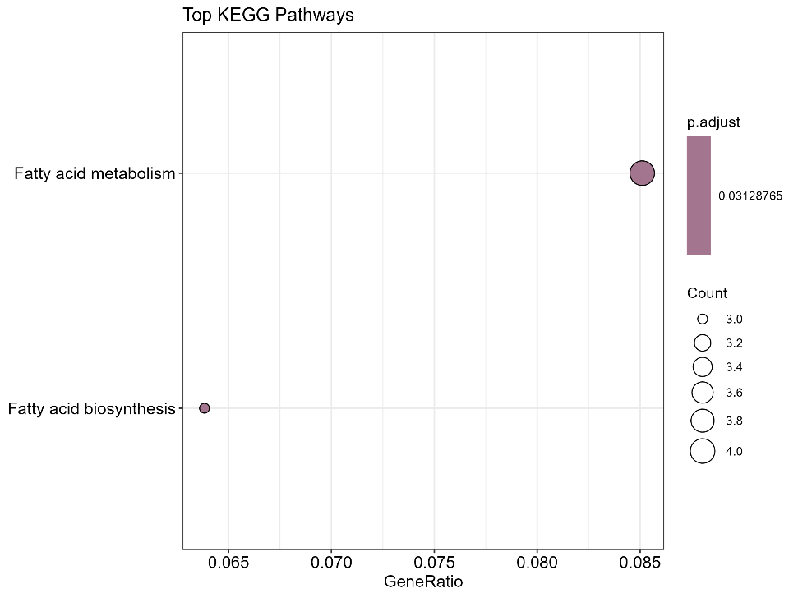
KEGG enrichment analysis of metastatic tumour genes revealed significant overrepresentation of lipid metabolism pathways, particularly fatty acid biosynthesis and fatty acid metabolism, suggesting altered fatty acid handling in metastatic disease.
Association Of FOLH1 With Immune Score Using Spearman’s Correlation Coefficient in metastatic tumours
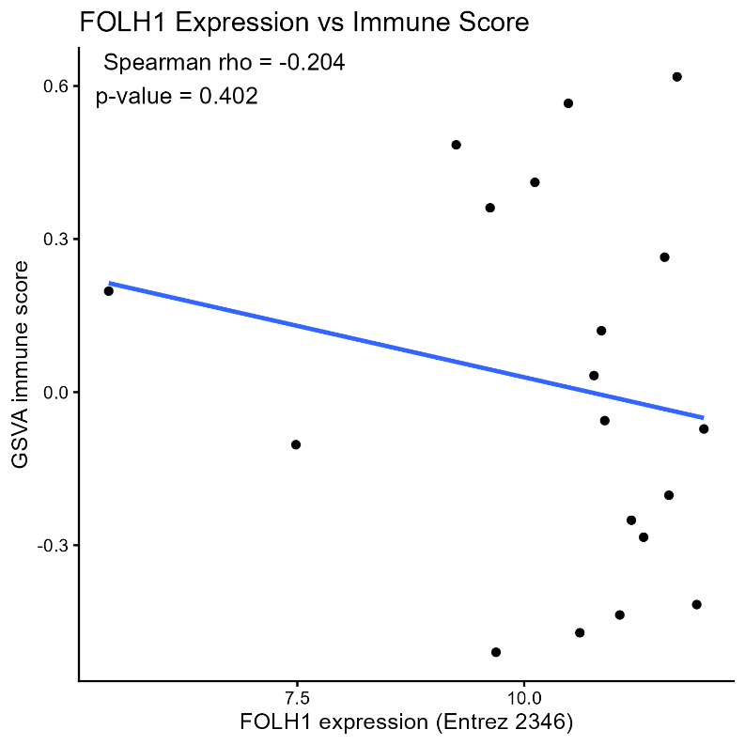
In metastatic tumors, FOLH1 expression showed a weak negative association with the GSVA-derived immune score (Spearman rho = -0.204), but the relationship was not statistically significant (p = 0.402)
KM survival curves based on high and low immune groups in metastatic tumours
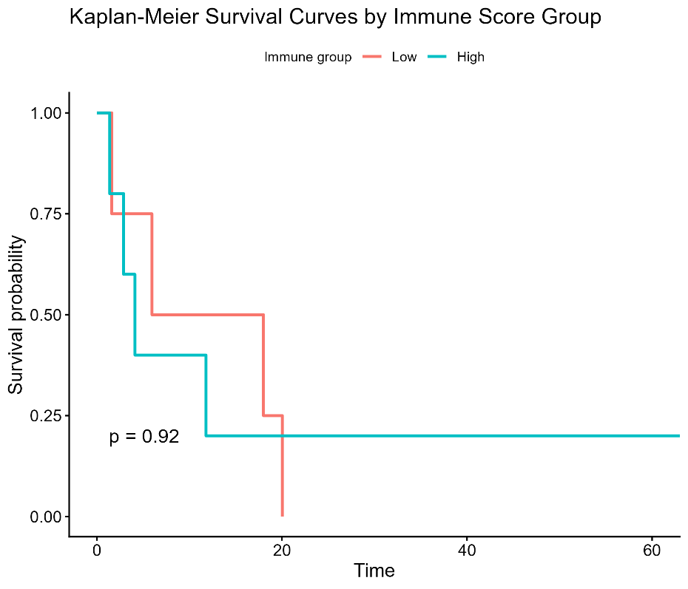
Kaplan–Meier analysis likewise showed no significant difference in survival between high- and low-immune-score groups (p = 0.92), indicating limited prognostic value of the immune score in this cohort.

MCP-Counter Analysis of The Tumour Microenvironment In TCGA-PRAD Primary Tumours
Primary tumour samples from TCGA-PRAD were analysed using MCP-counter to estimate the abundance of immune and stromal cell populations from transcriptomic data. The samples were compared according to FOLH1 expression status, and microenvironment scores were summarized across the FOLH1 high and low groups. Box plots were produced to show group-wise differences in inferred cell populations, a clustered heatmap was generated to display the overall microenvironment pattern across samples, and correlation plots were created to assess the relationship between FOLH1 expression and each MCP-counter score. Kaplan–Meier survival plots were also generated for individual cell populations to explore whether microenvironment features were associated with patient outcome.
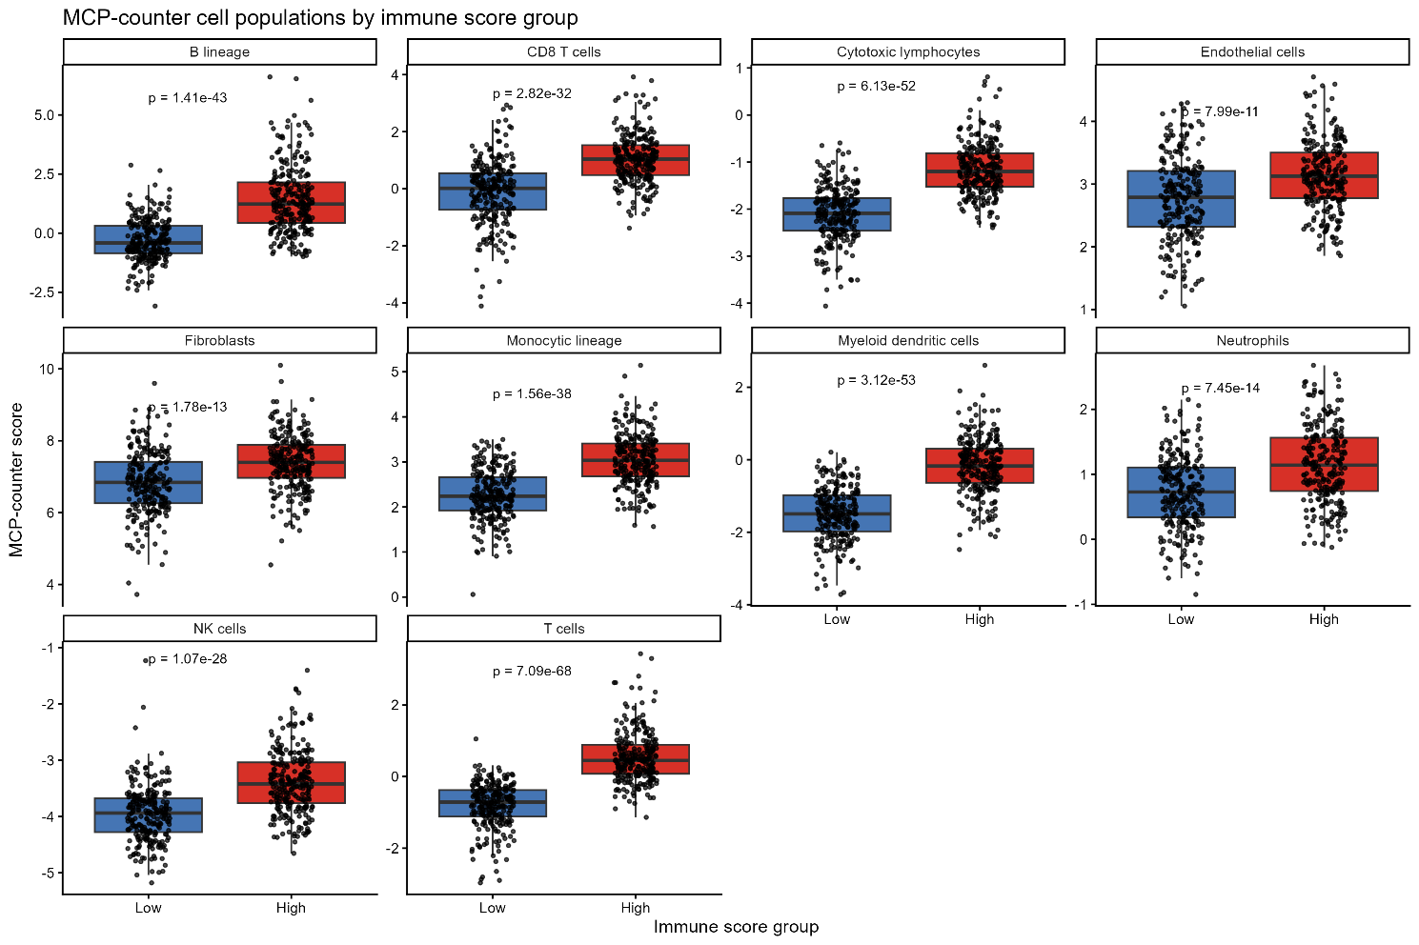
MCP-counter analysis showed that the high immune-score group had significantly increased abundance of multiple immune and stromal cell populations, including B lineage, CD8 T cells, cytotoxic lymphocytes, NK cells, T cells, dendritic cells, neutrophils, endothelial cells, fibroblasts, and monocytic cells. These findings indicate that the immune score captured a strongly infiltrated tumour microenvironment.
Correlation between MCP-counter score and FOLH1 expression
Cell population | rho | P value | Adj P Value
T cells | -0.24261 | 4.22E-08 | 4.22E-07
CD8 T cells | -0.0798 | 0.074335 | 0.106194
Cytotoxic lymphocytes | -0.09963 | 0.025783 | 0.051565
B lineage | -0.14235 | 0.001414 | 0.003535
NK cells | -0.08389 | 0.060621 | 0.101034
Monocytic lineage | -0.01968 | 0.660198 | 0.733554
Myeloid dendritic cells | -0.19453 | 1.20E-05 | 4.01E-05
Neutrophils | -0.07333 | 0.101109 | 0.126387
Endothelial cells | 0.008111 | 0.856234 | 0.856234
Fibroblasts | -0.19588 | 1.05E-05 | 4.01E-05

Correlation dot plot
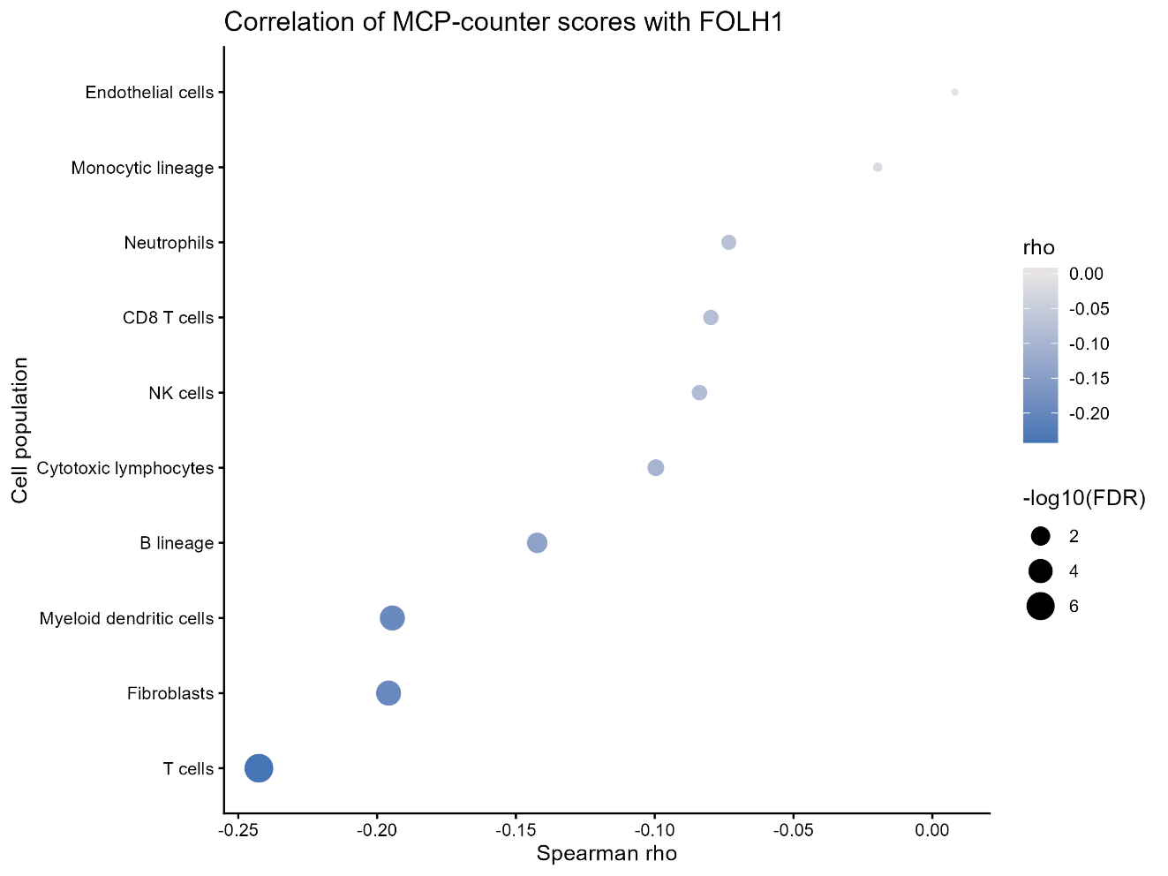

Heatmap
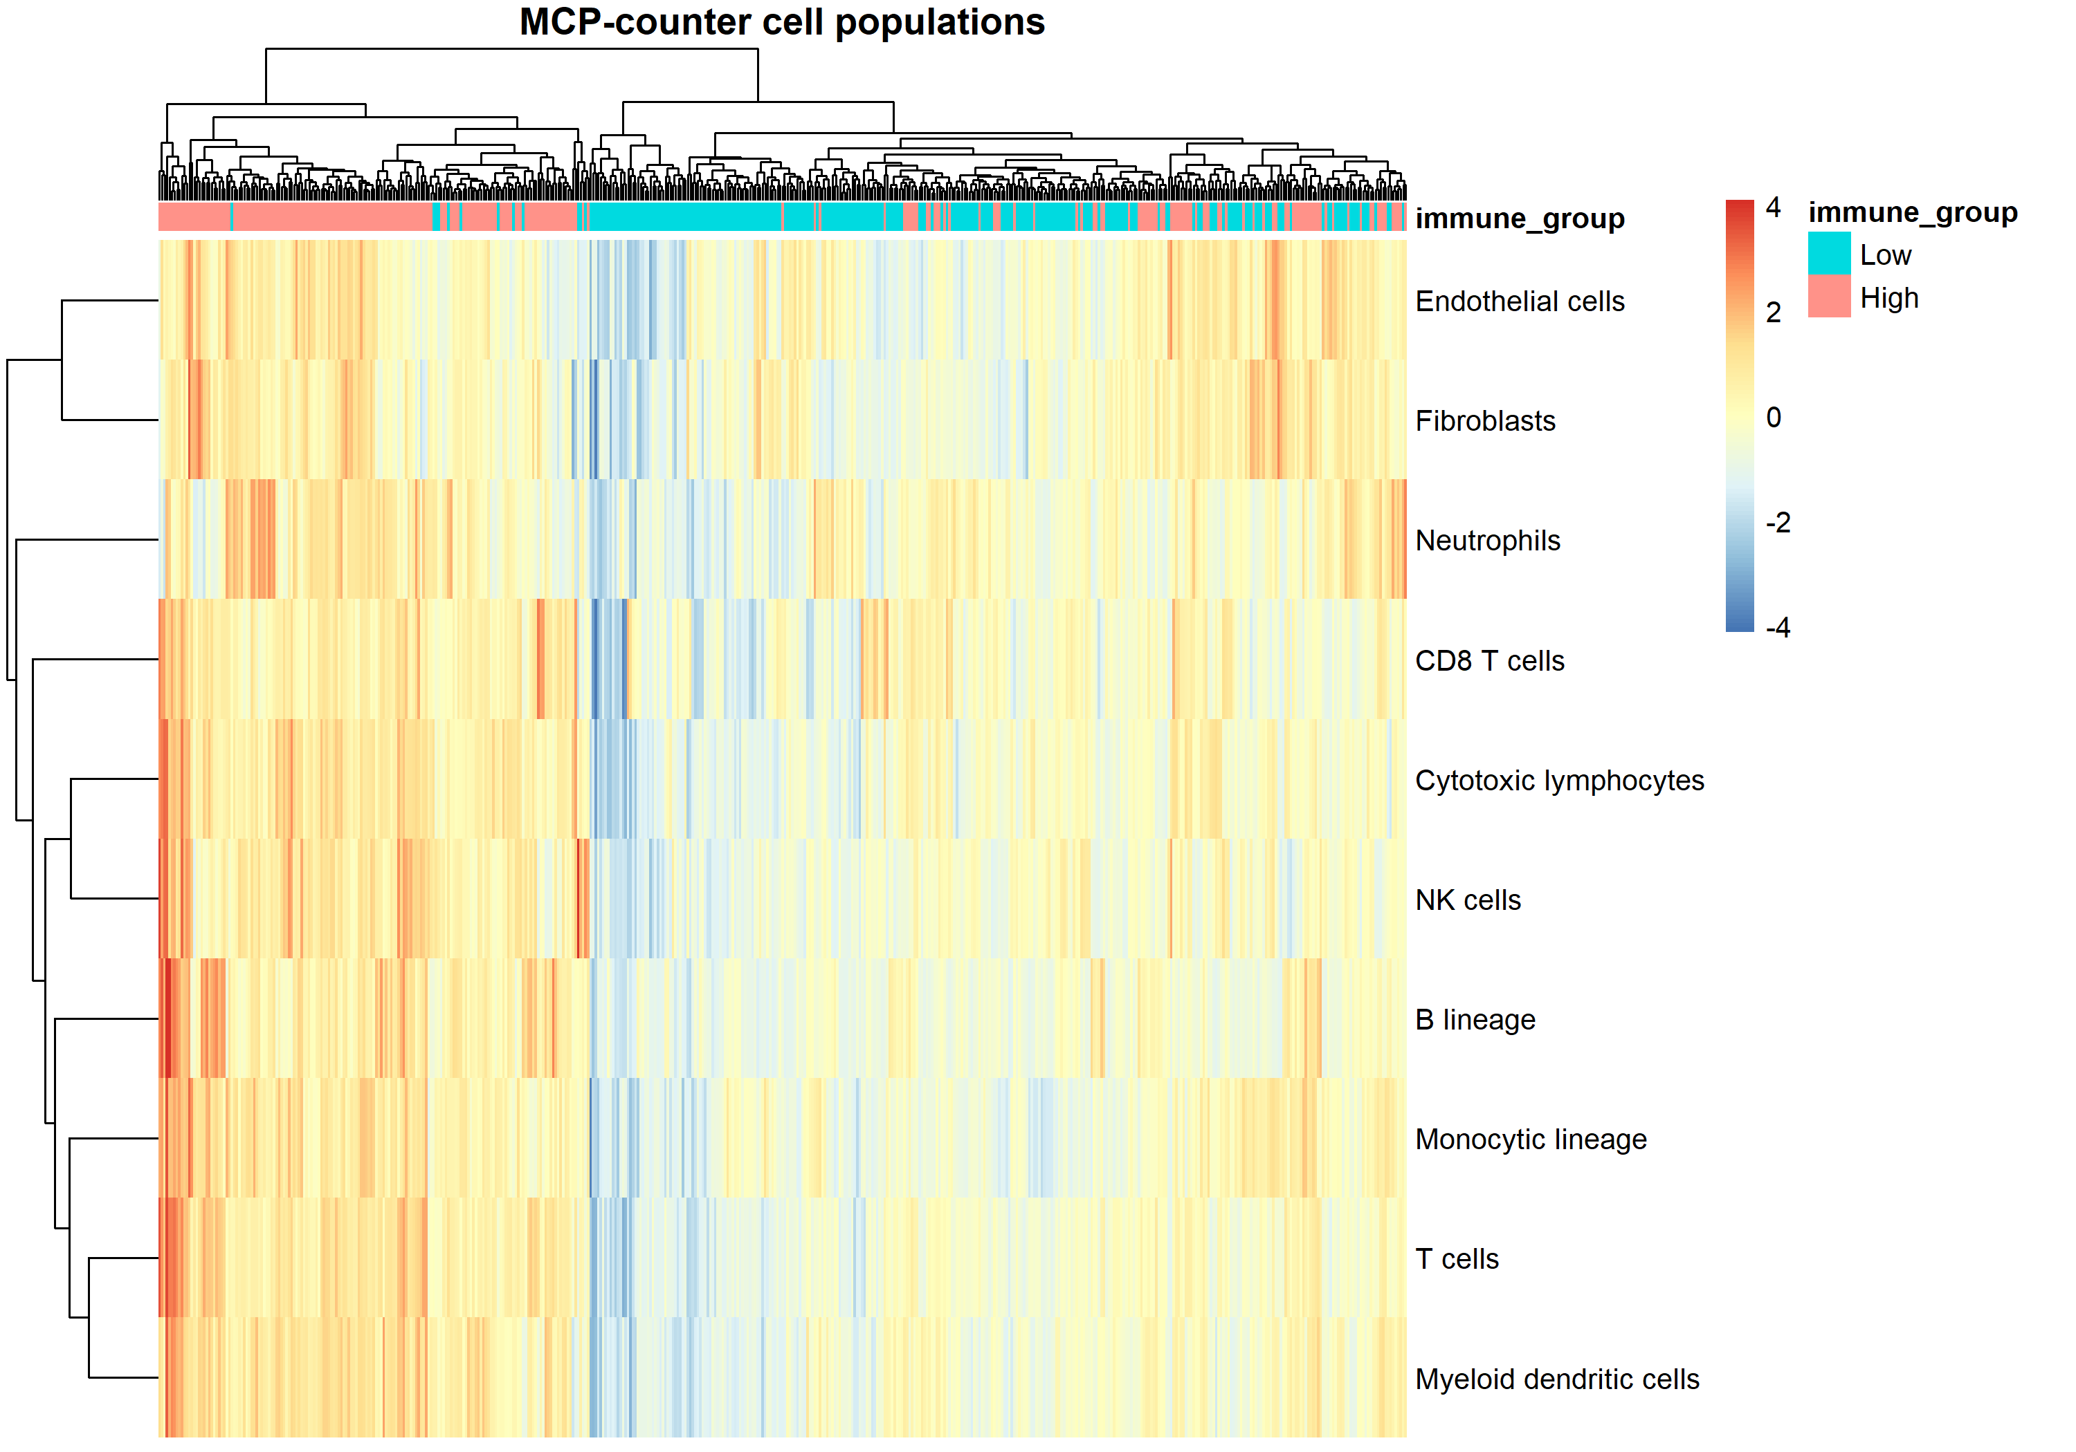
Survival analysis (OS)
Cell population | P value | HR | Adjusted P Value
T cells | 0.840924 | 1.136089 | 0.900477
CD8 T cells | 0.900477 | 1.08266 | 0.900477
Cytotoxic lymphocytes | 0.827137 | 0.866037 | 0.900477
B lineage | 0.405274 | 0.585663 | 0.900477
NK cells | 0.744688 | 0.808606 | 0.900477
Monocytic lineage | 0.375948 | 0.536944 | 0.900477
Myeloid dendritic cells | 0.412331 | 1.693141 | 0.900477
Neutrophils | 0.674576 | 0.762354 | 0.900477
Endothelial cells | 0.336959 | 0.505506 | 0.900477
Fibroblasts | 0.763999 | 1.217385 | 0.900477

KM Plots for each cell population
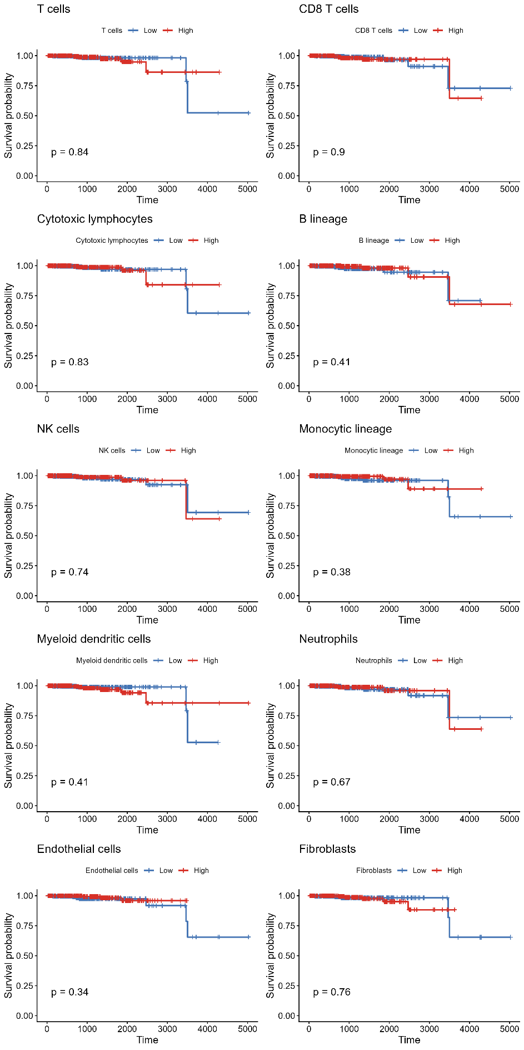
Kaplan–Meier analysis of MCP-counter cell populations showed no significant survival differences between high- and low-score groups for T cells, CD8 T cells, cytotoxic lymphocytes, B lineage, NK cells, monocytic lineage, myeloid dendritic cells, neutrophils, endothelial cells, or fibroblasts. These results indicate that, although immune and stromal infiltration varied across tumors, these MCP-counter features did not stratify survival in this cohort.

MCP-counter analysis of Tumour Microenvironment in SU2C Metastatic Samples of Prostate adenocarcinoma
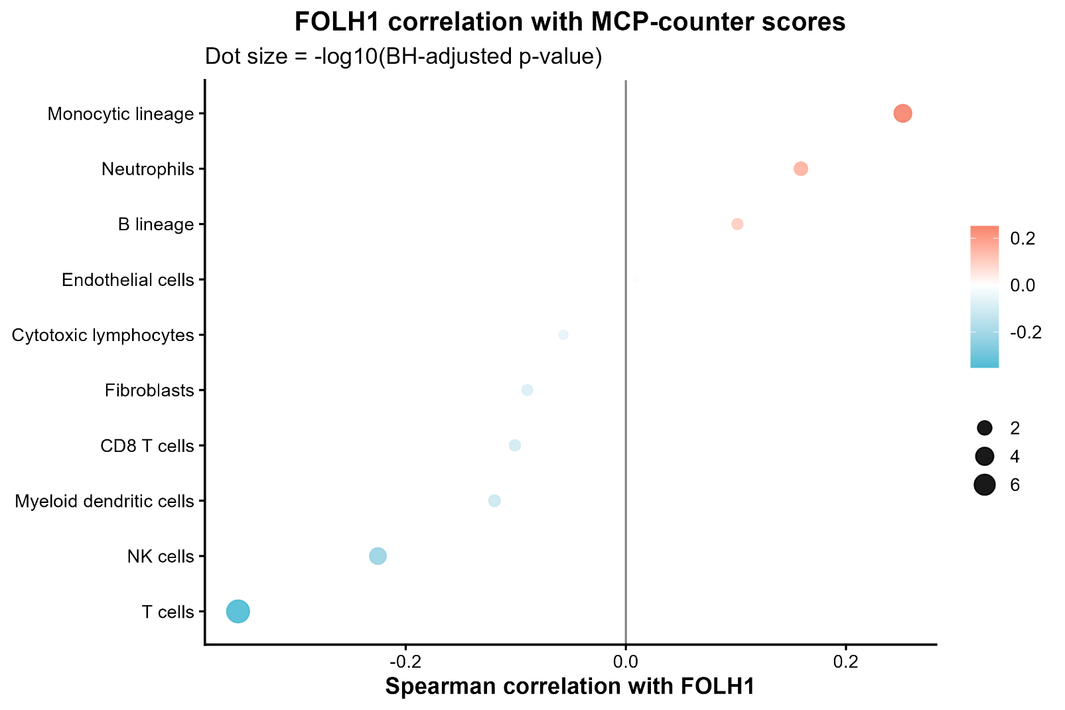
Similar to the previous analysis done on the primary tumour samples of TCGA-PRAD cohort, MCP-counter was used to look into the immune and stromal cell populations within the tumour microenvironment of metastatic tumours. These MCP-counter scores were then correlated with FOLH1 expression to explore any correlation and individual scatterplots as well as a combined dot plot was produced.

Individual scatterplots that showed a significant correlation with FOLH1 are shown in the next page. These cell populations were monocytic lineage, neutrophils, NK cells and T cells.

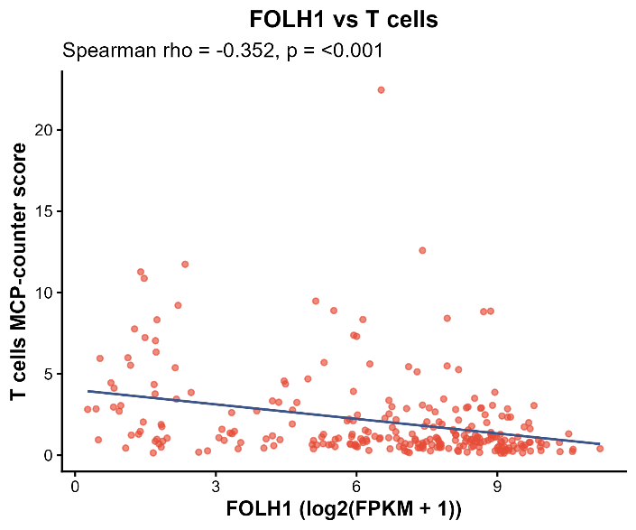
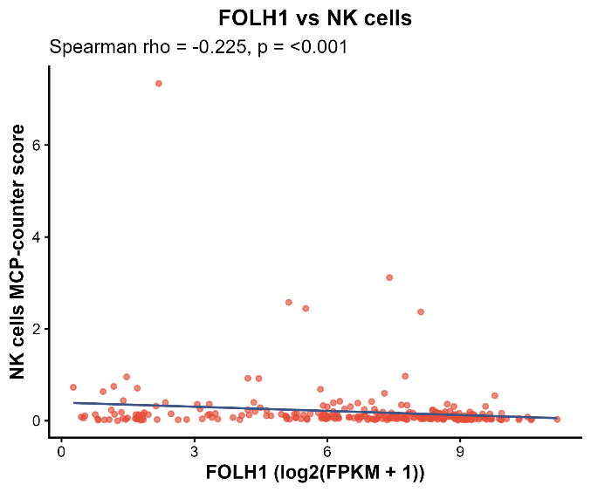
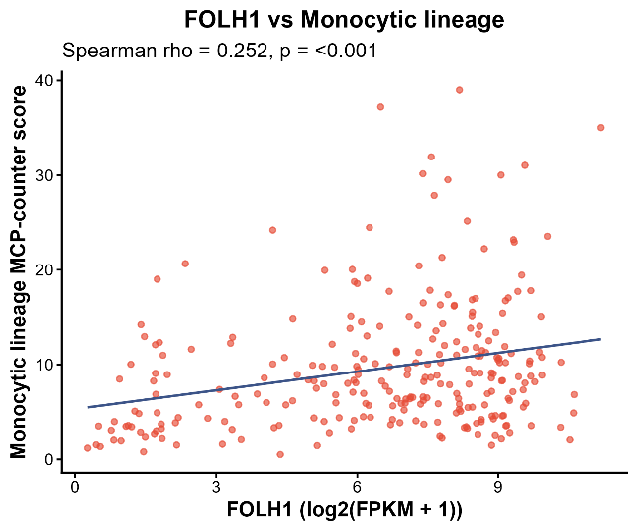
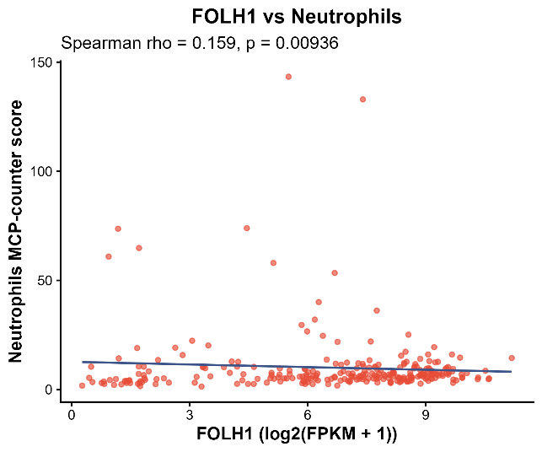
Next, Overall Survival study was conducted using the Cox model for each of the cell groups from MCP-counter to see if high and low expression groups showed stratification on survival trends. None of the cell populations showed a significant stratification in survival.
